The Thomson House Garden Project Summary Report for 2011

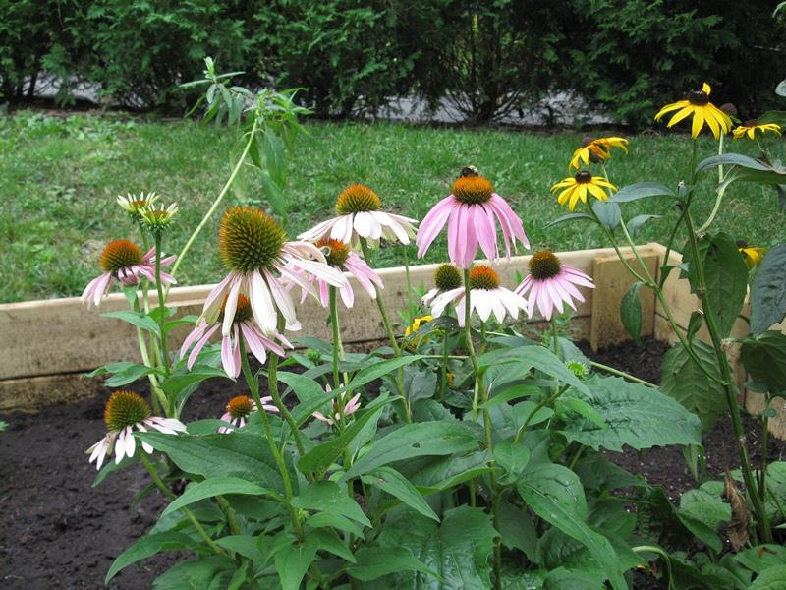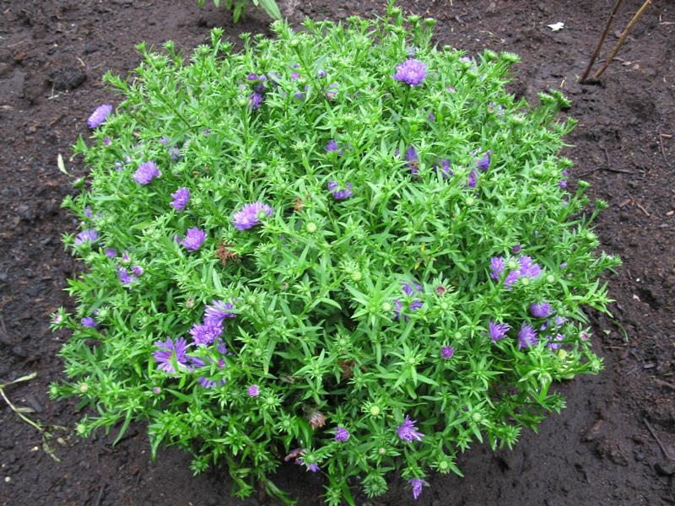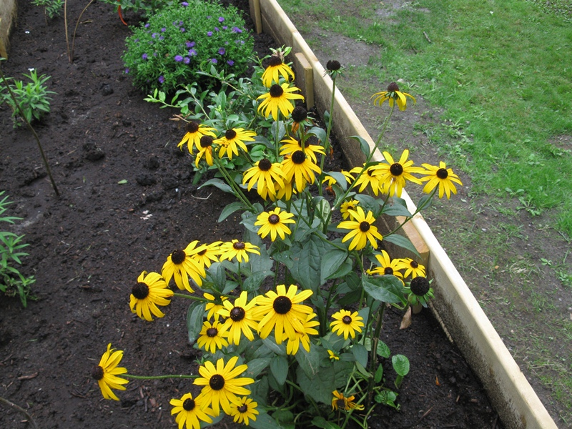
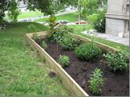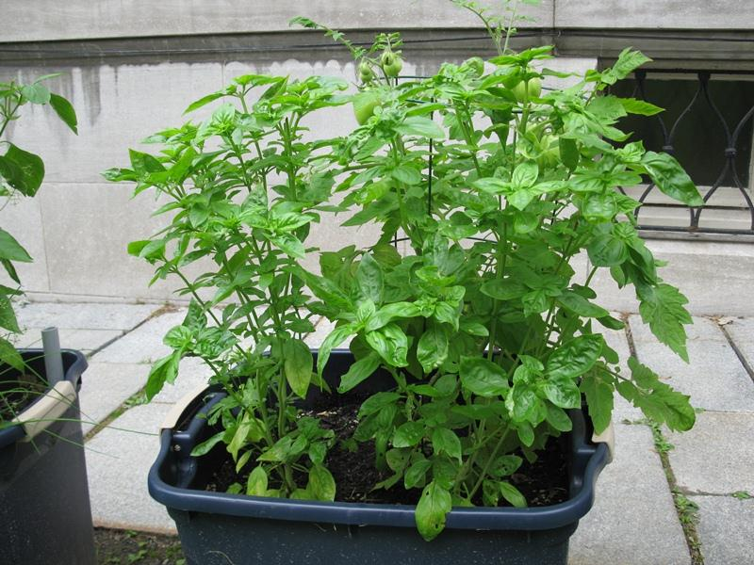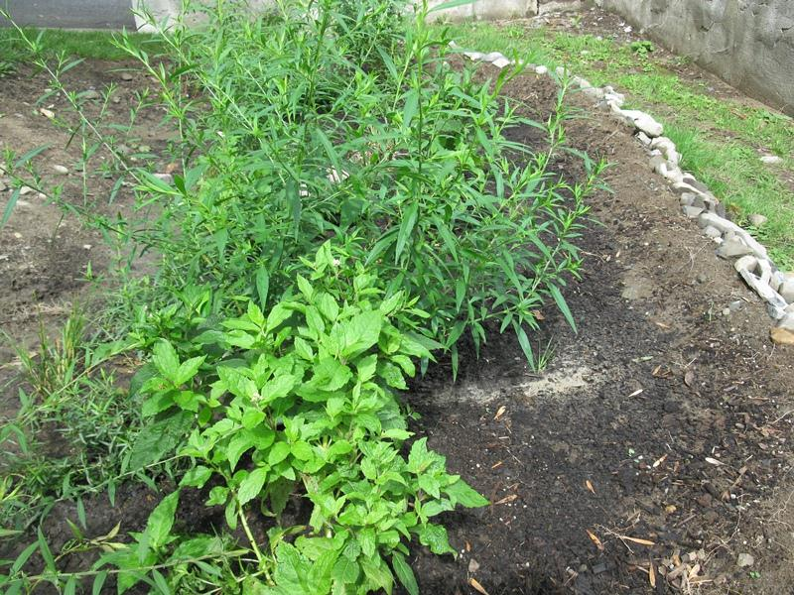
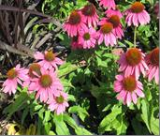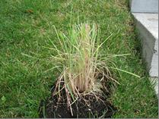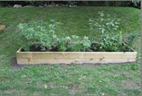

Chris Wrobel
PGSS Environment Committee 2006-2011
March 5, 2012
Acknowledgements
The Thomson House Garden Project is indebted to the leader of the project, Samantha Fink, for all the time and hard work that she put in. Amidst several problems such as delays in receiving project materials and resources, and sourcing high quality plants, she, as well as several student volunteers from the two student groups of the Urban Horticulture Course at the Macdonald Campus that designed the Thomson House Garden Project, learned to improvise and keep their focus on the attainment of the project goals. By drawing on their inner strengths the project was successfully completed. The project would like to thank the students from Campus Crops as well as a number of graduate student volunteers who helped at various times during the summer in helping the project achieve its goals. Additionally, undergraduate students Dzuy-Tam Tran and Sophie Yuan worked tirelessly to help build the garden features and maintain the health of the plants. Many thanks are also extended to Andre Pierzchala and several other staff of Thomson House for their help throughout the summer. And finally the Project would like to thank Mr. David Wees, Faculty Lecturer of the Urban Horticulture course, for his helpful suggestions regarding the project.

“Good timber does not grow with ease, the stronger wind, the stronger the trees.”

Forward
"If future generations are to remember us with gratitude rather than contempt, we must leave them more than the miracles of technology. We must leave them a glimpse of the world as it was in the beginning, not just after we got through with it."
-President Lyndon B. Johnson (Upon signing of the Wilderness Act, 1964)
"Permaculture" is a term coined in the 1970s by two Australians, David Holmgren and Bill Mollison. It broadly describes ecologically responsible agriculture, landscaping and habitat design techniques. Urban permaculture is permaculture that is practiced in cities, and it observes and incorporates the symbiosis that already exists in nature's ecosystems. It translates these examples into best practices for sustainable city planning and design. Urban transportation patterns, habitat destruction and excessive natural resource consumption has led to degradation of the human environment worldwide. The objective of urban permaculture is to create more sustainable urban communities. It encourages city governments and residents to nurture and rehabilitate public and private spaces with techniques that duplicate nature's harmonious self-regulating systems. It requires that people respect and work with nature to create an environment that sustains humans, animals and plants. Urban permaculture also embraces policies that help prevent further degradation of the air, water and land. Its best practices employ multipurpose land use as a cornerstone of urban planning. These design techniques create smart cities that integrate activities such as working, shopping and recreation with housing.
Native-plant cultivation is an important urban permaculture practice that helps balance natural resource utilization. It also encourages the return of wildlife that forages on local vegetation, and it decreases the need for pesticides to control non-native plants and weeds. This supports the rehabilitation of urban storm water runoff systems. Edible landscaping and community gardens are permaculture strategies that increase food security in urban areas. They also provide opportunities to enrich and replenish urban soil by composting post-harvest waste instead of relying on chemical fertilizers. Planting fruit and nut trees also improves biodiversity. The increased availability of locally produced food also reduces the energy used for transportation to deliver food from distant locations.
It is estimated that a slight majority of the world's population now lives in cities and urban areas. These large communities provide both challenges and opportunities for environmentally conscious developers. The goal is to create the smallest possible ecological footprint, and produce the lowest quality of pollution possible, to efficiently use land; compost used materials, and recycle or convert waste to energy. Thus a city's contribution to climate change will be minimized. The City of Montreal, along with other cities in North America, is currently instituting programs to do such. The hope is to attract people back to the city core, allowing them to live closer to their workplace.
Ecological models are required that can be duplicated throughout a city. From this idea the Thomson House Garden Project was conceived. A permaculture garden system integrated with a food producing unit was implemented last summer with help from the Sustainability Projects Fund at McGill. Hopefully this project will serve in the future as a source for education and research which will help further the development of the University's sustainability curriculum, and in turn further sustainable development in the City of Montreal.

Project History
Currently there is no graduate program in landscape design at McGill University. The only place that it is taught at McGill is at the Macdonald campus as an undergraduate course. In the fall of 2010, David Wees, a Faculty Lecturer who teaches a course on urban horticulture at the Macdonald campus, was approached to help design a permaculture garden at Thomson House. Student groups from his classes had successfully designed permaculture gardens in several locations, such as the Co-op du Grand Orme, an organic food cooperative in Ste. Anne de Bellevue. He enlisted two groups of students in his class to design such a space as part of their class projects for this course. The student group Campus Crops, a QPIRG McGill project that encourages campus gardening, was approached to help with the implementation and management of a vegetable container garden that would be associated with the permaculture design. After several weeks of consultation with the operations manager of Thomson House, the chef of the Thomson House restaurant, and several students and staff, both student class groups came up with a computerized design of what such project would look like. The projects were later merged into one (Figure 1).
Figure 1. Computerized image of Thomson House Garden Project

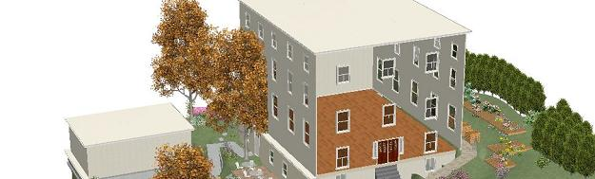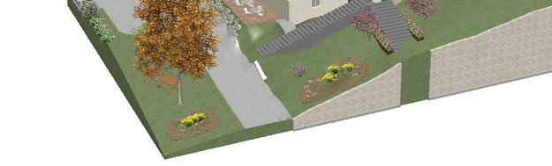
The project included a rain garden – a landscaped area designed to receive storm water and allow it to infiltrate into the soil – positioned on the front ground of Thomson House facing McTavish, a container garden area on the north side with accompanying flower beds, ferns on the heavily shaded west side of the building, and ornamental grasses along the stairs on the east side. An application was made to the Sustainability Projects Fund for money to implement the project. The project was accepted for funding in late May by the Fund under the project leader, Samantha Fink, a U4 student in Anthropology and Environmental Studies.
There have been several successful projects funded by the Sustainability Projects Fund that have been implemented by undergraduate students in several locations on both McGill campuses. One is the McGill Student Run Ecological Garden Project which occupies a quarter of an acre at the Macdonald campus Horticulture Center, and another acre on the edge of the Arboretum. Another example of a successful project is the Campus Crops container garden behind the James Administration Building on McGill’s lower campus.
Immediately following final acceptance, an event was held at Thomson House on June 9 to recruit graduate student volunteers for the project. Presentations were made by Chris Wrobel of the PGSS environment committee and Samantha Fink. Over 30 people came to the event and signed up to help with the project.
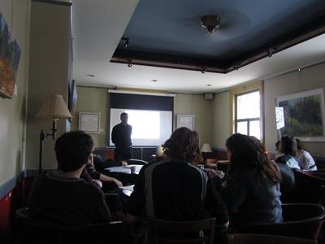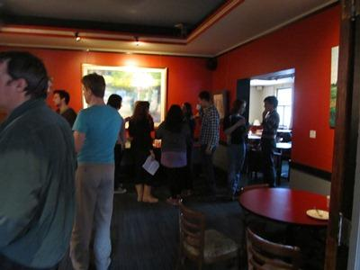
The first element of the project that was implemented was the container garden. This was done in one afternoon with about ten volunteers in the middle of June. This was followed by the rain garden at the end of June, the fern bed on the western side of Thomson House in early July, the three flower beds on the north side of Thomson House in July and early August, and the ornamental grasses in the middle of August. There were twelve work sessions/workshops from the middle of June to the middle of August. Only one had to be cancelled. All others had between 3-10 volunteers.
From the middle of August to early fall grass sod was put on the areas of Thomson House that had been dug up during the project implementation, structurally reinforcing the largest of the three flower beds on the north side of Thomson House, and general maintenance of the project. The garden components were repeatedly fertilized with a balanced mixture of nitrogen, phosphorous and potassium every two weeks during the growing season, and a fertilizer solution relatively high in phosphorous in October to encourage plants to store the above ground biomass into their root system for the winter. The container garden was closed at the end of October after a heavy ground frost killed all the vegetable plants growing in them. The carbon rich earth in the containers was applied to different areas of the project gardens, and to some of the trees and shrubs growing around Thomson house.
The project achieved all its objectives. There was a presentation of the project by Samantha Fink at Green Night, the orientation event organized by the PGSS environment committee, on September 13. A description of the project, including a you tube video description by Samantha Fink, the project leader, is available at http://www.mcgill.ca/sustainability/thomson-house-permaculture-garden . The project was presented at McGill’s Sustainability Fair in September (http://www.mcgill.ca/sustainability/node/188). And an article on the project was published in the October 31st issue of the McGill Daily newspaper which is available at http://www.mcgilldaily.com/2011/10/permaculture-greens-campus/.

Objectives
The objectives of the project were to make Thomson House more sustainable, interest the House’s users in urban agriculture, attract pollinators to the associated container garden, and add to the biodiversity of the surroundings around the building. The project’s desired outcomes were an increased knowledge by Thomson House’s members about project elements such as rainwater management, container gardening, and composting, as well as the significance of incorporating native perennials into outside green spaces. Thomson House would also benefit from sourcing some of their food supply requirements from the container garden.
The project would provide a site, readily accessible, for class field trips and workshops in urban planning and environmental sciences. The information generated by the project could serve courses in horticulture and landscape design, as well as engineering and architecture. And finally it could be a future teaching model for students seeking an original and stimulating study experience. Outside of the Santropol Roulant container garden on lower campus, there is no garden area at McGill that is accessible to the public in terms of use and education. This garden will provide an opportunity for people to learn about permaculture as an ecological gardening technique and rainwater management in urban environments. In urban, downtown settings it is difficult to gain access to this sort of information, and Thomson House could be a model of how future McGill landscaping projects (as well Montreal’s projects) may incorporate sustainable, ecological methods into the beautification of our campus.

The Rain Garden
Figure 2. The Rain Garden outside Thomson House
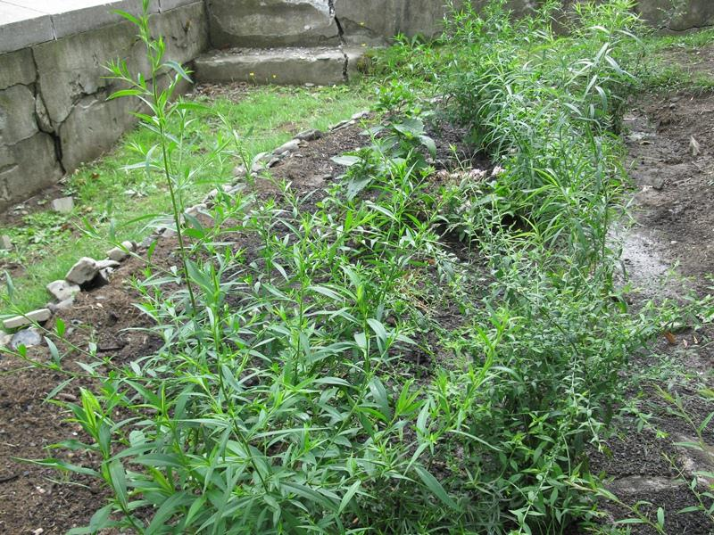
A rain garden is one composed of native shrubs, perennials, and flowers planted in a small depression, which is generally formed on a natural slope. It is designed to temporarily hold and soak in rain water runoff that flows from roofs, driveways, patios or lawns. The United States Environmental Protection Agency estimates that pollutants carried by rainwater runoff account for 70% of all water pollution (1). Rain gardens are effective in removing up to 90% of nutrients and chemicals and up to 80% of sediments from the rainwater runoff (2). Compared to a conventional lawn, rain gardens allow for 30% more water to soak into the ground. They also decrease municipal costs to convey and treat storm water. Rain gardens can also provide habitat for birds, butterflies and other fauna.
Figure 3. Cross section of a Rain Garden
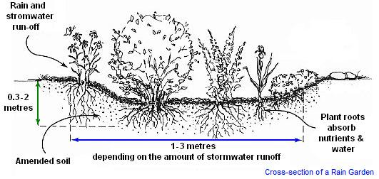
The rain garden included attractive plant species that can handle a sudden influx of rain water as well as drought conditions. It was placed on the southeast side of Thomson House to handle rain flow from the driveway/garage area. This garden can be used as an example of rain water management for workshops on ecological water use and urban storm water management.
Some of species in the rain garden were Joy-pye Weed (Eupatorium maculaum L.), Mountain Mint 3 (Pycnathemum virginianum (L.) T. Durand & B. D. Jacks. ex B. L. Rob. & Fernald), Ridell’s Golden Rod (Solidago riddelli Frank ex Riddell ), Bristly Green Briar (Smilax hispida Muhlenberg ex Torrey), and the spice thyme (Thymus vulgaris (LINN.) ). Compost and topsoil were added to the area to increase water retention of the garden which was located on a well-drained sandy loam.

The Raised Beds
Figure 4. The Three Raised Beds outside Thomson House in association with a row of container planted vegetables
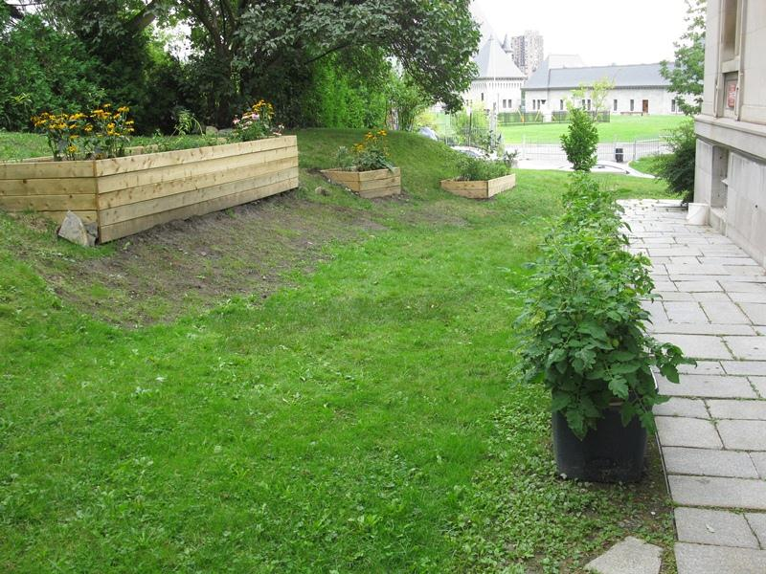

Three raised beds were put on the north side of Thomson House, the area that receives the most sunlight. These were placed alongside the container vegetable garden to attract various pollinators. The beds featured aesthetically pleasing native plants and flowers that had a variable bloom season and attracted a variety of wildlife. Some of the plant species used were Purple coneflower (Echinacea purpurea (L.) Moench), Heather aster (Aster ericoides L.), Sky blue aster (Aster oolentangiensis Riddell.), Pearly everlasting (Anaphalis margaritacea (L.) Benth. & Hook), Brown eyed Susan (Rudbeckia hirta L.), Pale leaved sunflower (Helianthus strumosus L.), New England aster (Aster novae-angeliae L.), and Tussock sedge (Carex stricta Lam.). There was also a cultivated species of bunch aster that was planted in the middle of the large bed, as well as two high bush blueberry bushes (Vaccinium corymbosum L.) to attract various bird species to the area. The predominant colors of the flowering species chosen were yellow and purple, which are shades of color that accentuate each other in a permaculture design.
Vegetable plant flowers tend to generally be relatively small, without scent, and bloom for a relatively short period of time. The flowering species in the raised beds with their prolonged blooms enable a more thorough pollination of the vegetables resulting in greater yields.
Landscape plants, such as those used in the container gardens, remove smoke, dust, and other pollutants from the air. One study has shown that one acre of trees has the ability to remove 13 tons of particles and gases annually (3). In urban microclimates plants are useful in moderating the temperature effects of solar and infrared radiation, thus increasing comfort levels (4). Properly selected and spaced plantings absorb sound waves, and can reduce unwanted "noise pollution" (5). Additionally, in the presence of a breeze, some plants make pleasant sounds of their own. Further, the wildlife attracted to a planted habitat sometimes results in pleasant natural sounds. These sounds of nature mask and further diminish unnatural noise pollution.
Having a nice landscape may have a positive effect on Thomson's House business and the people that come to it. For example, in one survey of a southern community in the United States, 74% of the public preferred to patronize commercial establishments that had structures and parking lots planted with trees and other landscaping (5). And in a study of college students under stress from an exam, views of plants increased positive feelings and reduced fear and anger (6).
All plants were left unpruned at the end of the growing season. The seed heads of some species such as Purple coneflower and Brown eyed Susan can provide food for birds during the winter months.

The Container Vegetable Garden
Figure 5. A Container with a tomato plant companion planted with basil
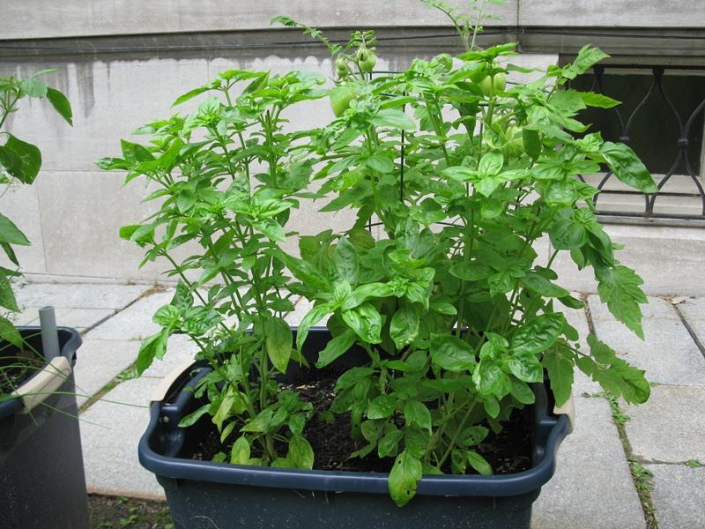

A dozen plastic containers were placed along the pathway on the north side of Thomson House to accompany the containers with flower beds. They were used for vegetable and herb production for the Thomson House restaurant. This area receives the most sunlight out of all the areas around Thomson House, as determined by a commonly used stake technique done by the student groups that planned this project. This location is sufficiently out of the way (and not very visible from the street) to ensure that there is a minimal risk of vandalism from passersby. Several varieties of vegetable and herbs were selected from a list provided from the Thomson House chef. These included paste tomatoes, green bell peppers, basil, parsley and cilantro. The tomato plants were caged after 3-4 weeks of initial growth. The container vegetable garden was a joint project with the student group Campus Crops who have such a project behind the James Administration Building.
Container gardens require less maintenance compared to conventional ones. The topsoil and compost placed in the containers are free of weeds and disease organisms. This was the case with this year's growth and permitted greater yields and less maintenance. The contents of the containers can also be easily emptied at the end of the growing season.
The basil was planted beside the tomato plants in the containers. This is an example of a concept in permaculture design called companion planting. In this system the growth of the two plant species augment each other through soil mediated interaction. The strong fragrance of herbs such as basil can also protect vegetables like tomatoes against certain insect pests.
The vegetable and herb garden was put in early June when the funds were made available from the Sustainability Projects Fund. The frost free period around Thomson House begins in early May. In the future vegetables and herbs can be planted earlier which could result in higher yields. Care can also be taken to choose the best varieties of plants for the container garden. The Edible Campus on the lower campus could be consulted in the future about this issue. And the first frost did not occur until late October. This provides an opportunity to grow some vegetables and herbs well into the fall when the price has risen for both. It is estimated that between $70 - $100 of herbs and vegetables were produced in the garden. This can easily be increased by planting earlier and good variety selection.

Behind Thomson House
Figure 6. An Ostrich fern in the back of Thomson House
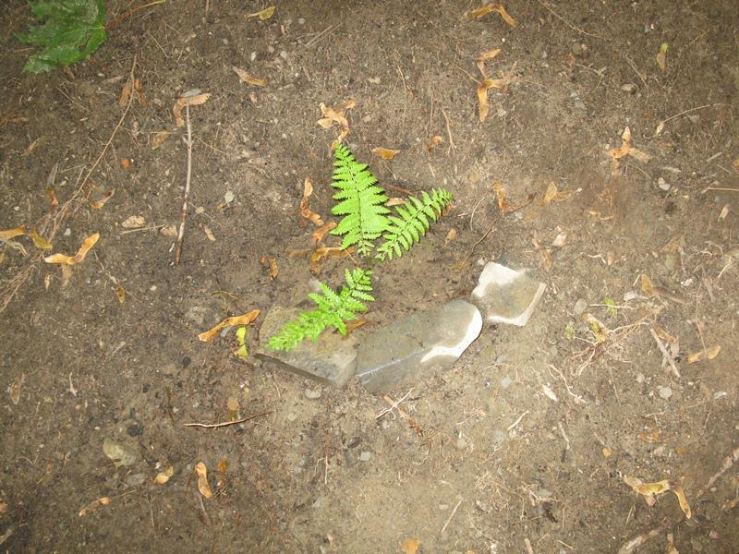

Ferns were planted on the western side of Thomson House. This was done to help reduce soil erosion as well be to add some aesthetic appearance to the area. Ostrich ferns (Matteuccia struthiopters (L.) Todaro var. pensylvanica (Willd.) C.V.Morton) were selected because they were shade tolerant, tolerated a low pH and low moisture levels, were not poisonous or harmful, and had the potential to attract various wildlife such as butterflies which lay their eggs under ferns.
Ferns are very slow growing and difficult to establish. They require a symbiotic association with fungi found in the soil micro flora to obtain nutrients for their growth. To enable this to occur two shovels full of compost were placed underneath each fern planted, along with some topsoil to improve the water holding capacity of the surrounding soil (a sandy loam). And all leaves were cut to induce new leaf growth. The ferns, as well as other plants in the project, were watered when necessary during dry periods, such as those found in late July and early August.

Ornamental Grasses
Figure 7. Ornamental grass beside the side steps of Thomson House
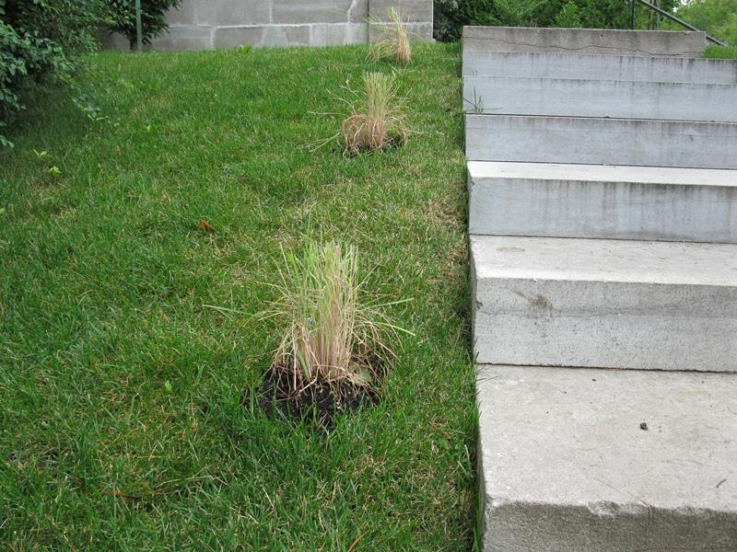

The native Canadian grass species Prairie fire (Panicum virgatum L.) was planted on the side steps leading to Thomson House. The grass plants were cut to a stubble height of 3-4 inches when planted to minimize the transpirational loss of water by the plant to aid in its establishment. These grasses grow to a height of 5-7 feet and turn an orange-red color in the fall. They would make a colorful addition to the landscape around Thomson House. The grasses also serve an ecological function by sequestering carbon dioxide into the soil which increases organic matter and consequent micro flora, as well as reducing soil erosion.

The Future
Figure 8. Children from McGill Daycare’s four-year-old group visit the Thomson House Garden
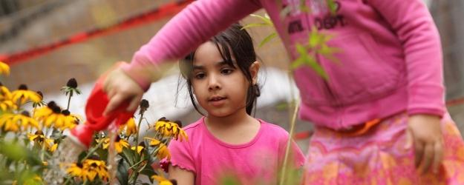

The true value of the Thomson House Garden Project is as an educational tool. It can used to teach graduate students and others how to grow their own vegetables and herbs, as well as instruct people on the value of incorporating native flowering species into a garden, which can increase yields and serve other ecological functions. This can enhance the University experience for the students that are interested. There is a demand for this as witnessed by the number of people (about 30) that came to the awareness evening last June for the Garden Project at Thomson House. Further to this, the Student Society of McGill environment committee has a current project (one of three) to develop a series of teaching workshops on how to grow vegetables and herbs.
A budget for maintenance of the permaculture gardens and for the container vegetable garden is presented in Table 1. It would cost approximately $344.94 to maintain the permaculture gardens, and $778.56 in total to include the container vegetable garden. The work on the garden could be done by volunteers (possibly recruited at an awareness event) and coordinated by the newly hired PGSS environment coordinator and/or the PGSS environment committee. A full day would be required to put some replacement plants to replace those few that didn't survive the winter, add compost and topsoil to the rain garden to increase its water retention, and put in the container vegetable garden. An average of one hour a week would be required to water all gardens during prolonged dry periods and fertilize them every 2-3 weeks.
Native plant species normally do not need fertilization. They are able to recycle nutrients in the above ground biomass in the fall back to the roots and then translocate these nutrients for above ground growth in the early spring of the subsequent year. However, there may not have been sufficient above ground growth last year, which was the establishment year for the gardens. Therefore, additional fertilization is required for this year’s growth to be optimal.
Efforts should be made to divert some or all of the kitchen waste from the Thomson House restaurant to the industrial composter on campus. Landfills are the nation’s largest emitter of methane, a gas that is 23 times more potent than carbon dioxide as a greenhouse gas. Landfill methane production is due primarily to the anaerobic decomposition of organic matter in municipal solid waste. For every ton of waste composted, there is a net decrease of 0.82 metric tons of carbon dioxide equivalent (7). If some of the resulting compost can be applied to the gardens, this would create a closed production loop, the first of its kind at McGill. This would provide additional research and educational opportunities, and a platform to extend such a system to other parts of the University.
Figure 9. A closed food production loop
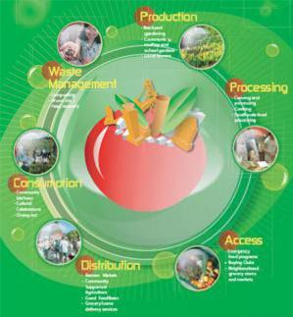
Finally, the sourcing of some of the foodstuffs for the Thomson House restaurant from the container garden should be advertised by PGSS. This has been done with success by other commercial food establishments in North America with a resulting increase in sales. An example in Canada is the Seasoned Spoon Café at Trent University in Ontario that has part of its food requirements supplied by a rooftop garden (8).
It is also possible to expand the array of vegetables grown in the container garden by the addition of items such as kale and Swiss chard. Incorporation of produce from the garden could form the basis for a sustainable food menu option at Thomson House. This could be achieved in cooperation with the McGill Food Systems Project and the School of Dietetics and Nutrition at McGill. This could lead to drawing more clientele to the House with a more sustainable and nutrient dense food selection.

Table 1. Budget for the Thomson House Garden Project for the year 2012

Permaculture Garden Maintenance
Cost
Fertilizer $100.00
Replacement Plants 200.00
Subtotal 300.00
Tax GST +PST (14.98%): 44.94
Grand Total $344.94

Container Vegetable and Herb Garden**

Topsoil (12 containers x 3 bags ($2.99)) $107.64
Compost (12 bags) ($5.00)) 60.00
Vegetable Plants 60.00
Delivery (Jasmine nursery in Montreal) 106.00
Subtotal 633.64
Tax GST +PST (14.98%): 94.92
Grand Total $728.56
Awareness Event at Thomson House $ 50.00
Grand Total $778.56

** Prices are from Jasmine Nurseries Inc. in Ville Ste. Laurent

Bibliography

- Legg A, Bannerman R, Panuska J. Variation in the Relation of Rainfall to Runoff From Residential Lawns in Madison, Wisconsin, July and August, 1995. Madison, Wis: US Geological Survey; 1996. Water-Resources Investigation Report 96-4194.
- http://www.groundwater.org/ta/raingardens.html
- Florida Department of State, 2000.http://www.dep.state.fl.us/law/Grants/CMP/pdfs/stormwatermems.pdf. University of Rhode Island Cooperative Extension http://www.uri.edu/ce/wq/has/html/has_landpublc.html
- “Enhancing Our Environment through Landscaping”, Virginia Cooperative Extension, 1996. http://www.ext.vt.edu/departments/envirohort/articles/lawns_and landscaping/enhanenv.html
- Center for Urban Horticulture, University of Washington College of Forest Resources, 1998. “Urban Forest Values: Economic Benefits of Trees in Cities”. Human Dimensions of the Urban Forest Fact Sheet No. 3. http://www.cfr.washington.edu/research.envmind/HumanBens/EconBens-FS3.pdf
- Ulrich, R.S. 1979. “Visual landscapes and psychological well-being”. Landscape Research 4(1): 17-23.
- U.S. Environmental Protection Agency, 2002. Solid Waste Management and Greenhouse Gases: A Life-Cycle Assessment of Emissions and Sinks.
- http://www.cog.ca/documents/RooftopRestaurantFA06.pdf

