Shut your Sash!

Project Background
Fume hoods are enclosed workstations that are used in laboratory research to ensure the safety of the laboratory personnel. Hoods protect users from breathing hazardous chemicals by capturing and exhausting dangerous gases produced during chemical reactions. This exhaust is managed by ensuring a constant air flow through a moving window (sash) in front of the hood and blowing the air outside of the building.

The energy consumption of the hood is positively correlated with how much air it exhausts per minute. Air exhaust rates in variable air flow (VAV) hoods are dependent on the height of the sash relative to the bottom (or fully closed position) of the hood. Because the speed of the air passing into the hood is kept constant, lowering the sash decreases the total volume of air exhausted while still maintaining a safe work environment.

The energy demand for the fume hood is intensive. The energy consumption is high because the exhausted air needs to be replaced by new air. New air taken from the outside needs to be heated and/or cooled to the set room temperature to replace the exhausted air. One cubic feet of air per minute (CFM) of air exchange on average costs $3.9 per year (Figure 1). To operate a standard fume hood costs approximately $1900 annually if the sash is left at the optimal working height at all times.

McGill University hosts more than 850 research laboratories and more than 800 chemical fume hoods. Closing the sash of the hood while not in use can save energy and subsequently money. For example, if only the sash of the hood is closed for 12 hrs per night, it will dramatically reduce the energy consumption and could save up to $1000 per hood/per year. McGill has taken initiative to exchange most of the old hoods (constant air flow: rate of air flow does not alter with respect to sash height) with new VAV hoods. However there are no education programs to show researchers how to operate these hoods optimally. Given the difference in the intake airflow of these two types of hoods we feel that it is essential to educate researchers on how to optimally use VAV hoods. Therefore, we run a pilot campaign at the Life Science complex to observe if an educational campaign about the optimal fume hood usage can change the behavior of the scientists.

Pre- Campaign
The Project had one main objective: to promote energy conservation by implementing sustainable fume hood usage practices. In order to assess the baseline conditions for fume hood usage, in September 2011 we measured the sash heights of fume hoods during period of inactivity. While some laboratory personnel was very careful of closing the sash of the hood when not in use, we assessed that in some laboratories sashes were usually left open even after everyone in the laboratory left the work for the day. On average, the sash height per hood was 11.8 inches based on two weekday and one weekend-day measurements (Figure 2). 11.8 inches of sash opening translates to 418 CFM, $1626 in operating costs and 47.2 Green Gas Emissions (GHG) per hood annually (Figure 3 &4).

The Life Sciences complex holds 56 fume hoods (52 being used). Based on these calculations, it costs the University $65,468 just to operate the fume hoods in the Life Sciences complex (Figure 5). In addition, the green gas emissions produced by the open sashes of the fume hoods require 51 trees to be fixed (Figure 6). After establishing the baseline conditions, and confirming the substantial energy conservation that can be achieved by shutting the sash of VAV fume hoods, we continued with the campaign to promote the “Shut your Sash!” campaign.

The Campaign
We run the "Shut the Sash" campaign in the Life Sciences complex that hosts twenty-five research laboratories. The campaign promoted energy-conservation by shutting the fume-hood sashes during periods of inactivity. This campaign consisted of three phases: 1) communication; 2) distribution of educational material; and 3) monitoring of sash height, including an inter-lab competition. In the first phase (communication), we talked to the lab members from these 25 laboratories about how much energy each fume hood is consuming and the importance of closing the sash of the fumehood when not in use. During communication, it was really important to use concepts that the lab personnel can relate to. For example, one fume hood consumes as much energy as 4 Canadian households when the sash is left open all the way. A ruler sticker is placed next to the fumehoods that marked how much energy (in terms of cars and households) is required to operate the fumehood at specific heights (Fig.7). In addition, we marked the fume hoods with a sticker that reminded the user to close the sash when not in use. (Fig. 7). Stop signs are placed on the glass doors at the eyesight to remind people to turn off the equipment and the lights when leaving the lab. These stop signs are again reminded people to shut the sash of their hoods (Fig.7). In addition, posters are placed all the walls around the Building to remind people of their environmental impact and promote the Shut your Sash Contest (Fig.8).

The campaign was run as a contest among labs, with a "Free Pizza Lunch" as the prize. Because the winners were publicly announced, and the prize was free lunch, we believe that the contest motivated lab personnel to change their behaviors. We assumed that changing one’s behavior for one week will induce a long term behavioral change, and closing the sash of the hood will eventually become a habit. We tested this hypothesis by secretly measuring the sash heights of the fumehoods 1.5 months after the actually contest.

Results
Our results show that the campaign was successful in communicating the message “Shut your Sash!” to the lab personnel resulting in a significant reduction of the sash heights over the one week campaign period (p<0.001). In addition, lab personnel did change their behavior long-term as assessed by the sash height measurements one and a half month after the campaign has ended. The sash heights before the campaign was 11.8 inches/hood while during the campaign this height dropped to 2.67 inches/hood. Our measurements after 1.5 months have shown that the sash height was on average 2.7 inches and was not different (p=0.99) compared to during campaign measurements (Fig. 2).

This change in behavior has not only shown that the campaign was successful, but also contributed to the sustainability efforts at McGill University. The average drop in sash height did result in a decrease in the energy consumed by the laboratories at the Life Sciences Complex (Fig 3) as shown by the estimated cost to operate a single fume hood annually. Prior the campaign, the fume hoods were left at 11.8 inches high when they were not in use. This height translates to $1,626 and 47.2 GHG produced by a single hood annually (Table 2). During and after the campaign the cost of operating a fume hood dropped to $370 while the GHG produced by a fume hood decreased to 10.68 (Table 2). These results show that this campaign resulted in overall 77% reduction in energy consumption and green gas emission produced by the fume hoods.

The Life Sciences Complex hosts 56 hoods of which 52 are being actively being used. Based on these measurements, to operate only the fume hoods in the Life Sciences Complex, the university spent approximately $85,000 (annual) pre-campaign (Table 3). After the campaign, the costs to operate fume hoods dropped significantly to $19,000. We estimated the savings from this campaign to be $65,000 annually.

In addition to the operating costs, leaving the sashes open during periods of inactivity has significant environmental consequences. Fro the life sciences complex, prior to the campaign, the fume hoods generated annual green gas emissions that required 66 trees to be neutralized (Table 3). After the campaign, the number of trees required to neutralize the GHG decreased to 15 (table 4). This means a small behavioral change can have a big environmental affect, resulting in annual savings of 50-tree equivalent green gas emissions.

Conclusions and Future Directions
Shut you Sash campaign was successful in implementing a long term behavioral change in lab personnel’s fume hood usage. This success stems from three factors;
- Most people did not know how much energy a single fume hood used. Through personal communication and educational posters, lab personal realized that their behavior can have a significant impact on the environment.
- We designed and planted stickers around the lab space that remind people that the hoods should be closed when not in use. We believe that using examples that people can relate to was the most important aspect of the campaign as it is difficult to understand what it means to spend 400 GJ of energy or produce 50 GHG of green gas emissions. The posters pointed out how many trees it takes to neutralize the green gas emissions created by the keeping the sash of the fume hood open. The Ruler stickers reminded people how much energy they are using in terms of houses and cars when they leave the sash open.
- The contest was very useful in implementing the quick behavioral change that persisted for another 1.5 months.

We calculated the savings based on the report that Jerome Conraud prepared. His team and Jerome meticulously calculated every aspect of the fume hood energy consumption and green gas emission production. In addition to these estimates it would be of great interest to be able to compare these results to the “Pulse-Energy” ratings. While this campaign used 3-5 time points to get an average measurement, the pulse-energy measures the energy usage of the buildings continuously. Therefore, if the campaign resulted in a real long-term behavioral change, we should be able to observe the changes on the Pulse-meter.

The success of the campaign suggests that it will be a great idea to implement it in other faculties that use variable flow fume hoods. While individual fume hoods in each lab or building might be different, the differences in their energy consumption and green gas emission can be calculated easily using our template. We believe that the educational material used in this campaign can be used in other faculties with minor changes based on these calculations. We calculated savings of $65,000 and Green Gas Emission equivalent of 50 trees based on 52 fume hoods. The McGill University campus holds more that 850 fume hoods. This suggests a big potential for behavioral change and subsequent savings (40 fold). If a similar success can be obtained, that will save the University $ 2,000,000 in energy costs and Green Gas Emissions equivalent of 2,000 trees annually. Therefore, we suggest that the same campaign to be repeated in other buildings. We also suggest that the campaign to be repeated every 2 years as the lab personnel, mostly consistent of students, changes over time.

Acknowledgments
Lauren Van Der Kraak: For brainstorming, and measuring the sash heights. She is an essential part of this project.

Jerome Conraud: For helping throughout the way with every single calculation and meeting with me throughout this process to answer every question I had.

Carmen Lampron: For supporting the campaign and providing the laboratory access necessary to run the campaign.

Lilith Wyatt: For her comments on the proposal and making sure that everything run as smoothly as possible.

Ian Blum: For designing the educational material and his patience for changing them 10 times until my final OK.

Christopher R Wrobel: For supporting me to apply to Sustainability Projects Fund and introducing me to Lauren.

Sustainability Projects Fund: For creating the incentive and the financial support to run this campaign.

Figures
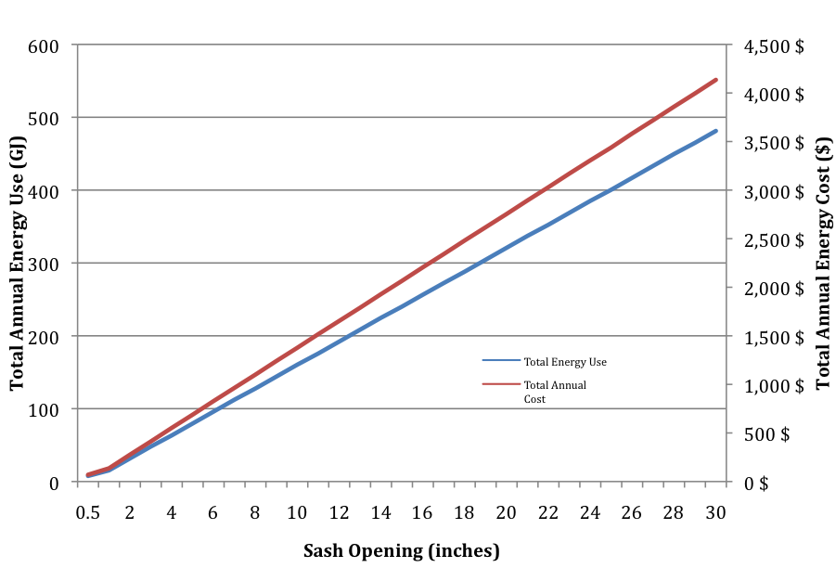
Figure 1. Annual Energy Usage and Cost to operate a single fume hood in the Life Sciences Complex
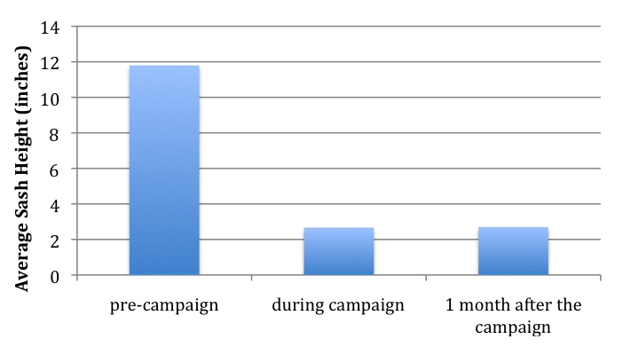
Figure 2. Average Sash Heights per Hood before, during and 1 month after the campaign.
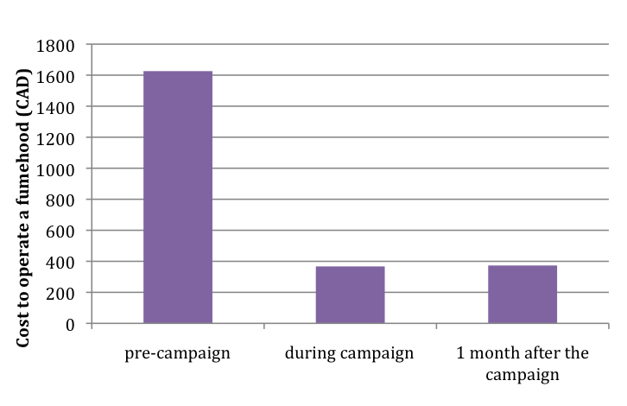Figure 3. Average Cost to operate a single fume hood annually before, during and 1 month after the campaign.
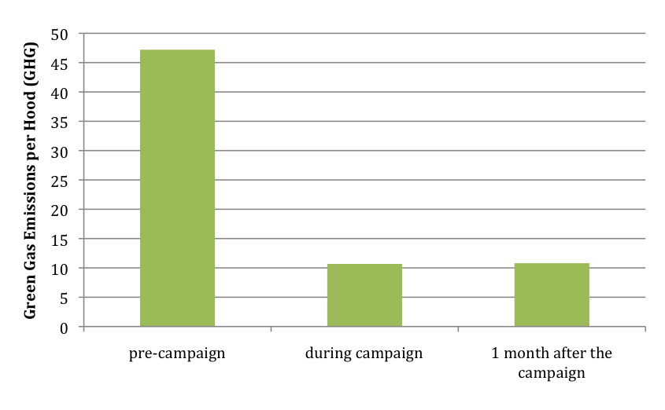Figure 4. Average green gas emissions produced to operate a single fume hood annually before, during and 1 month after the campaign.

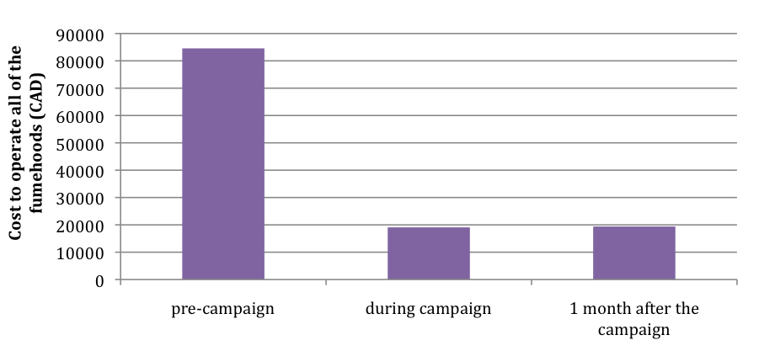
Figure 5. Total Cost to operate all the active fume hoods in Life Sciences Complex annually before, during and 1 month after the campaign.
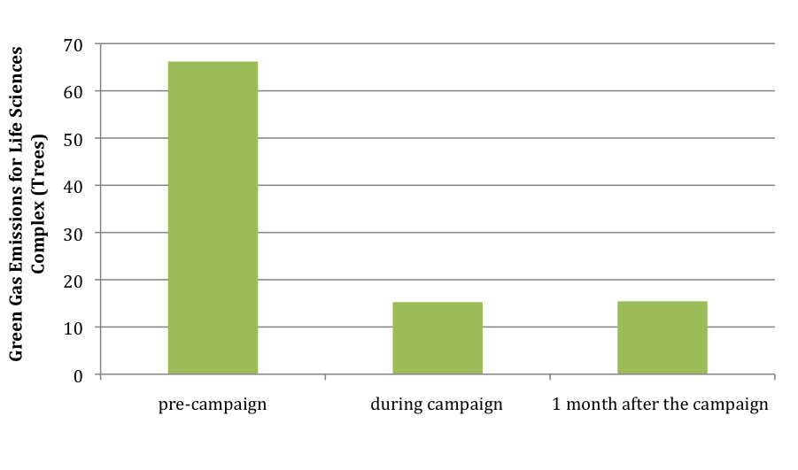Figure 6. The number of trees required to neutralize the Green Gas Emission produced by the 52 active fume hoods in the Life Sciences Complex annually before, during and after the campaign.

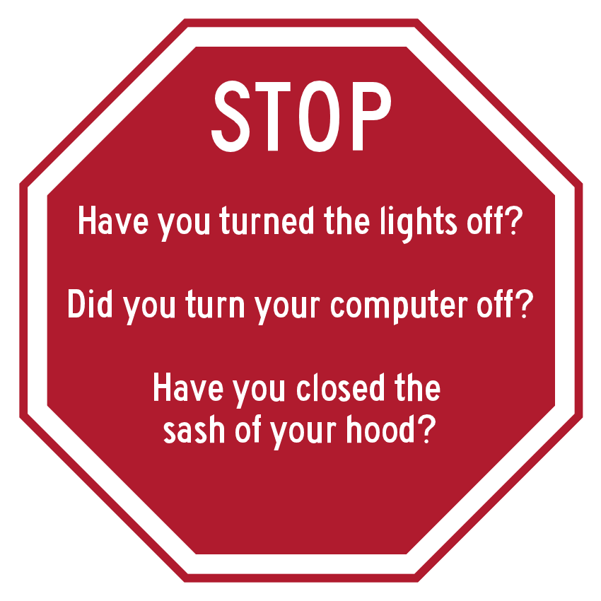



Figure 7. Stickers used in the Campaign

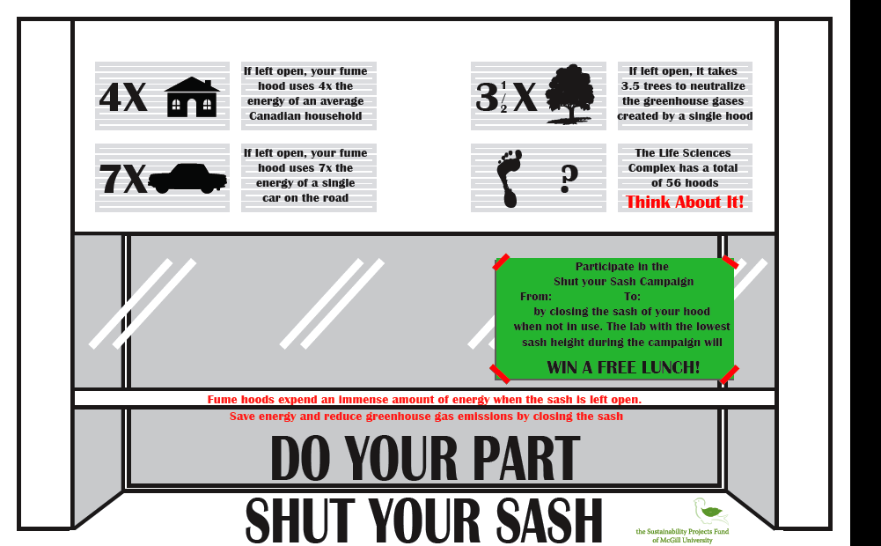

Figure 8. Poster used in the Campaign

Campaign Measurement Averages
 |  | Descriptive Statistics
 | N | Minimum | Maximum | Mean | Std. Deviation | Date | Time
M1 | 56 | 0 | 27 | 12.3889 | 6.99828 | 2011, Sept 1 | 12:00
M2 | 54 | 0 | 26.4 | 12.178 | 6.09382 | 2011, Sept 8 | 5:15 PM
M3 | 51 | 0 | 21.5 | 10.656 | 6.13862 |  | N/A
Overall Average |  | 11.8 inches
During Campaign
 |  | Descriptive Statistics
 | N | Minimum | Maximum | Mean | Std. Deviation | Date (2012) | Time
M1 | 53 | 0 | 18 | 1.5145 | 4.00527 | 19-May | morning
M2 | 52 | 0 | 21 | 1.2721 | 3.67047 | 21-May | Midday
M3 | 52 | 0 | 21.5 | 5.0769 | 7.11763 | 15-May | 4PM
M4 | 52 | 0 | 28 | 3.3365 | 6.61454 | 22-May | 6PM
M5 | 48 | 0 | 18 | 2.6354 | 4.74873 | 23-May | 3:30 PM
M6 | 51 | 0 | 17.5 | 2.2331 | 4.79913 | 28-May | Midday
Overall Average |  | 2.67 inches
1 Month after the campaign
 |  | Descriptive Statistics
 | N | Minimum | Maximum | Mean | Std. Deviation | Date (2012) | Time
M1 | 49 | 0 | 27.5 | 2.8634 | 5.58011 | 8-Jul | 14:45
M2 | 40 | 0 | 24 | 2.5575 | 5.22582 | 11-Jul | 14:15
M3 | 47 | 0 | 15.25 | 2.1649 | 3.60679 | 18-Jul | 16:50
M4 | 53 | 0 | 18 | 3.5519 | 5.0951 | 22-Jul | 11:45
M5 | 50 | 0 | 25 | 2.26 | 5.03355 | midweek | 12:00
Overall Average |  | 2.70 inches

Table 1. Descriptive Statistics of the Campaign Measurements

 | Average Sash Height (inches) | CFM | Cost ($) | Green Gas Emission (GHG) | Trees
pre-campaign | 11.8 | 418 | 1626 | 47.2 | 1.298
during campaign | 2.67 | 94 | 367 | 10.68 | 0.2937
After the campaign | 2.7 | 96 | 373 | 10.8 | 0.297

Table 2. Costs and Green Gas Emission to operate a Single Fume Hood annually

 | Costs ($) | Green Gas Emissions (in Trees)
pre-campaign | 84552 | 66.198
during campaign | 19084 | 15.2724
After the campaign | 19396 | 15.444

Table 3. Total Cost and Green Gas Emission For Life Sciences Complex (based on 52 Hoods)

Savings (After-
pre campaign)
Costs ($) | 65156
Trees | 50.754

Table 4. Total Annual Savings For Life Sciences Complex (based on 52 Hoods)

