Sustainability Project Fund Application
Applicant/Project Leader: Jill Parlee

Contact Information:
Name: Jill Parlee
Email: jill.parlee@gmail.com
Daytime Phone: 978-417-6733 or 246-247-4429 or 246-422-2087

Project Title: Bellairs Recycling Program

Budget Requested: $4,425 CAN

Project Group - Please include the names and contact information of all group members
Susan Mahon, Managing Director, Bellairs Research Institute
Email: susan.mahon@gmail.com
Nicole Garofano, Administrative Director, Future Centre Trust
Email: nicole@futurecentretrust.org

In an attachment (maximum 4 pages), please summarize the proposal using the following structure. Please ensure that all relevant points listed below are addressed. Last revised: November 22, 2026

I. Project Overview

Project summary:

Bellairs Research Institute of McGill University is a research station of McGill located on the island of Barbados. The achievements of Bellairs directly contribute to the overall achievements of McGill. Researchers come from McGill and around the world to do research in a variety of fields. In Fall 2010, a group of McGill students came to Bellairs as part of the Barbados Field Studies Semester Program. One team of students interned with the Future Centre Trust, a local environmental non-profit organisation, and completed a project on Streamlining Hotel Waste Management. To ensure that their project had a personal connection, the students included a waste audit of their own residence, Bellairs, complete with an assessment and implementation plan to assist Bellairs in reducing its waste. Now Bellairs needs the financial assistance to implement this plan and reduce its waste impact.

Objectives:
1. Install recycling receptacles around the grounds of Bellairs for guests and staff to use,
2. Construct a recycling shed to house the recyclables until collection,
3. Create signage and other resources to disseminate information about recycling at Bellairs, and;
4. Create and administer monitoring and evaluation techniques to acquire feedback from participants.

Outcomes:
- Recycling facilities and a recycling program that are
  - understood, and effected by the staff at Bellairs Research Institute; and
  - understood and used by visitors at Bellairs Research Institute
- Reduction of waste entering landfill
- Reduction in the ecological footprint of Bellairs
- Increase in public awareness and attention to sustainability efforts through leading by example

Project eligibility:

The project will inherently contribute to building a culture of sustainability at Bellairs because it will be used and visible to all guests and visitors of Bellairs, as well as promoted by the Bellairs employees. Every time a guest goes to dispose an article of garbage he or she will see that they have the choice to do something better for the environment. Furthermore, as this will bring attention to your waste it shall also bring attention to your consumption. The visibility of this project will support a message to reduce one’s consumption of wasteful products and further promote an individual and communal commitment to sustainability.
Please refer to Appendix D for the student research project which shows that there are recyclable and compostable materials that can be recovered from the common waste stream. Recycling has been done on a small-scale at Bellairs in the past, but there is the institutional desire to now implement a complete and coherent program.

Timeframe/Milestones:

Already, the research and data collection necessary for this project has been completed. Now, these findings must be confirmed and action must be taken towards implementation. The majority of these tasks shall encompass acquiring and setting-up materials. This is projected to be completed within three-months between March 1st and May 29th, 2011. The main milestones will be:
- Recycling receptacles are chosen and purchased in collaboration with staff
- Recycling receptacles are set-up
- Materials are chosen and sourced to construct the recycling shed
- The recycling shed is designed and constructed.
- Attractive vegetation is grown around the recycling shed.
- Signs are posted
- The first trucking of recyclable materials, away from Bellairs to recycling facilities, is celebrated
- There is a schedule of monthly reporting on the kinds and amounts of materials that are recycled at Bellairs
- Planning, implementation and results of the recycling project are showcased during the Bellairs Research Festival held May 23 to May 29, 2011.

Performance indicators are matched and listed according to each of the main milestones listed above. These performance indicators are:
- Six sets of practical recycling receptacles are purchased
- Recycling receptacles are;
  - installed near to each of the five kitchens and one office at Bellairs
  - used by staff and visitors to separate garbage into various categories of recyclable and non-recyclable materials
- The recycling shed is constructed according to a design that is customised for keeping and disposing of recyclable waste at Bellairs according to the principals of sustainable living in Barbados
- The recycling shed is designed and constructed based on models from the community-based CoRe Recycling Project implemented by the Future Centre Trust
- The recycling shed is made attractive through beautification in keeping with the rest of the architecture and landscaping of Bellairs
- A survey instrument administered during the Bellairs Research Festival demonstrates that staff and visitors have noted the information posted on signs about recycling around the Bellairs campus
- Staff and others involved in the design and implementation of the recycling program celebrate the first trucking of recyclable materials, away from Bellairs to recycling facilities, at a special staff meeting
- A log-book is used to record the kinds, amounts, and cash deposits returned when materials are recycled at Bellairs
- The Bellairs Research Festival includes a poster and/or presentation that explains the research, planning, implementation and results of the Bellairs Recycling Program

Participants and members of the public who visit the Bellairs Research Festival are expected to be sensitised to the benefits of recycling by viewing and using the recycling program demonstrated at Bellairs. This sensitization shall also continue with all visitors to the Bellairs Research Institute from May 2011 onwards.

Stakeholders:

Bellairs Research Institute will be the managing organization in charge of maintaining an efficient recycling program. This will require operational commitment for designing the receptacles and shed and keeping them in working order. Bellairs will need to allocate the responsibility to at least one staff member of depositing the recyclables from the receptacles into the shed. Bellairs must also keep informative resources updated and continue encouraging educational measures for staff and visitors of Bellairs. Lastly, Bellairs will be responsible for monitoring and evaluation; this will be administered through the recording of collection dates and the review of surveys. The maintenance of these measures will require financial and/or in-kind commitments. The main source of financial revenue for this program will be procured through the redemption of the recyclables, and this will be supported through the operational budget of Bellairs where necessary.
The Future Centre Trust was the coordinating organization in the waste audit of Bellairs. The FCT will coordinate the construction of the recycling shed, and provide other necessary materials and assistance. This organization will also assist with the educational promotion of this initiative through in-kind donations of time and/or services. A letter of support is included in Appendix C.
B’s Bottling Depot and the Sustainable Barbados Recycling Centre are the two main recyclers on the island. They will accept recyclables brought to them by Bellairs, or will be contacted to collect the recyclables from the premises of Bellairs. B’s is a private hauler and does not charge for collection but rather compensates for items they collect. SBRC is a recently developed, private-public enterprise and may soon be offering business and/or residential pick-up of recyclables. They shall assist with this project in the capacity of a business associate.

II. Project Implementation

Tasks and Responsibilities:
Please refer to Appendix A – GANNT Chart

III. Financials

The critical date for receipt of funds is March 1, 2011.

Detailed expenses:
Please refer to Appendix B - Budget

Detailed revenues:
Revenue Source | Amount Requested (CAN$) | Confirmed?
Sustainability Projects Fund | $4,425 | No
Bellairs Research Institute | In-kind | Yes
Future Centre Trust | In-kind | Yes
B’s Bottling Depot | $50-$200 per month | Yes, estimated monthly revenues from recyclables redemption

IV. Additional information:

The project leader, Jill Parlee, is a McGill Alumni and she was the mentor for the Streamlining Hotel Waste Management Project through the Future Centre Trust. She is fully aware of the findings of this project and of the implementation requirements. As such she will be able to effectively coordinate the implementation of this initiative.
Jill Parlee, is now also the Festival Coordinator for the Bellairs Research Festival; staff member of the Bellairs Research Institute of McGill University. She will be able to manage the grand unveiling of the program and the set-up of the monitoring and evaluation materials.
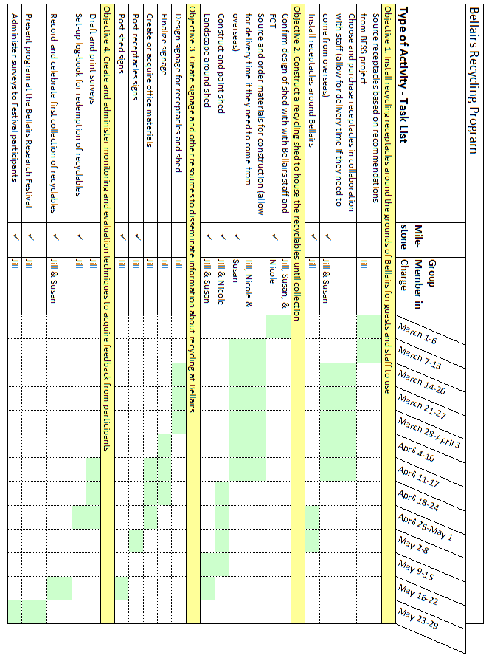
Appendix A – GANNT Chart

Appendix B – Budget

Bellairs Recycling Program - Budget
Expense Description | Units | Unit Price | Estimated Cost (CAN$)
Recycling receptacles | 20 | $15.00 | $300.00
Receptacle stickers | 20 | $5.00 | $100.00
Receptacle signage (printing and laminating fees) | 6 | $5.00 | $30.00
Recycling shed (fully enclosed solid structure, lockable doors, permaclad included) | 1 | $3,250.00 | $3,250.00
Shed signage (outdoor signs, 9 recycling streams, 1 main sign) | 10 | $20.00 | $200.00
Paint supplies for shed | 3 | $35.00 | $105.00
Landscaping for shed | 1 | $100.00 | $100.00
Information brochures (printing fees) | 200 | $1.50 | $300.00
Surveys (printing fees) | 200 | $0.20 | $40.00
Total |  |  | $4,425.00

Appendix C – Letter of Support from Future Centre Trust
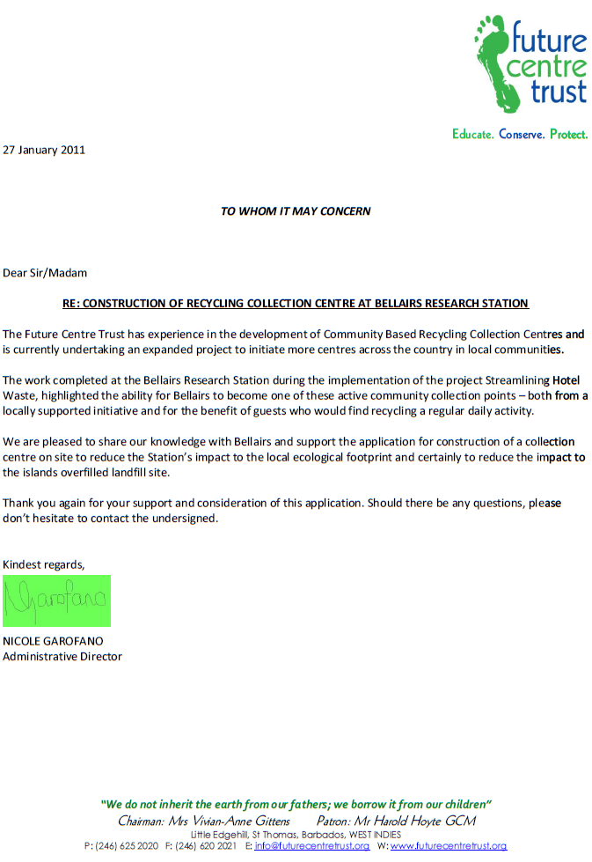
Appendix D – Copy of ‘Streamlining Hotel Waste Management: Bellairs Results and Implementation Plan’

Citation:
Dery, A., Gosse, C. and Paquin, G. (December 2010) Streamlining Hotel Waste management. Unpublished. Barbados Field Study Semester: Final Report. McGill University, Bellairs Research Institute, Barbados.



