AREA EXAM
For students entering the Ph.D. program in the 2019-20 academic year and earlier
Area Exam – Preparation and Areas
Students are required to be examined in two substantive areas. The area exams in sociology provide an opportunity for students to read comprehensively in two broad areas within the discipline, after which they write an exam that assesses their competence in each area. Preparation necessary to pass these exams is substantial, usually requiring 2-3 months of intensive study. Students are strongly encouraged to work on their academic writing skills in preparation for their area exams. The Writing Center offers a number of courses that can help develop these skills (https://www.mcgill.ca/graphos/courses).
Area exams are currently offered in ten areas: 1) development and social change 2) deviance and social control 3) race and ethnic relations 4) work, labour markets and the economy 5) medical sociology 6) political sociology 7) population dynamics 8) sex and gender 9) social stratification and 10) sociology of knowledge. Students are required to take an exam in two of the ten substantive areas listed above.
In preparing for an exam, students draw on a core reading list (designed by the respective area exam committee) and a specialized reading list. The combined reading lists – core and specialized – total approximately 40 books and 40 articles (or their equivalents). Some area exam committees have pre-defined specialty reading lists while others require students to define and design the specialty list. When taking an area exam that requires students to define and design the specialty reading list, students work with the chair of the area exam committee to create a suitable specialty topic within the area. Once the topic has been approved, the student, working closely with area exam committee members will create a relevant specialty list, so as to insure coherence and coverage. Once complete, students are required to submit their proposed specialized reading list to the area exam committee chair for review and approval. Note that the final specialized reading list must be approved no later than two months prior to the exam date.
The area exam committee is responsible for defining the expectations of each exam, writing the questions, and assessing the answers. The chair of an exam committee formulates the questions and exam format in collaboration with other committee members. Students should contact area exam committee chairs for copies of core reading lists. Students may also contact the Graduate Program Coordinator for reading lists and copies of past exams.
Area Exam – Committee Chairs and Members
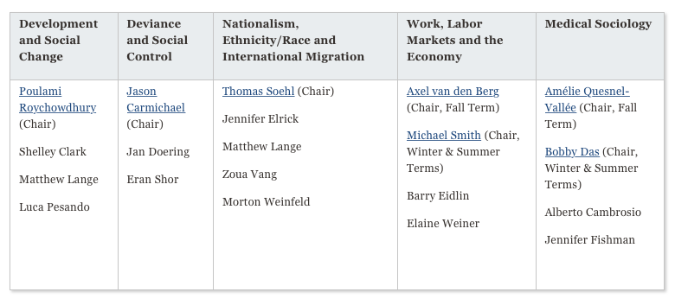
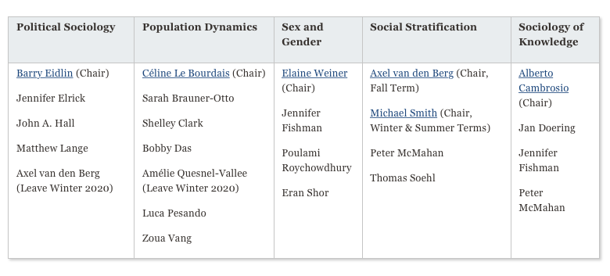
Area Exam - Timing
Area exams in sociology are offered three times a year: 1) during the second week of January 2) the last week of May and 3) the last week of August (under some circumstances, minor modifications to exam dates are possible with the approval of the chair of the area exam committee and the GPD). Students should register for the area exam courses – SOCI 700: PhD Area Examination 1 and SOCI 701: PhD Area Examination 2 in the term that they intend to take the exam. Both exams must be passed by the end of the PhD3 year. Students failing to pass their two area exams by this point will be put on probationary standing.
Area Exam - Format
The format of an area exam is a three-day open-book exam. The exam may be written in either French or English. An additional day is permitted for students whose mother-tongue is neither French nor English and for students whose first language is French but who choose to write the exam in English. That said, no student is allowed seek outside assistance with editing their answers. The Graduate Program Coordinator sends the student the exam questions at the exam start time; students are to return the exam within 72 hours to the Graduate Program Coordinator, the area exam chair and the committee members. Students typically respond to three questions; at least one must focus principally on the core reading list.
Area Exam -Assessment
Area exams are assessed on a pass/fail basis. Passing an area exam requires: 1) synthesis in coherent, concise and accurate fashion of relevant literature and 2) display of an intelligent and critical perspective on pertinent readings in response to a given exam question. Answers should be the student’s own and assistance from others in either content or style, is prohibited (https://www.mcgill.ca/students/srr/academicrights/integrity/cheating). The student is expected to demonstrate sufficient mastery of key concepts and theories of an ‘area’ such that s/he could design and teach a course in this area.
After students submit their area exam, the area exam committee will evaluate the answers. The committee will convey the outcome of the area exam to the student within 4 weeks after submission. In instances where answers are deemed to be insufficient, the chair of the area exam committee will inform the student whether a partial or full retake is required. Retakes must occur on or before the next official area exam date. Form and content of the re-examination are at the discretion of the exam committee. Note that students are required to re-take failed area exams. Switching to another area exam after a full or partial failure is not permissible. If committees deem a rewritten area exam insufficient, or should the student fail to retake the exam on or before the next exam date, the student will receive a grade of F for the exam and will be withdrawn from the Ph.D. program.

