Intellectual Capital

General Information
Course #: GLIS 662
Term: Winter
Year: 2021
Course pre-requisite(s): None
Course co-requisite(s): None
Course schedule: Tuesdays, 5:30 to 8:30 PM
Number of credits: 3
Course location: myCourses

Instructor Information
Name: Daniela Oliveira, Sessional Lecturer
E-mail: daniela.oliveira@mcgill.ca. All questions on content or class pragmatics should be posted to the appropriate discussion forum in myCourses so that the whole class can benefit from the response. Email should only be used for correspondence of personal nature. Student’s McGill email should be used to contact the instructor. The email’s subject should begin with “[Winter 2021 - GLIS-662-001 - Intellectual Capital]”, as it is the case when email is sent through myCourses.

Course Overview
Understanding the strategic role of intellectual assets: how individuals, communities and organizations can identify and leverage their knowledge, experience, expertise and innovation more systematically to create value for the organization. Emphasis is placed on understanding the links between individuals and the organization in the sharing of intellectual assets.

Learning Outcomes
- Demonstrate understanding of key intellectual capital and organizational memory management concepts;
- To model the flow, sharing and leveraging of intellectual assets;
- To identify some of the principal cultural characteristics that are necessary to encourage organizational learning, innovation and creativity;
- To describe the links between individual and organizational learning;
- To monitor, value, categorize and report intellectual capital.

Instructional Method
A combination of lectures, directed reading, group discussions and eventual guest lectures will be used. A myCourses space is dedicated to this course and should be accessed by students at least once a week.
Class lectures will be available in video in myCourses. A synchronous session will be held through the Zoom platform every Wednesday, starting at 5:30 PM. The synchronous session will be dedicated to questions about the material and to a short discussion. Questions can also be posted in the Forum section. The short discussion will be held in groups, allowing participants to get more acquainted with their peers. The same discussion topic will be posted in myCourses in the Forum section, allowing for an asynchronous opportunity to get acquainted with their peers.

Required Course Materials
Students may expect around 10 pages of recommended reading per week. All readings references will be posted on myCourses. All readings are electronic. They are open-access, available on the web or through the McGill library. Business cases, journal articles, book chapters and web pages will be used.

Course Content
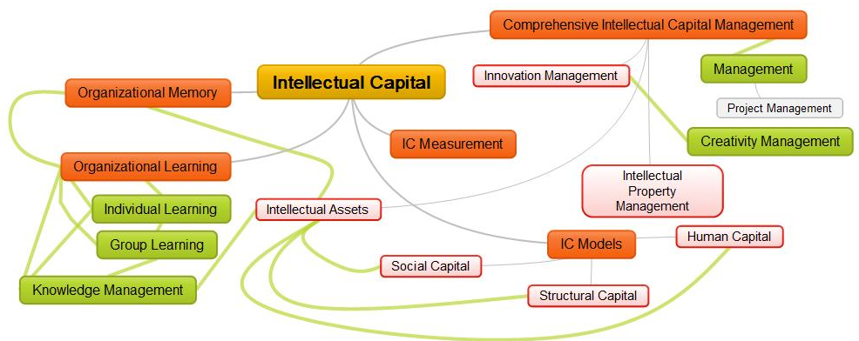
Topics will be presented in a progression from simple to more complex or from broad to more specific.
Class | Topic | Date | Description
1 | Introduction to Intellectual Capital Management | Jan 12 | A brief history, definitions of key concepts, components of intellectual capital and organizational memory; the phenomenon of corporate amnesia; managing and measuring IC; IC, creativity and innovation.
2 | Intellectual Capital Models | Jan 19 | Human capital, organizational capital and social capital; different types of intellectual assets in organizations; identification of different types of intellectual assets at three levels – organization, group and individual.
3 | The Intellectual Capital Audit | Jan 26 | How to identify intellectual assets (knowledge audit) and their strategic alignment.
4 | Individual and Organizational Learning | Feb 2 | What does it mean that an organization learns? Major processes through which individual learning advances organizational learning.
5 | Organizational Memory | Feb 9 | Organizations as behavioural systems; transfer and sharing of mental models; different ways in which knowledge may be stored in an organization, across organizations and within society. Knowledge Strategy and project management principles.
6 | How to measure the value of intellectual capital | Feb 16 | Overview of measurement strategies; description of major types of evaluation methods.
7 | How to measure the value of intellectual capital - Part II | Feb 23 | How to use the major evaluation instruments (balanced scorecard, house of quality, benchmarking and results based accountability frameworks).
Study Break
8 | How to measure the value of intellectual capital - Part III | Mar 9 | Adapting Key Performance Indicators to a context; dealing with different stakeholders and using different evaluation frameworks in the same project
9 | Mapping Intellectual Capital | Mar 16 | Harnessing participation, identifying existing Intellectual Assets
10 | Creativity management and innovation support | Mar 23 | Methods, techniques and tools to promote creativity; how to document and manage ideas; the innovation support cycle.
11 | Student Presentations | Mar 30 | Evaluation and Knowledge Sharing Projects
12 | Organizational Memory, Social Capital | Apr 6 | Models of organizational memory. The power of social capital in organizations.

Evaluation
Due dates and percentage of final grades may be affected by comments or suggestions of students in the first week of course or in the case of major external event. An updated version of this document will be posted on myCourses. Assignments will require a maximum of ten hours of work each. Assignments 1 to 4 will require the analysis or exploration of a maximum of 5 items. Groups will be composed of 2 to 4 members.

Name of Assignment | Due Date | % of final grade
Identification of intellectual assets (in groups of up to 4 members) | Feb 22 | 20
Evaluation Project – Paper (in groups of up to 4 members) | Mar 23 | 20
Evaluation Project – Presentation (in groups of up to 4 members) | Mar 29 | 20
Knowledge Sharing Project (individual or in groups of up to 4 members):  - Two reviews of two assigned readings for 10% each, posted on myCourses  OR  - Presentation of a real life project with objectives or challenges related to the course  OR  - Presentation of results of a non-exhaustive literature review of a topic related to the course | Mar 29 | 20
Quizzes: Five quizzes in myCourses of five minutes duration each - 3% each | Apr 5 | 15
Participation | ongoing | 5

McGill Policy Statements

“McGill University values academic integrity. Therefore, all students must understand the meaning and consequences of cheating, plagiarism and other academic offences under the Code of Student Conduct and Disciplinary Procedures” (see www.mcgill.ca/students/srr/honest/ for more information).
“In accord with McGill University’s Charter of Students’ Rights, students in this course have the right to submit in English or in French any written work that is to be graded.”

“The University Student Assessment Policy exists to ensure fair and equitable academic assessment for all students and to protect students from excessive workloads. All students and instructors are encouraged to review this Policy, which addresses multiple aspects and methods of student assessment, e.g. the timing of evaluation due dates and weighting of final examinations.”

“© Instructor-generated course materials (e.g., handouts, notes, summaries, exam questions, etc.) are protected by law and may not be copied or distributed in any form or in any medium without explicit permission of the instructor. Note that infringements of copyright can be subject to follow up by the University under the Code of Student Conduct and Disciplinary Procedures.”

“As the instructor of this course I endeavor to provide an inclusive learning environment. However, if you experience barriers to learning in this course, do not hesitate to discuss them with me and the Office for Students with Disabilities, 514-398-6009.”

“End-of-course evaluations are one of the ways that McGill works towards maintaining and improving the quality of courses and the student’s learning experience. You will be notified by e-mail when the evaluations are available. Please note that a minimum number of responses must be received for results to be available to students.”

“In the event of extraordinary circumstances beyond the University’s control, the content and/or evaluation scheme in this course is subject to change.”

