*Who are they? Les connaissez-vous ?*

A lunch series on some of Quebec’s national figures and key historical moments

Organised by Quebec Studies Program in collaboration with Student’s Society of McGill University (SSMU)

**FEBRUARY 9 2012**

**11 h 45-13 h**

**Break-out Room-University Centre, 3480, McTavish**

***Montreal and Quebec as seen by Gabrielle Roy***



A talk and discussion with Prof. Jane Everett, professeure au département de langue et littérature françaises, Université McGill et doyenne à la vie étudiante.

Host: Prof. Gillian Lane-Mercier, professeure au département de langue et littérature françaises, Université McGill et vice-doyenne, faculté des arts.

Who is Gabrielle Roy? How could one describe Gabrielle Roy’s work? What can we learn about Montreal and Quebec by reading Gabrielle Roy’s work? How has the teaching of Gabrielle Roy's work changed over the last 50 years ?

*Who are they? Les connaissez-vous ?*

A lunch series on some of Quebec’s national figures and key historical moments

Organised by Quebec Studies Program in collaboration with Student’s Society of McGill University (SSMU)

**February 13th 11h45**

Break-out room University Centre, 3480 McTavish Street

**Maurice Duplessis, la *Grande Noiceur*, labour relations and mining workers in Asbestos**

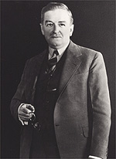

A talk and discussion with Dr Jessica van Horssen, post-doctoral student, Quebec Studies, History Department McGill University

Host: Jarrett Rudy, Professor, Department of History, McGill

Who is Maurice Duplessis? How could we describe the Duplessis regime in terms of its relations with workers and unions? What was the state of labour relations in Quebec at that time? What happened in the Asbestos strike in 1949?

*Who are they? Les connaissez-vous ?*

A lunch series on some of Quebec’s national figures and key historical moments

Organised by Quebec Studies Program in collaboration with Student’s Society of McGill University (SSMU)

**February 29th 2012**

**11 h 45-13 h**

Lev Buckhman Room, University Centre, McGill University

3480, McTavish,

***Céline Dion and the national performance of Quebec Identity***

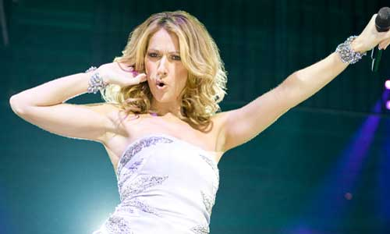

**Photo credit : Céline Dion Official web site : celinedion.com**

**A talk and discussion with Professor Erin Hurley**, **Department of English, McGill University**

**Host : Will Straw, Director, McGill Institute for the Study of Canada**

Born in Charlemagne, Québec, how and in what ways, International pop diva, Céline Dion expresses Quebec Identity?

Is Céline Dion personal path very different than Quebec’s national and historic narratives? How does Dion participate in Quebec’s national imaginaries? What could we learn about Quebec national identity by looking at the case of Céline Dion?