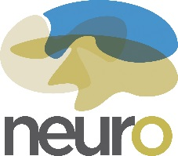 Centre for Neurological Disease Models
Tel: 514-398-1403 REQUEST FOR TECHNICAL SERVICES
CNDM-VTS.neuro@mcgill.ca
Investigator: | Protocol Number: | Phone number:
Contact: | Email:
FOAPAL number: | Request date: Click or tap to enter a date. | Date/time required:

Species: Rodent: Mouse☐ Rat ☐ NHP: Macaque ☐ Marmoset☐
Procedures: Choose an item. Other:

Please provide details of requested procedure (must be described in currently approved animal use protocol):

Please submit your filled request by email at CNDM-VTS.neuro@mcgill.ca at least seven (7) working days in advance.

