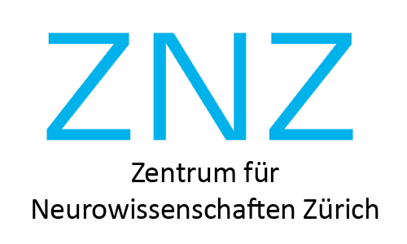

The Neuroscience Centre Zurich-McGill University
Neurodevelopmental Disorder Research Collaboration

Title of the proposal

McGill University Applicant Details
 | Name, Position, Department | E-mail and phone number
Principal Investigator
Co-PI
(if applicable)
Co-applicant
(if applicable)
Co-applicant
(if applicable)
 | Name, Degree, Year and Department | E-mail and phone number
Trainee Participating in Joint Research (if applicable)

ZNZ Applicant Details
 | Name, Position, Department | E-mail and phone number
Principal Investigator
Co-PI
(if applicable)
Co-applicant
(if applicable)
Co-applicant
(if applicable)
 | Name, Degree, Year and Department | E-mail and phone number
Trainee Participating in Joint Research (if applicable)

Funding requested

Amount requested for each institution | ZNZ McGill
Other financial contribution to the activity | ZNZ McGill

Please append the following information to this application form

- A two-page description of the proposed activity and anticipated outcomes, including how it may lead to joint applications to external research funding organizations in the future. The added value of the joint effort must be demonstrated clearly.
- The proposal should contain enough information for scientific peer review, and include Background, Aims, Samples, Methods, Planned Analysis, and likely Impact.
- CVs: For Principal Investigators, short CVs including a list of publications in the last five years (not to exceed 3 pages). For listed co-applicants, a shorter CV (a publication list is not required). No CVs are required for those involved in the proposed activities.
- A budget including justification of all costs requested. Please indicate which costs will be incurred by the Zurich applicant and which costs will be met by the Montreal applicant. Please calculate costs using the current exchange rate.

Please email completed application form along with attachments in a single pdf file to stefano.stifani@mcgill.ca and wknecht@neuroscience.uzh.ch by 12 August 2022.

