LISTENING TO ONE ANOTHER TO GET STRONG

CULTURAL ADAPTATION

7 WORKSHOPS
WITH THE COLLABORATION OF COMMUNITY MEMBERS

Table of Contents

Introduction 4

Agreement 5
Budget & Time sheets 7

WORKSHOP 1: Goals & Translation 12

WORKSHOP 2: Images & Symbols 20

WORKSHOP 3: Ways of Doing 28

WORKSHOP 4: Traditional Stories 34

WORKSHOP 5: Past & Present 42

WORKSHOP 6: Cultural Teachings 54

WORKSHOP 7: Cultural Activities 62

INTRODUCTION

The Listening to One Another program has been promoting family wellness in Indigenous communities across Canada since 2011. At present, we are developing a culturally adapted version of the program for Inuit communities. However, we need your help. With your cultural expertise, we can make a version of the program available to families in your region.

What makes this program different from others?
Culture! The ‘Listening to One Another’ research teams believes that culture is an essential key to wellness. It increases well-being by strengthening participants’ identities and by providing additional perspectives celebrating the strengths of indigenous cultures. In order to do justice to the diversity of Indigenous cultures and ways of life throughout Canada, the Listening to One Another research team collaborates with community members from all the participating groups. In this way, the format and the content of the program can truly reflect the knowledge and expertise of your community.

After consulting leaders from your community, the research team believes that you would be a good person to help culturally adapt the program. We invite you to participate in seven (7) two-hour workshops, where you will attend meetings with other community members. During these workshops, we will translate content, share ideas, and most importantly add a cultural material to the program. If you are interested in attending these workshops, please read and sign below. Note that an honorarium ($15/hour) will be given to each community member who participates in the workshops.

AGREEMENT FORM

To provide my community with a culturally adapted version of the Listening to One Another program, I, _________________________________, agree to participate in the program’s cultural adaptation workshops. Doing so makes me a research partner, who will be working in collaboration with other community members and researchers.

By taking part in the cultural adaptation workshops, I will respect the Participatory Action Research principles, which are:
- To respond to the community’s needs
- To take part in a two-way dialogue with other partners (in order to learn from one another).
- To combine action and research; Action: producing supporting documents for the delivery of the program)
Research: reporting and disseminating knowledge on the process.
- To be part of a respectful and equal relationship between partners.

Expected results: The goal of the cultural adaptation workshops is to adapt 3 documents, which will provide your community with a unique family program that promotes wellness:

- The Facilitator Manual, which guides facilitators through the delivery of the program
- The Youth and Adult Booklets, which contain activities to be done during the sessions or at home

Each of the seven workshops is designed to help format these three documents. Once all workshops are completed, the research team in Montreal will draft a first version of the Manual and Booklets, which will then be revised by community partners until they are satisfied with the materials. In the upcoming years, feedback from Elders, facilitators, participants, and leaders will be taken into consideration to make regular improvements to these three documents.

For each of the following three clauses, please CIRCLE yes or no:

- I agree to participate in the workshops (meetings): YES NO

- Since I will participate in the cultural adaptation workshops, I consent that my name be acknowledged as a research partner in publications related to the development or evaluation of the program: YES NO

- I am interested in collaborating in the authorship of documents that will be eventually published or posted on the project’s website (www.mcgill.ca/mhp): YES NO

Name (Printed): ___________________________________
Signature: ____________________________________
Phone #: _________________________________
Email Address: ________________________________________________
Witness Name (Printed): ___________________________________
Witness Signature: _________________________________
Date: ______________________

TIME SHEETS to be filled by the coordinator YEAR 1
Events | Date | # Hour | Comment
Coordinator: Recruiting Elders and Knowledge Keepers |  | 1 | Write names and phone # of culturally knowledgeable Elders who are interested in the revision of the program:  1)  2)
Coordinator: Recruiting Elders and Knowledge Keepers |  | 1 | Write names and phone # of culturally knowledgeable Elders who are interested in the revision of the program:  3)  4)  5) Find a potential substitute to replace a person who cannot attend a meeting:
Coordinator:  Organizing 7 two-hour meetings in one week |  | 1 | Reach everyone to tell the place and time of the meetings; the researcher should be present to the meetings
Meeting #1 |  | 2 | Write the names of attendees:  1)  2)  3)  4)
Meeting #2 |  | 2 | Write the names of attendees:  1)  2)  3)  4)
Meeting #3 |  | 2 | Write the names of attendees:  1)  2)  3)  4)

Events | Date | # Hour | Comment
Meeting #4 |  | 2 | Write the names of attendees:  1)  2)  3)  4)
Meeting #5 |  | 2 | Write the names of attendees:  1)  2)  3)  4)
Meeting #6 |  | 2 | Write the names of attendees:  1)  2)  3)  4)
Meeting #7 |  | 2 | Write the names of attendees:  1)  2)  3)  4)
Coordinator: Meet with leaders, health directors, social services to inform them about the new program and its revision at an upcoming meeting |  | 1 | Write names and phone # of people met:
Preparation of a meeting with interested stakeholders and Presentation of the program |  | 2 | Write the names of attendees:
Write a report on their feedback (revision) |  | 1

WORKSHOP 1:
Goals & Translation

- LTOA Family program (14 weekly sessions): Starts with a meal + activities enhancing wellness
- Attendees: Youth ages 10-14 with their parents or guardians (+ siblings)
- When: October 2016
- Where: ________________________________
- Cost: Free
- Website: www.mcgill.ca/mhp
Date of the workshop: _____________________________________
Where: __________________________________________________

Attendees and contact info:
_______________________________________________________________________________________________
_______________________________________________________________________________________________
_______________________________________________________________________________________________
_______________________________________________________________________________________________
_______________________________________________________________________________________________
_______________________________________________________________________________________________
The first step in the cultural adaptation is to review each session’s goals and to translate important words. Note that each goal relates to a family wellbeing factor such as cultural revitalization, knowledge or social and communication skills.
(Write a √ in the o if you like this goal) | Titles to Translate | Inuit Translation (Please fill-in)
Session 1 goals:  - To feel welcome and safe  - To introduce traditional values | Opening Feast
Session 2 goals:  - To explore Inuit history and strengths  - To learn about traditional ways of life | Community History
Session 3 goals:  - To see sources of strengths in family  - To practice a Talking (Sharing) Circle | My Family
Session 4 goals:  - To learn from our mistakes  - To learn from role models | A Good Way of Life
Session 5 goals:  - To develop skills to help others  - To learn ways to ask for help | Working Together
Session 6 goals:  - To be more aware and accepting of our emotions  - To learn strategies to stop bullying | Living in Harmony
Session 7 goals:  - To identify and cope with stressful situations  - To deal constructively with anger | Emotional Balance
Session 8 goals:  - To learn problem solving skills  - To learn to apply our talents (gifts) to solving problems | Problem Solving

(Write a √ in the o if you like this goal) | Titles to Translate | Inuit Translation (Please fill-in)
Session 9 goals:  - To practice critical thinking  - To learn skills to deal with peer pressure | Making choices
Session 10 goals:  - To appreciate our own and others’ strengths  - To identify strong & positive relationships | Communication
Session 11 goals:  - To be proud of oneself (uniqueness)  - To learn how to handle discrimination | Valuing Differences
Session 12 goals:  - To recognize which behaviours build trust  - To realize that everything is connected | Social Support
Session 13 goals:  - To reflect on the skills we have acquired  - To share ideas to help the community | Empowerment
Session 14 goals:  - To feel proud of our accomplishments in the program  - To honour participants & celebrate | Celebration Feast

The program’s name: ‘Listening to One Another’ reflects the wisdom shared in discussions among Elders, facilitators, youth and caregivers. However, the program’s name varies between regions. Refer to the first column (below): The various names of the program are listed; discuss them or add new ideas. Then, write the options for names and translate them. By the end of the 7 workshops we will decide on a final program name for your region:
Would you like to propose a different name for the program?
If so, please indicate your suggestion:

__________________________________________________
Translation:
- Listening to One Another
- To Get Strong
- A Good Life
- Other ideas….
OVERALL GOALS
How would you describe the overall goals and aims of this program? Family wellness…
________________________________________________________________________________________________________________
________________________________________________________________________________________________________________
________________________________________________________________________________________________________________

LISTENING / COMMUNICATING WITH ONE ANOTHER
Each session, participants take part in discussions on different topics. To make sure that everyone feels comfortable expressing themselves, the discussions take place in a Talking (Sharing) Circle, in which participants sit in a circle and take turns speaking from the heart, while others listening attentively. The Anishinabe cultural adaptation of the program notes “the Talking Circle is said to have originated as a form of legal process and eventually spread to our communities where people got together for face-to-face discussions… it is a time to share and be respectful to others by listening with all our senses. Eyes are windows to the soul and communicate feelings…”

- Does your community have a similar communication practice? If so, how would you describe it (origin, rules to respect)?

- What form would it take during the sessions (Examples from First Nations adaptations: sit in a circle, a smudge might be performed, a symbol such as a feather or talking stick might be passed around)

- Who in your community would know more about this form of communication?

Here is an example of another community’s activity. It aims to practice a Family Circle at home after having experienced it in Session #4.

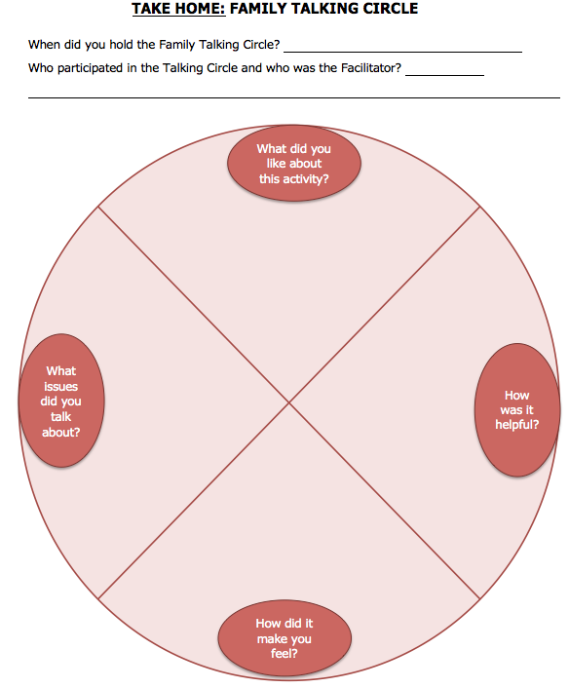
The program participants are invited to plan a Talking Circle at home. In the youth booklets, ‘Guidelines’ are given. Also as shown on the right side, the youth may answer questions that relate to the activity.

Comments from the community members: Any dilemmas? Other ideas? Questions?

WORKSHOP 2:
Images & Symbols

- LTOA Family program (14 weekly sessions): Starts with a meal + activities enhancing wellness
- Attendees: Youth ages 10-14 with their parents or guardians (+ siblings)
- When: October 2016
- Where: ________________________________
- Cost: Free
- Website: www.mcgill.ca/mhp
Date of the workshop: _____________________________________
Where: __________________________________________________

Attendees and contact info:
_______________________________________________________________________________________________
_______________________________________________________________________________________________
_______________________________________________________________________________________________
_______________________________________________________________________________________________
_______________________________________________________________________________________________

STEP 2 is to choose images, symbols, colours, and patterns, to integrate into the program’s material, activities, and session content.
Use the space on the right side of the page to draw some ideas.

Images & colours
What images and symbols would you like to see in the program materials that will be distributed to participants? These images and symbols will also be part of the flyers and posters that will promote the program in your community. Remember that the main goal of the program is to promote family wellness.  In your words or as a group, describe the reasons for these choices.  Image/Symbol #1 represents a ____________________________________  The preferable colour is: __________________________________  Why this image/symbol is important? _______________________________  _____________________________________________________________  _____________________________________________________________  Image/Symbol #2 represents a ____________________________________  The preferable colour is: __________________________________  Why this image/symbol is important? _______________________________  ______________________________________________________________  ______________________________________________________________  Image/Symbol #3 represents a ____________________________________.  The preferable colour is: __________________________________.  Why this image/colour is important? _______________________________  _____________________________________________________________  _____________________________________________________________.  Image/Symbol #4 represents a ____________________________________.  The preferable colour is: __________________________________.  Why this image/colour is important? _______________________________  _____________________________________________________________  _____________________________________________________________ | Image / Symbol #1  Image / Symbol #2  Image / colour #3  Image / colour #4

Symbols

Before providing examples from other cultural adaptations of the program, spontaneously, what other symbol that is important in your culture that might not relate to wellness but is meaningful for other concepts?  In your words or as a group, describe the origin and the meaning of this / these symbol(s): _______________________________________________  ______________________________________________________________  ______________________________________________________________  ______________________________________________________________ |  | Symbol(s) that represent our culture
Session 1: Opening Feast  For some communities, the Sacred Tree is a symbol representing a healing space, where people can find healing, power, wisdom, and security. It was taught that the life of the Tree is the life of the people.  Are there any symbols in your culture that represent a similar concept of a safe and healing space? | Symbol of a safe and healing space

Session 11: Valuing Differences  For some communities, the Culture Tree symbolizes different parts of the community’s culture. For example, the roots represent the history and ancestors of a community. The trunk represents the values that the community lives by. The leaves represent the visual aspects of the community that everybody sees or doesn’t see.  Are there any symbols that represent a similar concept of the parts of your culture? | Symbol that represents the different parts of the culture

Session 6: Living in Harmony  List objects that could symbolize safety, connectedness, or protection against dangers: ________________________________________  _______________________________________________________  _______________________________________________________  What object could families make to represent their connection and love for each other? This could serve as a reminder of their commitment to each other when times are rough or difficult. | Objects symbolizing protection from dangers and connectedness

Session 9: Making Choices  To help participants practice critical thinking, a game has been developed with communities that resembles “snakes and ladders”. When participants land on a “snakes” space, they move or “slip” back to a space that they had already passed. When participants land on a “ladder” space, they move forward or “climb” to a higher space they had not yet been on.  Some communities, they have adapted the “snake” and “ladder” to more relevant symbols, such as “fish and canoes”. Fish are like the snakes, and players will slip back. Canoes are like ladders; they move players forward.  Are there any symbols that represent a similar concept?  What symbol could represent “moving up/forward”?  What symbol could represent “moving down/backwards”? | Moving up / Forward | Moving down / Backward

Comments from community members on this part of the cultural adaptation

WORKSHOP 3:
Ways of Doing

- LTOA Family program (14 weekly sessions): Starts with a meal + activities enhancing wellness
- Attendees: Youth ages 10-14 with their parents or guardians (+ siblings)
- When: October 2016
- Where: ________________________________
- Cost: Free
- Website: www.mcgill.ca/mhp
Date of the workshop: _____________________________________
Where: __________________________________________________

Attendees and contact info:
_______________________________________________________________________________________________
_______________________________________________________________________________________________
_______________________________________________________________________________________________
_______________________________________________________________________________________________
_______________________________________________________________________________________________

STEP 3 is to integrate familiar and culturally accepted activities and ways of interacting into the program

Transmitting warmth, gratitude, and respect | Describe in details the usual or traditional ways of doing this:
- Welcoming participants:
Which words and which gestures should facilitators use to welcome participants to the session? How are greetings expressed in the community?
- Getting everyone focused:
Once the families have all arrived, how can the participants’ attention be brought together in a feeling of unity or oneness? For instance in some communities, the Elder is asked to do an opening prayer and/or perform a smudge.
- Feeling comfortable with each other:
What are some activities that can be done to help people meet each other and feel comfortable? For example, some communities start with a game called “Fancy Shawl Relay.” In this game, people divide into two teams, and one player on each team puts on a scarf, dances across the room, and passes the scarf to the next player.
- Respecting Elders:
Elders are invited to help out with the facilitation of the sessions. What would be their role? How would participants show their gratitude for their presence? For example in some communities, Tobacco is offered.
Transmitting warmth, gratitude, and respect | Describe in details the usual or traditional ways of doing this:
- Respecting each other:
Participants will be asked to create together a list of rules that should contribute to a safe and respectful environment. In your opinion, which behaviours are helpful when people meet together on a regular basis?
- Mealtime:
What are usual or traditional practices for shared meals? For instance in some communities, the Elder will be asked to do a blessing of the food. Also at the end, everyone will be asked to help setting aside leftovers and tidying up the room.
- Ending the session:
Typically at the end of an important gathering, how would leaders close the meeting? For example in some communities, the Elder is asked to do a closing prayer.
- Take Home Activities:
At the end of each session, participants will do an activity at home. These activities reinforce what they learned in the program session and prepare them for the next session. Some communities have activities that youth and parents do together or separately. Are there any particular types of take home activities you think families would like (or dislike)?
See Appendix for examples.
- Ending the program:
When someone in the community accomplishes a significant achievement, how is this person honoured? Is there a special Ceremony to celebrate success? For instance in some communities at the end of the program, a blanket is offered to participants.

- What kind of activities do youth and families usually enjoy?
Singing? Dancing? Movies? Puzzles? Drawing? Puppet shows? Board games? Racing? Other?

WORKSHOP 4:
Traditional Stories

- LTOA Family program (14 weekly sessions): Starts with a meal + activities enhancing wellness
- Attendees: Youth ages 10-14 with their parents or guardians (+ siblings)
- When: October 2016
- Where: ________________________________
- Cost: Free
- Website: www.mcgill.ca/mhp
Date of the workshop: _____________________________________
Where: __________________________________________________

Attendees and contact info:
_______________________________________________________________________________________________
_______________________________________________________________________________________________
_______________________________________________________________________________________________
_______________________________________________________________________________________________
_______________________________________________________________________________________________

STEP 4 is to choose traditional stories that fit some of the session topics. Typically the stories are told to the families after supper. Afterwards, the participants discuss together the things that were meaningful for them. It is not necessary to have a story for each session.

Before starting… few questions: | Answers from the community:
Are there any restrictions in telling traditional stories or legends? For example, in some communities, some stories are told only by certain people or at certain times or places.
Who in your community knows many traditional stories? Do you think they would be willing to review this aspect of the program with us?
Do you know of any books or videos on traditional stories that were previously developed and that would be interesting to youth aged 10-14? Do you know their titles and where to find them?
Do you know a Creation Story? If so, could you summarize it at the back of this page? Who are the most important characters?
Do you know a traditional story about family life? If so, could you summarize it at the back of this page? Who are the most important characters?
Do you know a traditional story about growing up? If so, could you summarize it at the back of this page?

First, list the traditional stories that you know. Later, we will try to match them to a session in the program based on the session’s goals.
Title of story | Important messages  What are some messages that participants may learn from the story? | Who knows this story?  - Everyone or almost  - Some families  - Few families | Other comments
Are there stories from the previous page that fit the session goals? Do you know other stories that would achieve these goals?
Session Goals | Titles | Among the listed stories, which ones fit these goals?
Session #1: The goals:  - To feel welcome and safe  - To introduce traditional values | Opening Feast  ________________
Session #2: The goals:  - To know Inuit History and strengths  - To learn traditional ways of life | Community History  ________________
Session #3: The goals:  - To see sources of strengths in family  - To practice a Sharing Circle | My Family  ________________
Session #4: The goals:  - To learn from our mistakes  - To learn from role models | A Good Way of Life  ________________
Session #5: The goals:  - To know skills for helping others  - To know skills on how to ask for help | Working Together  ________________
Session #6: The goals:  - To recognize emotions as natural signs  - To know how to deal with bullying | Living in Harmony  ________________
Session #7: The goals:  - To identify stressful situations  - To react appropriately to anger | Emotional Balance  ________________

Session Goals | Titles | Among the listed stories, which ones fit these goals?
Session #8: The goals:  - To learn skills to solve problems  To apply your talents to find solutions | Problem Solving  ________________
Session #9: The goals:  - To practice critical thinking  - To learn skills to deal with pressure | Making choices  ________________
Session #10: The goals:  - To know yours and others’ strengths  - Identify strong & positive relationships | Communication  ________________
Session #11: The goals:  - To be proud of self  - To know how to handle discrimination | Valuing Differences  ________________
Session #12: The goals:  - To know behaviours that build trust  - To realize that everything is connected | Social Support  ________________
Session #13: The goals:  - To reflect on skills acquired  - To share ideas to help the community | Empowerment  ________________
Session #14: The goals:  - To feel proud of accomplishments  - To honour participants & celebrate | Celebration Feast  ________________

Comments from the community members: Any dilemmas? Other ideas? Questions?

WORKSHOP: 5
Past & Present

- LTOA Family program (14 weekly sessions): Starts with a meal + activities enhancing wellness
- Attendees: Youth ages 10-14 with their parents or guardians (+ siblings)
- When: October 2016
- Where: ________________________________
- Cost: Free
- Website: www.mcgill.ca/mhp
Date of the workshop: _____________________________________
Where: __________________________________________________

Attendees and contact info:
_______________________________________________________________________________________________
_______________________________________________________________________________________________
_______________________________________________________________________________________________
_______________________________________________________________________________________________
_______________________________________________________________________________________________

STEP 5 is to integrate into the program knowledge about community history (Session 2) and a good way of life (Session 4). Because there is a lot to cover, you may want to divide your team into two groups: one group will discuss community history and strengths past and present, and the second group will discuss a good way of life. The two groups can then present their suggestions to each other.

Session #2: Community History: How would you divide up your community history? What are some of the important historical changes or landmarks? Mark each important event that changed the community with an arrow on the timeline below?
TIMELINE
Today
Beginnings of community
Why these historical markers are important?
Session #2: Community History
The goals of this session are to learn about community history and resiiience in order to develop a stronger sense of cultural identity and self-worth.

For discussion:  - What knowledge would you like families to retain about traditional ways of living?  - What were the some of the challenges that your ancestors faced?  - What are some of the strengths and ingenuity shown by the ancestors?  Who in your community would know more about traditional ways of living? What aspects could they talk about?  _________________________________________  _________________________________________  _________________________________________  _________________________________________  _________________________________________  Who in your community would have some tools or objects from this time period? What could they talk about or show?  _________________________________________  _________________________________________  _________________________________________  _________________________________________ | Knowledge to transmit to younger generations:  Traditional ways of life:  Challenges ancestors faced:  Strengths and Ingenuity:
Session #2: Community History (continued)
For discussion:  - How has life changed for the community?  - Which governmental policies had an impact on daily life?  - Which changes in technology have had an impact on daily life in the community?  - What are the consequences of these changes for the daily life of youth and families?  Who in your community would know more about these changes? What could they talk about?  _________________________________________  _________________________________________  _________________________________________  _________________________________________  _________________________________________  Who in your community would have some pictures or objects from the past? What could they talk about or show?  _________________________________________  _________________________________________  _________________________________________  _________________________________________  _________________________________________ | How has daily life changed?  How policies have changed daily life?  How technologies have changed daily life?  Consequences for youth and families:

Session #4: A Good Way of Life
The goal of this session is to define what is ‘a good way of life’.
- First start by listing important values that guide people through their life journey.
- You may be inspired by a traditional story, which you can write down.
- You may also draw an image that relates to this story.

Below is a description of stage of life stages? What are the usual life stages or milestones in development for a person in your community? What activities and responsibilities go with each life stage or transition? (Youth Booklet p.15)
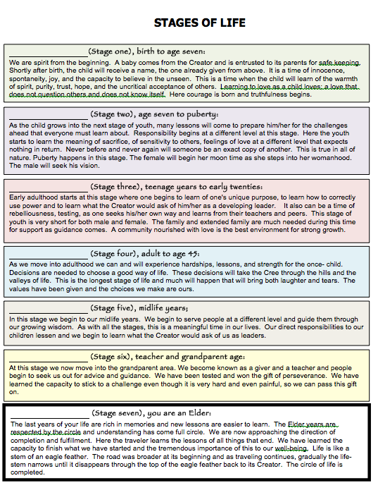
STAGES OF LIFE (start here, continue on the next page)
An example from the Anishinabe program is given (left).
- Is this section relevant to your culture?
- If so, describe each life stage that is relevant with your cultural perspectives. What are moments, activities, and rituals that indicate transitions?
STAGES OF LIFE (continued)
An example from the Anishinabe program is given
- Is this section relevant to your culture?
- If so, describe each life stage that is relevant with your cultural perspectives. What are moments, activities, and rituals that indicate transitions?
A GOOD WAY OF LIFE: (refer to the Anishinabe Youth Booklet p.16-17)
- What is a good way of life in your culture and community?
- What is a good way of life at each stage of life? (children, youth, adults, Elders)
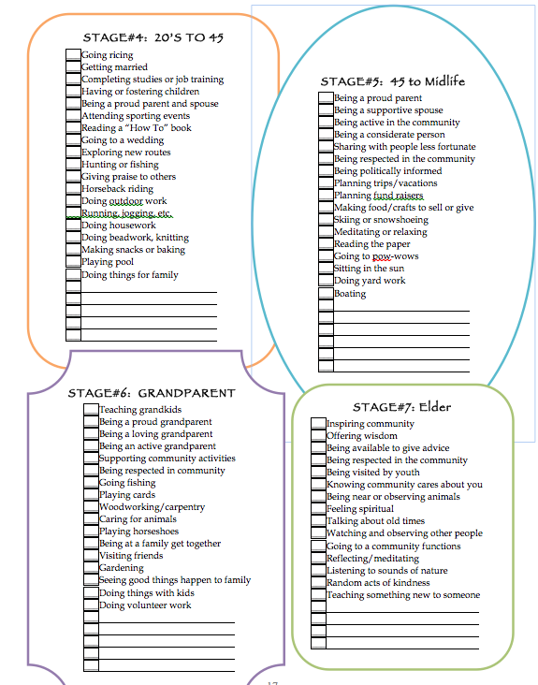
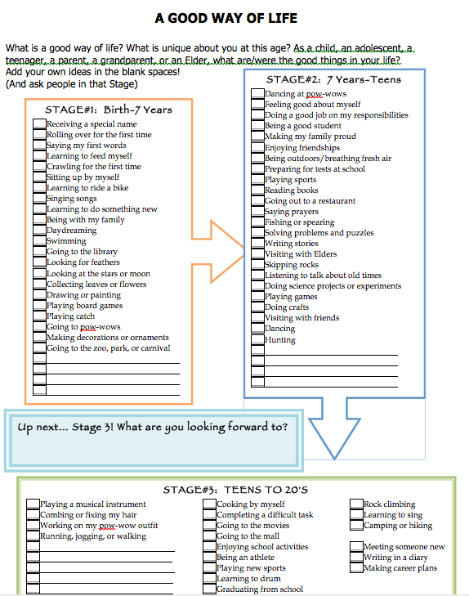

Comments from the community members: Any dilemmas? Other ideas? Questions?

WORKSHOP 6:
Cultural Teachings

- LTOA Family program (14 weekly sessions): Starts with a meal + activities enhancing wellness
- Attendees: Youth ages 10-14 with their parents or guardians (+ siblings)
- When: October 2016
- Where: ________________________________
- Cost: Free
- Website: www.mcgill.ca/mhp
Date of the workshop: _____________________________________
Where: __________________________________________________

Attendees and contact info:
_______________________________________________________________________________________________
_______________________________________________________________________________________________
_______________________________________________________________________________________________
_______________________________________________________________________________________________
_______________________________________________________________________________________________

Step 6 focuses on cultural perspectives and approaches to certain aspects of child rearing. The topics are: 1) Cultural teachings on well-being and connectedness (e.g. connectedness to nature and ancestors), 2) Cultural views on the expression of emotions, and 3) Cultural Child Rearing Strategies. After reviewing traditional perspectives, program participants will be asked to discuss a contemporary vision that responds to current situations of youth and families. You might all discuss all of these topics together, or you can divide the participants into three groups each of which will discuss one topic and then present the results of their discussion to the other groups for a final discussion.
Culture guides people on how to address important topics: | Write some text to guide facilitators on these issues (as it might be included in the Facilitator Manual)
- Cultural Teachings on Connectedness:
- How is a person connected to nature, land, animals, other people, spirits, ancestors, and the spiritual world?
- How does your culture express the value and importance of children to the family and community?
- What activities can be included in this program to encourage the recognition of these values and the development of these connections?

An example of spiritual connectedness from the Anishinabe version (Session 3):
The aabinoojii (baby) is believed to be a gift or a loan from the creator and therefore should be treated with much love and respect. We are all gifts of the creator, Gizhe Manido. From the time of conception, the aabinoojii has a spirit and begins to learn from its parents and the people around him. If the aabinoojii is surrounded by love, the baby will be born happy and full of love for those around him.
Culture guides people on how to address important topics: | Write a text to guide facilitators on these issues (as it might be written in the Facilitator Manual)
- Cultural views:
- To what extent are youth expected to express their feelings in the family? At school? With others?
- Are there differences in the ways that boys and girls are expected to express their feelings?
- How are conflicts within and between families best resolved? Are there traditional methods that can be used in current community settings?
- How should facilitators discuss ways to help youth deal appropriately with these emotions:
  - Sadness
  - Anger
  - Fear
  - Frustration
  - Other emotions or feelings?
An example to lead families to discuss dealing with anger or other emotions (Session 7):
The goal of our Swampy Cree ancestors was to maintain harmony at all times. Typically, we might think of harmony as an aspect of nature in that all things are interconnected. Our ancestors remembered to treat living things with respect in order to maintain balance. Harmony can also be found within ourselves… Do certain emotions disrupt the balance and harmony you feel inside?
Culture guides people on how to address important topics: | Write a text to guide facilitators on these issues (as it might be written in the Facilitator Manual)
- Cultural child rearing strategies:
- How do children learn to be responsible?
- Which parenting skills are important to transmit to young parents?
- What are the main barriers for families to live in harmony? How can harmony be restored in families when it has been disrupted?
- What is an example of a situation that can cause frustration for a parent and how can it be resolved?
- What activities can be included in this program to encourage the development of these skills and strategies according to your culture?

An example of parenting skills (Session 8):
For some people, the use of “I” messages improves communication when faced with a tough situation. An example is to say “when things are not picked up at home, I feel frustrated because it makes more work for me” instead of “pick up your things!”

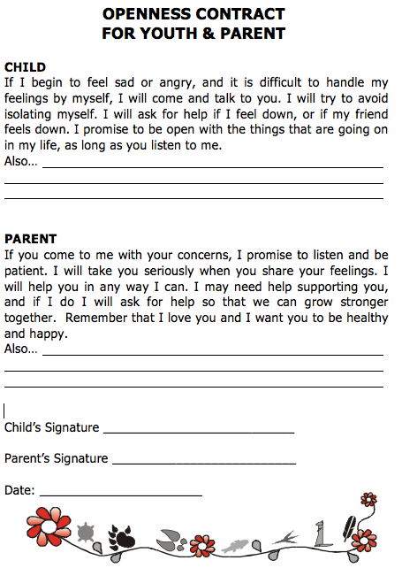
On the left is an example of how some communities come to an agreement to be there for each other. How do you think families in your community could share this sort of agreement? A drawing? A song? An agreement like this one? Something else?

WORKSHOP 7:
Cultural Activities

- LTOA Family program (14 weekly sessions): Starts with a meal + activities enhancing wellness
- Attendees: Youth ages 10-14 with their parents or guardians (+ siblings)
- When: October 2016
- Where: ________________________________
- Cost: Free
- Website: www.mcgill.ca/mhp
Date of the workshop: _____________________________________
Where: __________________________________________________

Attendees and contact info:
_______________________________________________________________________________________________
_______________________________________________________________________________________________
_______________________________________________________________________________________________
_______________________________________________________________________________________________
_______________________________________________________________________________________________

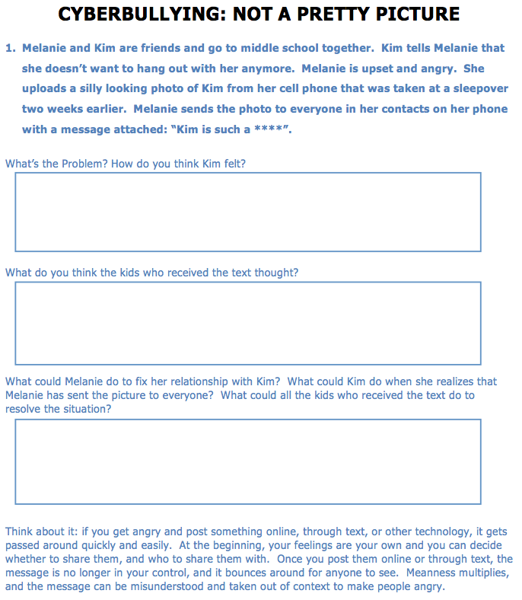
The Goal of Step 7 is to review some of the activities to see if it fits your community needs and the ways you would like to address these issues.

One aspect of the program is that it addresses bullying and discrimination. Is bullying, teasing, or cyber-bullying an issue in your community? How would you discuss it with the participating families? What strategies should parent and child use to respond to a situation, in which the child is feeling vulnerable? How does it feel to be vulnerable? What are situations that make people in your community feel vulnerable (good or bad thing? When?) Do youth value differences that make everyone unique? (Please answer on the next page)

Here is an example of another community’s cyberbullying activity.

- How would you change the way the page is set up, the questions that are presented, and the “Think About It” section at the bottom?

- What would be a more appropriate situation to describe for your community?

Is discrimination a problem in your community? How to discuss it with the families? Which strategies should parent and child use to respond to prejudices?

Answers to the questions from the page above regarding: teasing, bullying, cyber-bullying and discrimination

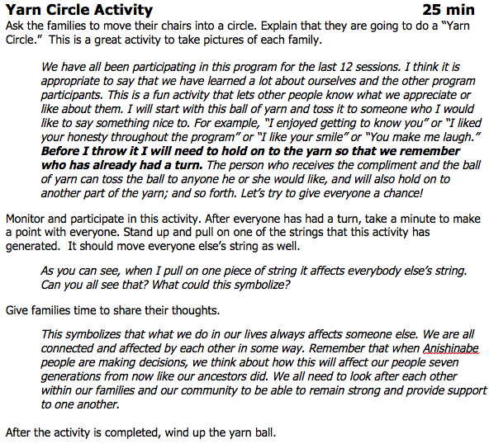
What do you think about this Yarn Circle game? It is meant to help people feel close to each other and to see how we are all connected and affect by each other. Do you like this activity or you would prefer to change it for another activity that has the same goals: to improve self-esteem and to realise how everyone is connected.
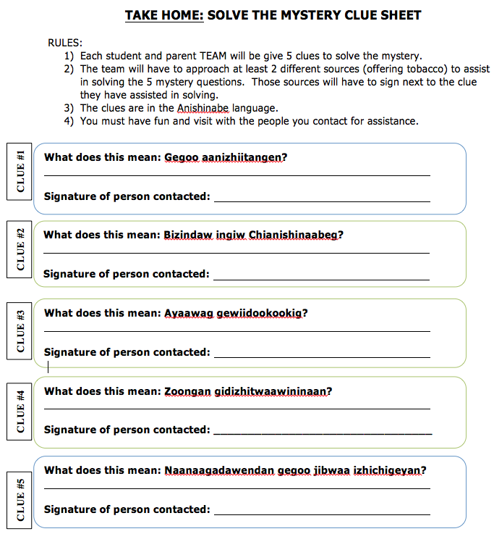
Here is an example of another community’s activity. It aims to create a network of support between generations by having youth and parents asking for help for solving the mystery…

How do people support each other in your community?

How to build positive social support?

What are the behaviours that build or damage trust?

“The assignment will encourage you to build social support, enforce the use of the language, and reintroduce visiting as a regular family activity. As you normally would do, approach the Elders in a positive, respectful, and eager manner.”
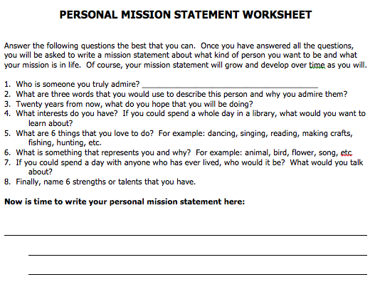
Here is an example of another community’s activity. It aims to bring together what participants have learned during the program to create a type of “plan of action” for them. What do you think about this sort of activity? How can it be adapted for your community?

Who are role models in your community? People who are looked to as an inspiration or as an example to be followed?
What have they accomplished? What challenges have they overcome? How do they teach us to learn from our mistakes?

How would you describe success? How do you discuss the future with your children?

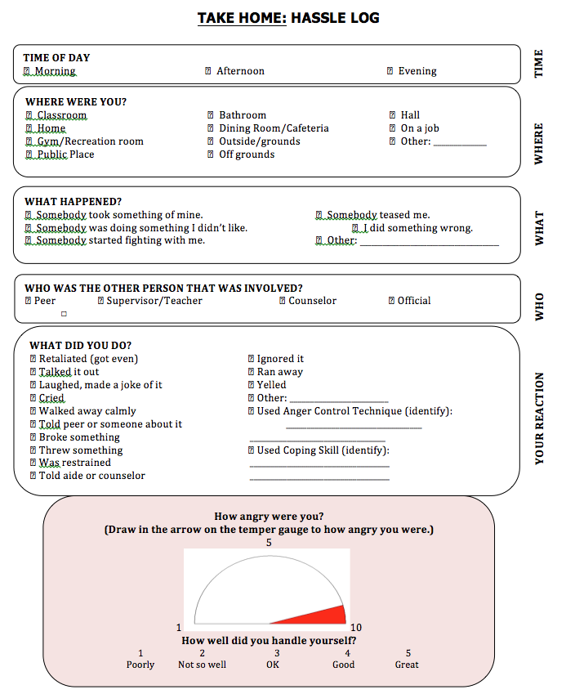
Here is an example of another community’s activity. It aims to monitor feelings of anger and strategies to handle it.

In your culture, is it acceptable for girls and boys to express these following emotions?

- Happiness (Heart feels full)
- Pride
- Love, caring
- Sadness (Heart feels sick / hurt)
- Surprise
- Shame
- Scare
- Anger
- Disgust
- Other: ___________

Which ways would be recommended to deal with sadness and anger?

- Talk to someone they trust
- Write, draw, create a song about these emotions
- Find ‘feel good’ places or activities (walk on the land, help others, other: _________)
- Stay away from stressors and use techniques to relax: deep breathing, meditate, sleep)
- Others: _____________________

Thank you for helping your community!

