**Step-by-Step Cultural Adaptation Process**

The **Color-coded priorities** are referring to the **following pages**

In the following pages, you will find a program summary (Anishinabe version). It is now up to you to adapt it to your culture.

**Priority #1**:

* **Translate the Theme-Words** from each session into your language. Who could help you with this task?
* Discuss the **traditional rituals** that you want to include into each session (pertinence/acceptability of rituals: to match your community cultural revitalization stage). The manual says: “Introduce the invited Elder to give the opening prayer and smudge”; “Ask the Elder for the blessing of the food”; “ask an Elder to give a closing prayer”. Who might be interested in doing this assignment during the sessions?
* One **banquet** (Session #1) and 13 **meals** are scheduled into the program; how will it be organized? Who will prepare it? How much funding have you received? Can traditional food or cooking methods be introduced during that time?

**Priority #2**:

* Not all sessions contain cultural content that needs to be adapted. For a quick overview of the work to be done, please refer to the “**Activities**” underscored in ‘blue in the last column of the Table below. For each of them, you may discuss whether the activity is part of your heritage or whether another one that has a similar content would be more culturally appropriate.
* **Video or speakers**: most videos are not yet available; please invite a speaker who has some knowledge on the Theme of the week (refer to the manual for more information).
* **Stories** and **worksheet/journal** are printed in a **booklet** that will be distributed to each participant (a different booklet for youth and caretakers); please review all pages and inform the research team as soon as possible if modifications are needed.
* We encourage you to make your **own material** (coloring book, puzzle, games, video); however since it takes a lot of time preparing and producing it, you may want to report this task to a future time. For instance, you may videotape speakers and use the videos during the next delivery of the program. Before creating any new material, please inform the research team.

**Priority # 3:**

* These **activities** have **no** formal cultural content and can be replaced by something else (keeping the same objectives).

**Anishinabe 2014 adapted version: LISTENING TO ONE ANOTHER/** BII-ZIN-DA-DE-DAH

**14-WEEK PROGRAM PROMOTING WELLBEING FOR INDIGENOUS FAMILIES**

**10-12 years old and their caretakers**

When adapting the program, it is important to **replace any ‘non-culturally appropriate activities’** by others more relevant, while keeping in mind **the objectives** that are to be reached in each session. Since cultural knowledge is to be transmitted to younger generations, we suggest you to bring together several community members in an **“advisory committee”** in order to **discuss relevant** rituals, stories, values, history, and traditional ways; and try to reach a consensus.

|  |  |  |  |
| --- | --- | --- | --- |
| **Session #** | **THEMES** | **OBJECTIVES** | **ACTIVITIES** |
| **1** | Welcoming Feast  **[Ashangewin]** | 1. Feel welcomed in a safe and respectful environment. 2. Understand the program and be willing to participate. 3. Think about traditional and healthy Anishinabe families. | * Welcome and Ice breaker: Team Dance; * Blessing and Banquet * Video or speaker: “Our Families, Our Culture”; feedback. * Youth: Sacred Tree puzzle * Caretaker: Discuss roles/values * Family: Story of Sacred Tree * Wrap-up and closing prayer |
| **2** | Community History  **[Gaapi Anishinaabe Ihzi Waabaak]** | 1. Know more about the community history and own identity. 2. Recognize the strengths of the Anishinabe people. 3. Gain a sense of pride in being Anishinabe. | * Welcome and Ice breaker: Fancy Shawl Relay * Blessing and Meal * Questions about culture (orally) and history (worksheet) * Video or speaker: “Anishinabe History” and feedback * Youth: Traditional Anishinabe Family (journal) * Caretaker: Discuss culture and language * Family: Anishinabe Creation activity (coloring book) * Wrap-up and closing prayer |
| **Session #** | **THEMES** | **OBJECTIVES** | **ACTIVITIES** |
| **3** | My Family  **[Gakina Indinawemaaganag]** | 1. Appreciate and improve own ability to listen from the heart. 2. Feel encourage to communicate in respectful and positive ways. 3. See potential for family and community togetherness. | * Welcome, Blessing and Meal * Talking Circle discussion and worksheet * Family: Traditional Family Story (practice skills) * Feedback discussion: How did it go? (Family Talking Circle) * Youth: Family portrait (journal) * Caretaker: Discuss skills for living and activity (worksheet) * Wrap-up and closing prayer |
| **4** | A Good Way of Life  **[Minobimaadiziwin]** | 1. Define ‘living a good life’ and list positive things from own life. 2. Identify the importance of role models (at home/community). 3. Understand that mistakes are learning opportunities. | * Welcome, Blessing and Meal * Video or speaker: Minobimaadiziwin and feedback discussion * Family: Stages of Life (worksheet) * Family: Minobimaadiziwin Board Game * Family: “My life: History timeline”, a journal activity * Wrap-up and closing prayer |
| **5** | Working Together  **[Naadamaagoziwin O’Nandowaabandan]** | 1. Learn the skills of seeking help from appropriate helpers. 2. Identify who needs help and learn to give assistance. 3. Notice positive and fun activities in daily life (finding opportunities to help or being help). | * Welcome, Blessing and Meal * Facilitator puppet show: Help-seeking * Youth: Puppet show preparation and journal activity * Caretaker: “My family goals” (worksheet) * Family: Youth puppet show * Video or speaker: “Help seeking” and feedback discussion * Wrap-up and closing prayer |

|  |  |  |  |
| --- | --- | --- | --- |
| **Session #** | **THEMES** | **OBJECTIVES** | **ACTIVITIES** |
| **6** | Living in Harmony  **[?]** | 1. View sadness and stress as arising from situations. 2. Learn the importance of sharing feelings with others.  * Find solutions to bullying. | * Welcome, Blessing and Meal * Family: Feelings activity (worksheet) * Discussion: Bullying and Cyber-bullying * Youth: Not a pretty picture activity (worksheet) * Caretaker: Discuss cyber-bullying * Wrap-up and closing prayer |
| **7** | Emotional Balance  **Dakoobidon Gi Nishkaadiziwin** | * View anger as a natural emotion; examine the reaction (behaviour). * Identify contributing factors and unresolvable controversies. * Learn approaches to anger based on Anishinabe values. * Know the link between anger and substance use/self-destructive behaviour. | * Welcome, Blessing and Meal * Discussion: Feelings of anger * The Nana’b’oozoo story and activities (worksheet) * Youth: Musical Chair Madness and Temper Gauges * Caretaker: Anger Management Talking Circle and Temper Gauges * Video or speaker: “Anger” and feedback discussion * Discussion: Temper gauge and anger busters * Hassle logs (worksheet) * Wrap-up and closing prayer |
| **8** | Problem Solving  **[Naadamaagoziwin]** | 1. Have a chance to discuss common problems with peers and practice STEPS model for solving them. 2. Foresee consequences to actions. 3. Be alert to Minobimaadiziwin, Anishinabe values, own identity. | * Welcome, Blessing and Meal * Family: Problem solving strategies (STEPS) and “Gifts and Values Activity” (worksheet) * Youth: Problem solving strategies (practice); “My Hero” and “Traditional Anishinabe conflict resolution” (worksheet) * Caretaker: “Parent STEPS” * Video or speaker: “Helen and Quincy”; feedback discussion * Wrap-up and closing prayer |
| **Session #** | **THEMES** | **OBJECTIVES** | **ACTIVITIES** |
| **9** | Making Choices  **[Gawiin Ni Wii Izhichigesii]** | 1. Explore ways to deal with peer pressure. 2. Be more aware of refusal skills and practice saying “no”. 3. Reinforce the STEPS model for problem solving. | * Welcome, Blessing and Meal * Youth: Fish & Canoe Board Game; “Saying No” (poster) discussion and activity; feedback discussion * Caretaker: Discuss discipline and self-discipline; activities: “Natural and Logical Consequences” and “Behavior Contract” (worksheet) * Video or speaker: “Refusal Skills” and feedback discussion * Planning Home activities (worksheet) * Wrap-up and closing prayer |
| **10** | Communication  **[Dibi Shkoo Dibaa Jimo Win]** | 1. Learn to identify real friends and to build positive relationships. 2. Increase self-esteem. 3. Recognize self, family, and peer strengths and use them when facing life’s challenges | * Welcome, Blessing and Meal * Youth: Friendship Brainstorm; “Qualities of Friendship Quiz” (worksheet) and “Group Up”; Friendship Disagreement discussion; Hand Activity and “My Best Friend” (journal) * Caretaker: Preparing children for success (worksheet) * Family: discussion: Peer communication * Wrap-up and closing prayer |
| **11** | Valuing Differences  **[Ma-Jaa-Nin-Diway]** | 1. Understand that differences make us unique, not unequal. 2. Realise own biases and their consequences. 3. Be sensitive to difference; value diversity and own ethnicity. | * Welcome, Blessing and Meal * Youth: Differences and Culture Tree (discussion/worksheet) * Caretaker: Discrimination Talking Circle and “Discussing Hate and Violence with Children” (worksheet) * Family: Culture Tree and “Family Discrimination Response Plan” (worksheet) * Wrap-up and closing prayer |

|  |  |  |  |
| --- | --- | --- | --- |
| **Session #** | **THEMES** | **OBJECTIVES** | **ACTIVITIES** |
| **12** | Building Social Support  **[Bimaadizi Wiidookaagewin]** | 1. Identify who and where to turn to if they need advice. 2. Build pro-social and pro-active support bridges. 3. Understand behaviours that build and break trust. | * Welcome, Blessing and Meal * Discussion “Stress and Problems” * 3 activities for both youth and caretakers: “Trust Walk”; “Yarn Circle” & “Personal Mission Statement” (worksheet) * Wrap-up and closing prayer |
| **13** | Community Empowerment  **[?]** | 1. Understand the idea of community empowerment. 2. Think of the ideas for empowering own community. | * Welcome, Blessing and Meal * Discussion: “Community Empowerment” * Youth: Ideal Community Drawing (worksheet) * Caretaker: Promoting Positive Change (worksheet) * Family: Scrapbooking (photo taken during the sessions) * Wrap-up and closing prayer |
| **14** | Celebration Feast  **[Gitchi Ashangewin]** | 1. Celebrate the conclusion of the program; receive gifts/award. 2. Discuss ways to incorporate the 14-session learning into daily life. | * Welcome, Blessing and Meal * Show and Tell activity * Traditional Blanket Ceremony * Awards * Wrap-up and closing prayer |

Why a focus on culture is especially important for the health of Indigenous People?

* History and contemporary conditions affect individual health by creating negative/positive feelings or stress.
* To prevent negative health outcomes; culture may act as a buffer (a protecting shield) by strengthening one’s identity.
* 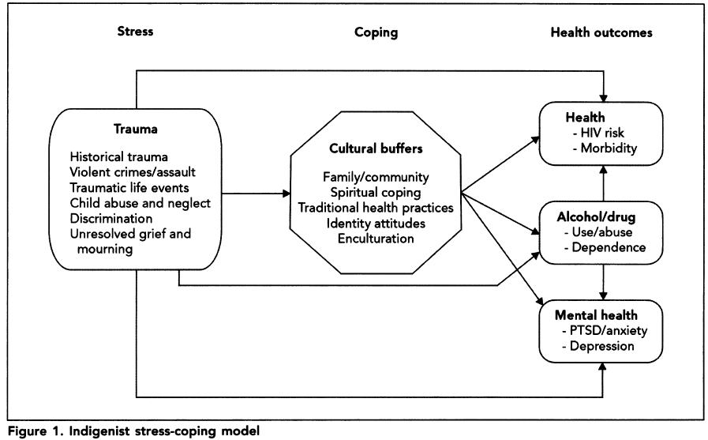In 2002, Walters and colleagues presented the “Indigenist” Stress-Coping Paradigm (refer to Model below).

Walters, K. L., Simoni, J. M., & Evans-Campbell, T. (2002). Substance use among American Indians and Alaska natives: incorporating culture in an "indigenist" stress-coping paradigm. [Research Support, U.S. Gov't, P.H.S.]. *Public Health Rep, 117 Suppl 1*, S104-117.