USER’s GUIDE:
MDCM Self-Reporting Workbook
2021-2022

TABLE OF CONTENTS
Understanding how your academic record is evaluated 4
Purpose of the MDCM Self-Reporting Workbook 4
Getting started 5
How to enter data 5
How to submit your completed workbook 6
Legend (Workbook): 6
Legend (This Guide) 8
LAST NAME 8
FIRST NAME 8
McGill ID 8
PROGRAM 8
APPLICANT CATEGORY 8
Section 2: SUMMARY OF POST-SECONDARY STUDIES 10
PROGRAM TYPE 10
PROGRAM NAME 11
MAJOR 11
LOCATION GROUP 11
LOCATION & INSTITUTION 11
START DATE & END DATE 11
CREDIT COUNT FOR PROGRAM 12
STATUS 12
DATE OF CONFERRAL 12
ADDITIONAL COMMENTS 12
HONOURS PROGRAM 13
STUDY ABROAD/EXCHANGE PROGRAM 13
SUMMER PROGRAM 13
PROFESSIONAL PROGRAM 13
PART-TIME STUDIES 13
SECTION 3: BASIS OF ADMISSION DEGREE 14
ADMISSION BASED DEGREE & INSTITUTION 14
ASSIGNED TO BACHELOR NAME 14
ACADEMIC YEAR 14
ACADEMIC TERM 15
COURSE CODE 15
COURSE NAME 15
COURSE LEVEL 15
GRADE STATUS 16
TRANSCRIPT NUMERICAL GRADE AND/OR LETTER GRADE AND/OR GPA 16
TRANSCRIPT COURSE CREDIT WEIGHT 17
MCGILL EQUIVALENT LETTER GRADE 17
MCGILL EQUIVALENT COURSE CREDIT WEIGHT 18
MCGILL GPA CONVERSION 18
Is this a Basic Science? (OPTIONAL) 18
SECTION 4: PRE-REQUISITES AND RECOMMENDED COURSES 20
BASIC SCIENCE COURSES 20
INCLUDES LAB 20
INSTITUTION 20
ACADEMIC YEAR 20
COURSE CODE 20
COURSE NAME 20
GRADE STATUS 21
TRANSCRIPT NUMERICAL GRADE AND/OR LETTER GRADE AND/OR GPA 21
TRANSCRIPT COURSE CREDIT WEIGHT 21
MCGILL EQUIVALENT LETTER GRADE 21
MCGILL EQUIVALENT COURSE CREDIT WEIGHT 21
EXEMPTION/SUBSTITUTION 21
SECTION 5: EXTENUATING CIRCUMSTANCES (OPTIONAL) 22
SELECT COURSE(S) AFFECTED BY EXTC 22
COURSE NAME 22
ACADEMIC YEAR 22
ACADEMIC TERM 22
MCGILL GPA 22
CLASSIFICATION OF COURSE 23
SECTION 6: FEEDBACK REPORT 23
IN PROGRESS SCIENCE PRE-REQUISITE COURSES (3 MAXIMUM) 23
Appendix -Tables of grade point values for basic science prerequisites completed in a pre-university setting 24
Quebec CEGEP 24
International Baccalaureate (IBO) Exams Results 24
College Board, Inc. AP Exams 25
A-Level (or equivalent) Exams Results 25
European Credit Transfer and Accumulation System (ECTS) Grading Scale 25
French Baccalaureate 26
McGill Equivalent grade point value 26

Understanding how your academic record is evaluated
The Office of Admissions considers several criteria in evaluating each candidate’s academic strength for admission to the MDCM program. The MDCM Self-Reporting Workbook is the tool used to assess a candidate’s academic profile. ‘Basis of admission degree’ means the undergraduate-level degree upon which your candidacy is assessed, and the cumulative grade point average obtained within that degree is the primary measure of degree performance.

Applications are first verified to ensure eligibility, and based on the academic evaluation or the CASPer score, approximately 4 to 6 times the number of candidates as there are interview seats are moved forward to the CV review and full prescreening step.

In order to determine who will be invited to interview, among candidates who move to the full pre-screening step, the academic performance is weighted at 70% and the non-academic context elements (the CV and the CASPer test score) are weighted at 10% and 20%, respectively. Within the 70% academic prescreening score, 63% is based on the undergraduate CGPA and 7% is based on academic context. The assessment of an applicant's academic context is based upon elements such as the progression of difficulty of coursework, graduate studies and recognition of professional programs (i.e.: programs that lead to the practice of a profession and for which one must be a member of a professional order).

For applicants invited to the multiple mini-interviews (MMIs), the final rank order list (which includes those who will receive an offer of admission and those who will be placed on a waiting list) is based 100% on interview performance.

For more information about the selection process, please see: www.mcgill.ca/medadmissions/applying/selection-process

Purpose of the MDCM Self-Reporting Workbook
Assessment of academic strength is based upon the undergraduate (Bachelor’s degree) record. This is the BASIS OF ADMISSION DEGREE, for which detailed information must be reported in Section 3: Basis of Admission Degree of the workbook. The basis of admission degree is expected to be a 120-credit university degree program, or, for candidates who hold a Diploma from a Quebec-based CEGEP or equivalent pre-university studies, a 90-credit program from a Quebec university is accepted.
If you are applying on the basis of a second bachelor’s degree you must report courses and grades for both bachelor’s degrees.
NB: While you will be asked to list all post-secondary programs undertaken in Section2: Summary of Post-Secondary Studies you will not be required to report individual courses or grades for all your programs if they are not part of your basis of admissions degree.

Getting started
Before you get started:
- You will need a valid McGill ID number in order to complete the self-reporting workbook. Once you have successfully submitted the online application forms (including payment), you will receive a confirmation and a nine digit McGill identification number by email; this may take 24-48 hours to receive.
- Have on hand copies of all of your academic records (i.e. transcripts) for your basis of admission degree or degrees.
- If your basic science prerequisite courses were not taken in a university, (i.e., CEGEP, AP exams, A-Level, French Baccalaureate, or distance education) you will also need these academic records for self-reporting.
- To get started, you need to download the workbook from the following website: www.mcgill.ca/medadmissions/applying/elements/maaw
- You must save the file to your hard drive before entering any text in order for the internal links to work.

Technical notes on the Workbook:
The Self-Reporting Workbook can be completed in Microsoft Excel® . The desktop version of this software is recommended. N.B. > McGill University does not endorse or support any of the above-mentioned software.
Those using an operating system in another language may run into some errors especially concerning the date. Please ignore and complete the workbook to the best of your ability. We are aware of these limitations and will correct them upon receipt of your workbook. If there are any issues with your submission our office will contact you directly.

How to enter data
BE CONSISTENT!
When entering data in a table, be consistent with terminology.
Ensure that your data entry accurately reflects what appears on your official records. The Self-Reported Workbook is verified against your transcripts by the Admissions Office. The information you provide in the Workbook must be accurate and true. McGill University reserves the right to require official academic records at any time during the admissions process and rescind any offer of admission made if discrepancies between unofficial and official records(s) are found.
Blank fields (do not enter “N/A”): the workbook will display feedback if a field MUST be completed. Otherwise, it is preferable to leave field blank rather than entering values such as N/A.

How to submit your completed workbook
Once you have finalised your workbook and ensured that the data presented is accurate and clean, you can submit it as per the instructions found at: www.mcgill.ca/medadmissions/applying/elements/maaw
Please note that unlike other documents in support of your application to medicine or dentistry, you do not upload your workbook to Minerva. The workbook is transmitted to the admissions office by email, once you click on the link provided in the final section of the workbook. Please allow a minimum of 10 business days for the workbook to appear as “received” on your Minerva document checklist.
Be sure to name the file as indicated in SECTION 6: FEEDBACK REPORT before submitting it.

Legend (Workbook):
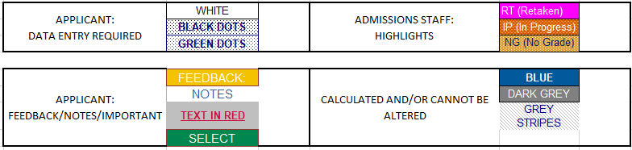
The following images are included as detailed example pages in the workbook; access them using the button available on the relevant pages:

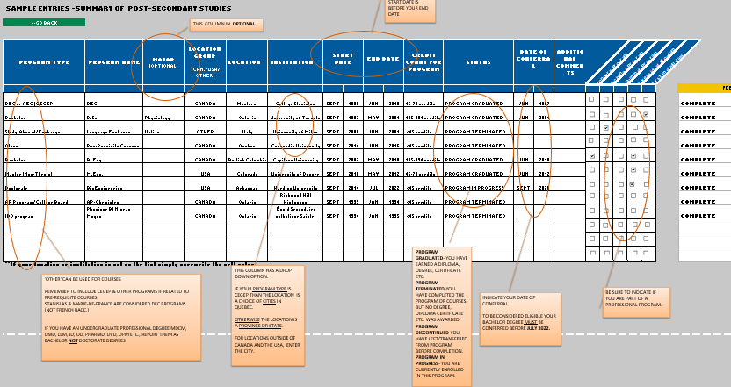

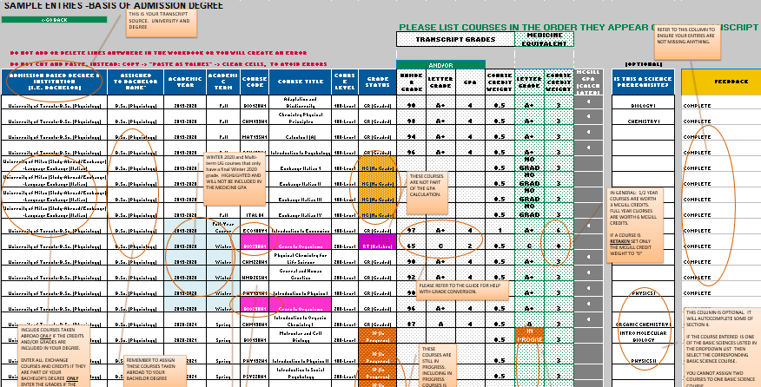
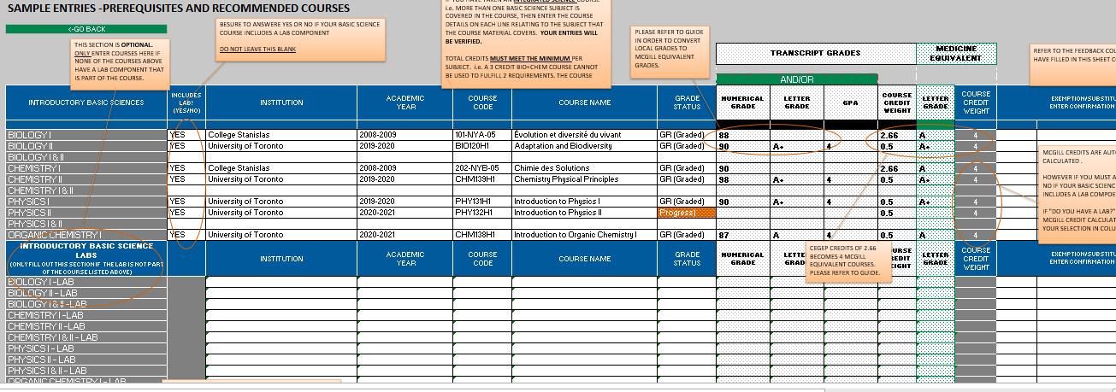

Legend (This Guide)
Example data entries are presented in a red, mono-spaced font.
FIELD NAMES are presented in green.
SECTION 1: Applicant General Information
This section identifies the owner of the data (that’s you!). You must have a valid 9-digit McGill ID number before submitting the completed version of the workbook.

LAST NAME
Enter your last name as per your application.

FIRST NAME
Enter your first name as per your application. Middle names are optional.

McGill ID
Enter your 9-digit McGill identification number. You receive this number once Step 1 of your application has been completed and your payment has been processed.

PROGRAM
Select (from a dropdown list) the short name of the program to which you are applying.

APPLICANT CATEGORY
Select (from a dropdown list) the short name of the Applicant Category in which you are applying.
MD-ROQ-U (Québec resident, university-level)
MD-CDN (Canadian (non-QC) resident)
MD-INTL (International resident)
MD-FNIN (First Nations, Inuit) For Quebec residents only

Medicine applicants: Optional Pathways.
Several additional application pathways are available. Read the eligibility information and use the drop-down to indicate if you are eligible and wish to be considered.

- Full-time members of the Canadian Armed Forces may be eligible for the Programme militaire d'études en médecine (training in French only. Read the eligibility requirements.
- Indigenous residents of Canada (outside Quebec) may be eligible for the Canadian Indigenous pathway.” Read the eligibility requirements. (select the ‘Canadian’ tab on this page). Note-First Nations & Inuit residents of Quebec should select the “MD-FNIN” program in the Applicant Category field and do not check this box –see details for the Quebec pathway here-select the ‘Quebec’ tab). Additional checklist items will be added to your file after your workbook is processed by the office.
- Quebec residents who self-identify as Black may be eligible for the Black Candidate Pathway. Read the eligibility requirements. Additional checklist items will be added to your file after your workbook is processed by the office.
- Quebec residents who attended a Quebec public high school in a rural or small population centre may be eligible for the Rural or Small Population Pathway. Consult the List of Quebec population centres, Read the eligibility requirements. You must provide the name, postal code and number of years you attended a public high school in Quebec located in a rural or small population area. Note- do not select this pathway or enter any high school information if you attended a private school in Quebec, or any high school outside Quebec.

Section 2: SUMMARY OF POST-SECONDARY STUDIES
This table is a summary of your entire post-secondary history, including CÉGEP, graduate programs, study abroad or exchange sessions, independent or open studies, and applicable advanced secondary studies such as AP courses, A-Levels, IBO or French Baccalaureate.

PROGRAM TYPE
Select from the dropdown menu the option that best describes the program type.
Select this Program Type: | To designate :
A-Levels | Advanced Level examinations or programs such as those in UK-based education systems
AP Program/College Board | Advanced Placement examinations or programs from CollegeBoard, Inc.
Bachelor | Bachelor degree program  Associate degree program  Undergraduate Professional program (MDCM, MD, DDS, DMD, LLB, JD, OD, PharmD, DVM, DPM etc.)  Other Bachelor degree programs that do not fit elsewhere.
DEC or AEC (CEGEP) program | Diploma of Collegial Studies (DEC) program from CEGEP, or equivalent AEC programs
Doctorate | Professional or thesis-based program leading to a Doctorate degree (PhD). This does not include undergraduate professional programs which should be reported as a bachelor degree.
French Bacc. | Program offered by or based on the French Baccalaureate system  Note: If you have received a French Bacc. from Stanislas or Marie de France please report as DEC or AEC (CEGEP) program.
IBO program | Program offered by International Baccalaureate Organisation (IBO)
Masters (Thesis) | Thesis-based program leading to a Master’s degree. Some examples include: M.Sc., M.A., etc.
Masters (Non-Thesis) | Non-Thesis-based, course-based, applied, or professional program leading to a Master’s degree. Some examples include: M.Sc (A)., M.B.A., LL.M., etc.
Dipl or Cert prog | Undergraduate- or graduate-level diploma or certificate program including post-baccalaureate programs
Tech/Vocational | For a technical training or vocational college program, including technical certifications
Study-Abroad/Exchange | For a university-organised or university-sponsored study-abroad or exchange program
Other | For undergraduate studies that are not part of any specific program, sometimes referred to as open studies or independent studies. For a graduate- or post-graduate-level program that does not fit elsewhere in this list. For a program that is not university-based (i.e., neither graduate nor undergraduate) that does not fit elsewhere in this list.

PROGRAM NAME
Enter the name that best describes the program.
- Example: Bachelor of Arts
- Example: Certificate in Accounting
- Example: Master of Applied Sciences
- Example: PHD
- Example: IB Health Sciences

MAJOR
Indicate the area of study in which you are majoring (optional).

LOCATION GROUP
Indicate the location of the relevant institution using the dropdown menu. Your choices are Canada, USA or Other.

LOCATION & INSTITUTION
Indicate the location of the relevant institution using the dropdown menu. If your institution does not appear in the menu, enter the name manually.
If you must manually enter the name of the institution you attended, use the official name of the institution as indicated on official records. If there is a specific campus involved, include the campus name.
- Example: McGill University
- Example: University of Western Ontario
- Example with campus: University of British Columbia (Vancouver)

START DATE & END DATE
Use the drop-down menus to enter the month and year in which you started attending this institution and in which you finished or will finish attending the institution for the relevant program.
N.B. > the start and end dates should match the dates appearing on your transcript for the program.
If you are ‘in progress’ studying another bachelor’s program that is expected to be completed after July 2022, section 2 will display feedback to that effect and the summary page will indicate that section 2 is incomplete. Ignore the comment if you have already completed a previous bachelor’s degree that will be used as your basis of admission degree. Degrees that are not completed by July 2022 will not be included in our evaluation.

CREDIT COUNT FOR PROGRAM
Select from the dropdown menu the option that best describes the number of credits required for graduation.

STATUS
Select from the dropdown menu the appropriate STATUS for each of your listed programs.
Enter this text: | To designate that:
PROGRAM IN PROGRESS | the program is in progress at the time of your application.
PROGRAM DISCONTINUED | you have abandoned the program.
PROGRAM GRADUATED | all degree requirements have been successfully completed at the time of application (enter the date of conferral of the degree/diploma/certificate in the DATE OF CONFERRAL column).
PROGRAM TERMINATED | you are reporting course work, or the program did not lead to a degree/diploma/certificate etc. (i.e.: could be used to enter an elective course taken outside of your home institution that is not part of any degree.)  you transferred to another institution before completing the program

DATE OF CONFERRAL
Enter the date of conferral of the degree/diploma/certificate for programs that have been successfully completed. (Leave this field blank for programs that are IN PROGRESS or DISCONTINUED).

ADDITIONAL COMMENTS
Use this space to enter any comments.
- Summary of transfers (e.g. “30 credits transferred from Concordia Univ.”)
- Special or exceptional conditions
N.B. > If there were extenuating circumstances that had an impact on your academic performance and wish for special consideration of your application due to these circumstances, please review our policy at www.mcgill.ca/medadmissions/applying/elements/extenuating-circumstances . Circumstances described in this document may not be considered if the criteria set out in above policy are not respected.

HONOURS PROGRAM
Select the drop-down menu if your program is an honours program

STUDY ABROAD/EXCHANGE PROGRAM
Select the drop-down menu if your program was part of a study abroad or an exchange program
Note that if the study abroad/exchange program is part of your basis of admissions degree you will need to enter these courses in section 3. Study abroad/exchanges that are greater than 1 semester of course work, the grades must be entered and not marked as NG (No Grade).

SUMMER PROGRAM
Select the drop-down menu if your program is part of a summer program or were independent summer courses.

PROFESSIONAL PROGRAM
Select the drop-down menu if your program is a professional program. (i.e.: programs that lead to the practice of a profession and for which one must be a member of a professional order).

PART-TIME STUDIES
Select the drop-down menu if you completed this program on a part-time basis (i.e. usually 9 or fewer credits /3 or fewer courses per term).

SECTION 3: BASIS OF ADMISSION DEGREE
This is the degree upon which your academic assessment for admission is based. In most cases, the BASIS OF ADMISSION DEGREE is your most recent undergraduate degree (exceptions include professional degrees such as Doctor of Medical Dentistry). This should be a 120-credit university degree program, or, for candidates who hold a Diploma from a Quebec-based CEGEP or equivalent pre-university studies, a 90-credit program from a Quebec university is accepted.
If you are applying on the basis of your second bachelor’s degree you must report courses and grades for both bachelor’s degrees.
If you participated in a study abroad/exchange program during your basis of admissions degree studies you will need to enter these courses in section 3. Study abroad/exchanges that are greater than 1 semester of course work, the grades must be entered and not marked as NG (No Grade).
Please list the courses in the order they appear on your academic transcript for ease of verification.
NB: While you were asked to list all post-secondary programs undertaken in Section 2, you are not required to report individual courses or grades for these programs in Section 3.

ADMISSION BASED DEGREE & INSTITUTION
Select from the drop- down menu the institution-program type-major combination that corresponds to your transcript. This is to identify the source of the course.

ASSIGNED TO BACHELOR NAME
Select from the dropdown menu the bachelor’s degree that these course credits are contributing to.
This is useful in the case of transfer credits, multiple institutions, exchange programs and switched programs.
- Example: You attended institution A and studied X then after a year you transferred to institution B and studied Y. After three years you were able to graduate from institution B with a degree in Y because you also used the credits earned when you were studying X at institution A. Make sure that you assign all the courses taken at institution A to your degree in Y.

ACADEMIC YEAR
Enter the academic year in which the course took place. It should always be in the YYYY-YYYY format.
- Example: 2008-2009

ACADEMIC TERM
Use the list below to enter a valid option:
Enter this text: | To designate this:
Fall | First session of the academic year.  “Fall” session for semester, trimester or quarter-based institutions.
Winter | Second session of the academic year.  “Winter” session for semester, trimester or quarter-based institutions.
Spring | Spring session for QUARTER-based institutions
Summer | Third session of the academic year.  “Summer” session for semester, trimester or quarter-based institutions.
Full-Year course | Courses spanning of the first and second sessions of the academic year  “Fall-Winter” in most institutions.
Term n/a | If the course is not a full term or if you feel that none of the above options correctly captures the nature of your term.

COURSE CODE
Enter the individual course code as it appears on the transcript.
- Example: for PHYS 101
- Example: for CHM138Y1
- Example: for 101-NYA-05

COURSE NAME
Enter the title of the course as it appears on the transcript. Feel free to abbreviate.

COURSE LEVEL
Select from dropdown menu the entry that most accurately represents the course level.
When completing the Course Level field, be sure to indicate the level as indicated by the institution (your university). If you are relying on ‘first-year’ or ‘second-year’ terminology, do not refer to the year in which you took the course, but the Level-Year in which this course is normally taken by a student in your institution. For example, you took COURSEXXX in your second year of a 4 year, 120-credit program. The course is an introductory level course in Latin, with no prerequisites. You should indicate this course as a 100-level course.
Select this value: | To designate this:
000-Level | a pre-freshman level course. Typically, these courses start with a “0” in their numbering (e.g. PHYS 099).
100-Level | a Freshman / “First Year” / U0 –level course, including all CEGEP courses
200-Level | a Sophomore / “Second Year” / U1 –level course.
300-Level | a Junior / “Third Year” / U2 –level course.
400-Level | a Senior / “Fourth Year” / U3 –level course.
500-Level | an advanced undergraduate course (e.g. Master’s-level course available to undergraduates)
GR-Level | a graduate-level course (i.e. part of an graduate program) but contributes to the bachelor degree.

GRADE STATUS
Use the list below to enter a valid option:
Select this value: | To designate:
GR(GRADED) | the course grade (letter or numerical) is calculated in the GPA
NG(NO GRADE) | the course result cannot be calculated in the GPA (does not have a point value). This includes Pass/Fail, Satisfactory/Unsatisfactory notations (e.g. PASS, CR, S, W, CNT, IPR, etc.)  Note: Please report all transfer credits and grades.  Note: Please report your study abroad/exchange program if taken during your basis of admissions degree. Study abroad/exchanges that are greater than 1 semester of course work, the grades must be entered and not marked as NG (No Grade).  Transfer credits do not include studies done in CEGEP or high school.
IP(IN PROGRESS) | the course is in progress and its final grade or notation is not available at this time.
RT(RETAKEN) | This course was subsequently retaken.  [EXAMPLE: You took BIO 101 in 2009 and got a D; enter this information in one row and indicate a GRADE STATUS of RT and set the McGill credits to zero. You took BIO 101 again in 2010 and got a B; enter this information on a separate row and indicate a GRADE STATUS of GR (Graded). This allows us to calculate your GPA in the manner most advantageous to the applicant, counting only the better of the two grades.]  Make sure to indicate the GRADE STATUS as RT on the course with the failed or lesser grade.

TRANSCRIPT NUMERICAL GRADE AND/OR LETTER GRADE AND/OR GPA
Where applicable, enter the grade, mark or notation of the course as per the transcript. Either a numerical grade and/or a letter grade and/or a GPA must be entered.
Special note regarding grades for courses taken in the Winter 2020 term
As described under Educational requirements:
- The workbook will not include Winter 2020 grades in the GPA, this applies equally to all applicants regardless of the impact of COVID-19 on your studies or the policy of your educational institution. However, please enter these grades in the workbook exactly as they appear on your transcript (letter, numerical, or Pass/Satisfactory/Credit, etc.)
- Winter 2020 credits for all successfully completed courses will be counted towards degree totals as reported on the institution’s transcript.
- Winter 2020 semester credits will not be considered when assessing eligibility related to full-time studies.
- Basic Science prerequisite courses with grades of Pass, Satisfactory, Credit, etc. will be accepted for Winter 2020 only.
- 2019-2020 full year courses are not counted in the GPA. Candidates who have fewer than 45 graded credits after the exclusion of 2019-2020 full year courses should submit a letter of extenuating circumstances.

TRANSCRIPT COURSE CREDIT WEIGHT
Enter the credit value or weight of the course, as per the transcript. This field is used in calculations and, therefore, should only contain a number.
- Example: 3.0, 6.0, 2.66 etc.
NB: To assist you in converting your institutional grades and credits to their McGill equivalents please consult the appendix. If the tables provided in the appendix do not capture the grading scheme of your institution, you may refer to the following links:
- USA: Consult https://aamc-orange.global.ssl.fastly.net/production/media/filer_public/2f/f2/2ff2540b-0e3c-4201-a6c8-c4829c9abcdf/amcas_grade_conversion_chart.pdf
- Canadian: Refer to the appendix (last page)
- International: Consult hwww.mcgill.ca/gradapplicants/international/apply/equivalency. If no scale here is appropriate, please contact the admissions office and request grading scheme for your country or institution.

MCGILL EQUIVALENT LETTER GRADE
Select from the dropdown menu the McGill grade equivalent that corresponds with the grade that appears on the transcript. A letter grade must be entered. These grades will be converted to a McGill scale. Refer to the Appendix for more information.

MCGILL EQUIVALENT COURSE CREDIT WEIGHT
Enter the credit value or weight of the course accordingly. Refer to the example below as a rough guideline. This field is used in calculations and, therefore, should only contain a number. Refer to the Appendix for more information.
- Example: For University of Toronto students a 0.5 credit semester course is equivalent to a 3.0 credit semester course at McGill.
- Example: For some international students if your local institution has courses weighing 10, 15, 80 credits then keep them as 10, 15 and 80 credits when entering the McGill equivalent.

Note: It is important that the conversion should hold the same proportion of weight as your overall GPA and
should reflect the local grade in your transcript. Often your local credit has a 1 to 1 relationship with a McGill
credit.

MCGILL GPA CONVERSION
This is a calculated field. The figure that appears in this box is a calculated field, generated by the Workbook on the basis of the data you entered. This field is locked for viewing only.

Is this a Basic Science? (OPTIONAL)
If the reported course also fulfills a basic science requirement or a recommended course select the appropriate basic science option that corresponds with the course from the drop down list provided. This will help to automatically populate some of section 4. This is optional and the applicant can also fill in section 4 manually in the case of basic sciences taken in CEGEP or outside of the basis of admissions degree.
You cannot assign multiple courses to one basic science course.
Select this value: | To designate:
BIOLOGY I | Introduction to biology part I (1 semester)
BIOLOGY II | Introduction to biology part II (1 semester)
BIOLOGY I & II | Introduction to biology part I & II (full year)
CHEMISTRY I | Introduction to chemistry part I (1 semester)
CHEMISTRY II | Introduction to chemistry part II (1 semester)
CHEMISTRY I & II | Introduction to chemistry part I & II (full year)
PHYSICS I | Introduction to physics part I (1 semester)
PHYSICS II | Introduction to physics part II (1 semester)
PHYSICS I & II | Introduction to physics part I & II (full year)
ORGANIC CHEMISTRY I | Introduction to organic chemistry (1 semester)
BIOLOGY I –LAB | Lab component to introduction to biology part I (1 semester)
BIOLOGY II – LAB | Lab component to introduction to biology part II (1 semester)
BIOLOGY I & II –LAB | Lab component to introduction to biology part I & II (full year)
CHEMISTRY I –LAB | Lab component to introduction to chemistry part I (1 semester)
CHEMISTRY II- LAB | Lab component to introduction to chemistry part II (1 semester)
CHEMISTRY I & II – LAB | Lab component to introduction to chemistry part I & II (full year)
PHYSICS I – LAB | Lab component to introduction to physics part I (1 semester)
PHYSICS II – LAB | Lab component to introduction to physics part II (1 semester)
PHYSICS I & II – LAB | Lab component to introduction to physics part I & II (full year)
ORGANIC CHEMISTRY I –LAB | Lab component to intro to organic chemistry (1 semester)
INTRO MOLECULAR BIOLOGY | Introduction to molecular biology (1 semester)
INTRO CELL BIO & METABOLISM | Introduction to cell bio & metabolism (1 semester)
INTRO MAMMALIAN PHYSIOLOGY | Introduction to mammalian physiology part I (1 semester)

SECTION 4: PRE-REQUISITES AND RECOMMENDED COURSES
Details about the Basic Science Pre-requisite courses and policies are found here: www.mcgill.ca/medadmissions/applying/requirements-edu/basic-science-prerequisites

This section will automatically populate most of the basic science information if you used the drop box option in section 3. Otherwise you may fill out this section directly for example if your basic sciences are from CEGEP or outside your basis of admission degree. Please verify that the entire section is complete before moving to the next section.

BASIC SCIENCE COURSES
These fields are populated automatically and cannot be altered.

INCLUDES LAB
Drop down box if your pre-requisite course includes a lab YES or NO. If the lab is a separate course, select NO and then enter the course below in the area designated for lab-only courses.

INSTITUTION
Select from the dropdown menu the appropriate institution. This menu is populated on the basis of information you reported in section 2. If the institution appears more than once (for example, you listed the institution for more than one program in Table 2), select any of the values as they are treated equally.

ACADEMIC YEAR
(refer to previous section)

COURSE CODE
(refer to previous section)

COURSE NAME
(refer to previous section)

GRADE STATUS
(refer to previous section)

Select from the dropdown menu the grading scale that best describes the source of your grade.

TRANSCRIPT NUMERICAL GRADE AND/OR LETTER GRADE AND/OR GPA
(refer to previous section)

TRANSCRIPT COURSE CREDIT WEIGHT
(refer to previous section)

MCGILL EQUIVALENT LETTER GRADE
(refer to previous section)

MCGILL EQUIVALENT COURSE CREDIT WEIGHT
This is a calculated field. The figure that appears in this box is a calculated field, generated by the Workbook on the basis of the data you entered. This field is locked for viewing only.
All courses are converted to a McGill-Equivalent credit weight of 3, with the exception of courses with an integrated lab, which are worth 4 credits.
All courses listed in the Introductory Basic Science Labs section are converted to a McGill-Equivalent credit weight of 1.

EXEMPTION/SUBSTITUTION
Use this section if you have obtained from the Office of Admissions approval of a request for exemption or substitution for a basic science prerequisite course.
- Select from the dropdown box whether you are reporting an exemption or a substitution.
- Enter the confirmation code that you received from the Office of Admissions granting the approval.

SECTION 5: EXTENUATING CIRCUMSTANCES (OPTIONAL)
This section will be considered ONLY if you have:
- indicated 'Extenuating Circumstances (EXTC)' on your web-based application
- UPLOADED via Minerva a written letter of explanation and supporting documents [Note: You cannot upload Extenuating Circumstance documentation via Minerva UNLESS and UNTIL you have indicated Extenuating Circumstances on your web-application.}.
- If you wish to apply for EXTC but did not indicate it in your web-based application please email admissions.med@mcgill.ca and the relevant checklist item will be added to your MINERVA account.
Please consult the policy and instructions here:
https://www.mcgill.ca/medadmissions/applying/requirements/elements/extenuating-circumstances

SELECT COURSE(S) AFFECTED BY EXTC
Select from the dropdown menu the courses that have been affected by the extenuating circumstances (EXTC) set out in your uploaded documentation.

COURSE NAME
These fields are populated automatically and cannot be altered.
For a description: (refer to previous section)

ACADEMIC YEAR
These fields are populated automatically and cannot be altered.
For a description: (refer to previous section)

ACADEMIC TERM
These fields are populated automatically and cannot be altered.
For a description: (refer to previous section)

MCGILL GPA
These fields are populated automatically and cannot be altered.
For a description: (refer to previous section)

CLASSIFICATION OF COURSE
This column displays whether the selected course will affect your BASIS OF ADMISSIONS DEGREE, PREREQUISITES COURSES and/or RECOMMENDED COURSES.
These fields are populated automatically and cannot be altered.

SECTION 6: FEEDBACK REPORT
The feedback report provided in this workbook is used to confirm and summarize the results of the data entered by the applicant.
Note that the Medicine CALCULATED GPA is a preliminary calculation and is subject to:
- Verification against your transcript
- Possible adjustments due to courses that are RETAKEN or due to EXTENUATING CIRCUMSTANCES. Any such adjustments will only be made if they are to the applicant’s advantage.
Remember that, due to COVID-19, no Winter 2020 courses are calculated in the Medicine GPA, so it is normal that you may see a discrepancy with your institution’s transcript.

IN PROGRESS SCIENCE PRE-REQUISITE COURSES (3 MAXIMUM)
Note that if you indicated in Section 4 that up to a maximum of 3 basic science courses are in progress as of the Nov. 1 application deadline, you will see a table appear. Use this table to indicate the anticipated date you will submit the official grades to the Admissions Office. You are required to submit your grades by uploading a copy of the relevant unofficial transcript to Minerva. A checklist item will be added to Minerva by early January for applicants who indicated in progress science pre-requisite courses. Grades must be submitted by May 30 at the latest for candidates who receive an offer of admission.

If you have any additional comments please enter them in the designated box.

Appendix -Tables of grade point values for basic science prerequisites completed in a pre-university setting
These tables are for your information only.

Quebec CEGEP
CEGEP Grades | McGill letter grade equivalent | McGill grade point value |  | CEGEP Credit Units to  Semester Hours
87% or higher | A | 4.0 |  | multiply by 1.5  (e.g. 2.66 cr = 4.0 sem hrs)
83—86% | A- | 3.7
79—82% | B+ | 3.3
75—78% | B | 3.0
71—74% | B- | 2.7
67—70% | C+ | 2.3
63—66% | C | 2.0
60—62% | D | 1.0
59% or lower | F | 0.0

International Baccalaureate (IBO) Exams Results
IBO Exam Result | McGill letter grade equivalent | McGill grade point value |  | IBO Exam weights to  Semester Hours
7 | A | 4.0 |  | Assign each higher-level exam  6 semester hours.  N.B. > Standard level exams are not considered to fulfill any of the basic science prerequisites.
6 | AB | 3.5
5 | B | 3.0
4 | C | 2.0
3 | D | 1.0
2 | F | 0
1 | F | 0

College Board, Inc. AP Exams
AP Exam Result | McGill letter grade equivalent | McGill grade point value |  | AP exam weights to  Semester Hours
5 | A | 4.0 |  | Assign each exam result  6 semester hours
4 | AB | 3.5
3 | B | 3.0
2 | F | 0
1 | F | 0

A-Level (or equivalent) Exams Results
A-Level Exam Result | McGill letter grade equivalent | McGill grade point value |  | A-Level Exam weights to  Semester Hours
A | A | 4.0 |  | Assign each exam  10 semester hours
B | AB | 3.5
C | B | 3.0
D | C | 2.0
E | D | 1.0
N | F | 0

European Credit Transfer and Accumulation System (ECTS)
Grading Scale
ECTS Results | McGill letter grade equivalent | McGill grade point value
A | A | 4.0
B | A- | 3.7
C | B+ | 3.3
D | B | 3.0
E | C | 2.0
FX | D | 1.0
F | F | 0.0

French Baccalaureate
French Bacc. Results | McGill letter grade equivalent | McGill grade point value
16.0-20 | A | 4.0
14.0-15.9 | A- | 3.7
13.0-13.9 | B+ | 3.3
12.0-12.9 | B | 3.0
10.0-11.9 | C | 2.0
0-9.9 | F | 0.0

McGill Equivalent grade point value
Letter Grade | Grade point value
A+ | 4
A | 4
A- | 3.7
AB | 3.5
B+ | 3.3
B | 3
B- | 2.7
BC | 2.5
C+ | 2.3
C | 2
C- | 1.7
CD | 1.5
D+ | 1.3
D | 1
D- | 0.7
DE | 0.5
E/F | 0

