McGill Libraries Research Commons 3D Printing Lab

**Printer Information Sheet**

TABLE OF CONTENTS

General Printer Tips 2

Nozzle Size 2

Ultimaker 2 Extended+ 3

Quick Info 3

Suggested Parameters 3

Printer Quirks 3

Ultimaker 3 4

Quick Info 4

Suggested Parameters: 4

Printer Quirks: 4

Ultimaker S5 5

Quick Info 5

Suggested Parameters: 5

Printer Quirks: 5

The Printing Process 5

Booking Your Time Slot 5

Printing With Cura 6

Download and registration: 6

Upload your .stl file: 6

Making changes to your .stl file: 8

Slicing: 9

# General Printer Tips

## Nozzle Size

* Larger diameter nozzles allow much more aggressive layer heights to cut print times.
  + 0.8 mm nozzle can print nicely at 0.4 mm layer heights
  + 0.4 mm can print 0.3 mm layers
* Typical nozzles
  + Ultimaker 3: 0.4 mm
  + Ultimaker S5: 0.4 mm

# 

# Ultimaker 2 Extended+

## Quick Info

* Build volume: 223 x 223 x 305 mm
* Proprietary Software: Cura

## Suggested Parameters

* Temperature: 220 - 225°C
* Bed Temperature: 60 - 70°C
* ***Current Nozzle Size:* 0.8 mm**

## Printer Quirks

* Leveling seems off / tape is being torn up
  + Auto-leveling procedure failed, abort print and restart
  + After the nozzle passes over the wire brush in back, it will perform four continuity checks in each corner (tapping twice each time). For this procedure to work, metal-to-metal contact with the metal rails and the nozzle is required and filament ooze will cause it to fail.
  + Just before the nozzle taps the front corners, try to wipe the nozzle with a piece of paper or tape.
* Filament snapping / Not extruding
  + Under <<Maintenance>> and <<Advanced>> select <<Move Material>> and try to advance filament.
  + Check for “Mouse-Bite” in Filament.

INSERT PICTURE OF FILAMENT SAMPLE WITH MOUSEBITE

* + Try extruding by manual advancement of filament.
* First layer not sticking
  + Put a little bit of glue on the glass bed (glue sticks can usually be found in the cabinet beneath)
* Printing in mid-air
  + Re-level the printing bed, someone may have improperly leveled the printer before without realizing.

# 

# Ultimaker 3

## Quick Info

* Build volume: 215 x 215 x 200 mm
* Proprietary Software: Cura
* Can produce the finest details (at the expense of increased time)
* Can print PVA water-soluble supports (only one of the Ultimaker 3’s will have PVA loaded at a time, due to how quickly it degrades. Please email us to confirm which printer has PVA loaded before you make your booking)

## Suggested Parameters:

PLA

* Temperature: 220 - 225°C
* Bed Temperature: 60 - 70°C

PVA[1]

* Print Temperature: 190 - 200°C
* Idle Temperature: Much lower than print temperature (70-120°C)

## Printer Quirks:

* Print not sticking to build plate
  + Check if the bed is heated to proper range.
  + Put a little bit of glue (glue sticks can usually be found in the cabinet) on the glass bed if the print doesn’t stick properly.

# Ultimaker S5

## Quick Info

* Build volume: 330 x 240 x 300 mm
* Proprietary Software: Cura
* Can produce the finest details (at the expense of increased time)
* Can print PVA water-soluble supports

## Suggested Parameters:

PLA

* Temperature: 220 - 225°C
* Bed Temperature: 60 - 70°C

PVA[2]

* Print Temperature: 190 - 200°C
* Idle Temperature: Much lower than print temperature (70-120°C)

## Printer Quirks:

* Print not sticking to build plate
  + Check if the bed is heated to the proper range.
  + Put a little bit of glue (glue sticks can usually be found in the cabinet) on the glass bed if the print doesn’t stick properly.
* This printer is capable of printing larger builds; however please make sure that your print job falls under the ten-hour print time limit. You can play around in your slicers advanced settings to try and reduce print time; if you need help doing this, please come during our office hours!

# The Printing Process

## Booking Your Time Slot

* Go to <http://libraryrooms.mcgill.ca/booking/groupstudy> and from the drop-down menu select Research Commons - 3D printers and scanner
* Choose the day you would like to print on in the calendar on the left and then select your time slots on the appropriate printer you are planning on using
* We recommend booking a little bit more time than you think you would need, if you encounter any complications
* If you are printing for the first time and feel uneasy, we recommend booking your printing time during our office hours: we will gladly help you out!
* When you are ready to book, click on Submit time slots
* Confirm you have read the regulations and took the training session and click on Submit
* Now you have to wait for your booking to get approved - we approve anyone’s booking which isn’t extremely long and the person took the training session

## Printing With Cura

### Download and registration:

* Go to <https://account.ultimaker.com/app/create> to create a Cura account using your school email address and preferred name.
* Go to <https://ultimaker.com/software/ultimaker-cura> to download the latest version of Cura; if you are unable to download Cura the computer by the 3D printers should have a version of the software ready for you to use.
* Launch Cura and sign in. The sign in button should be in the upper right-hand corner of the screen in Cura.

### Upload your .stl file:

* In the top bar, click on the file button to open up a file manager
* Select the .stl file from your computer

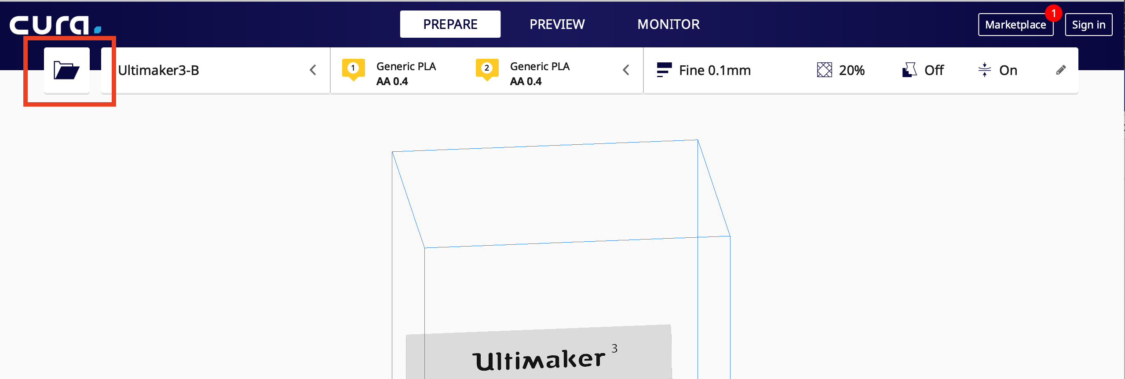

* Now you should see your .stl file loaded on the screen

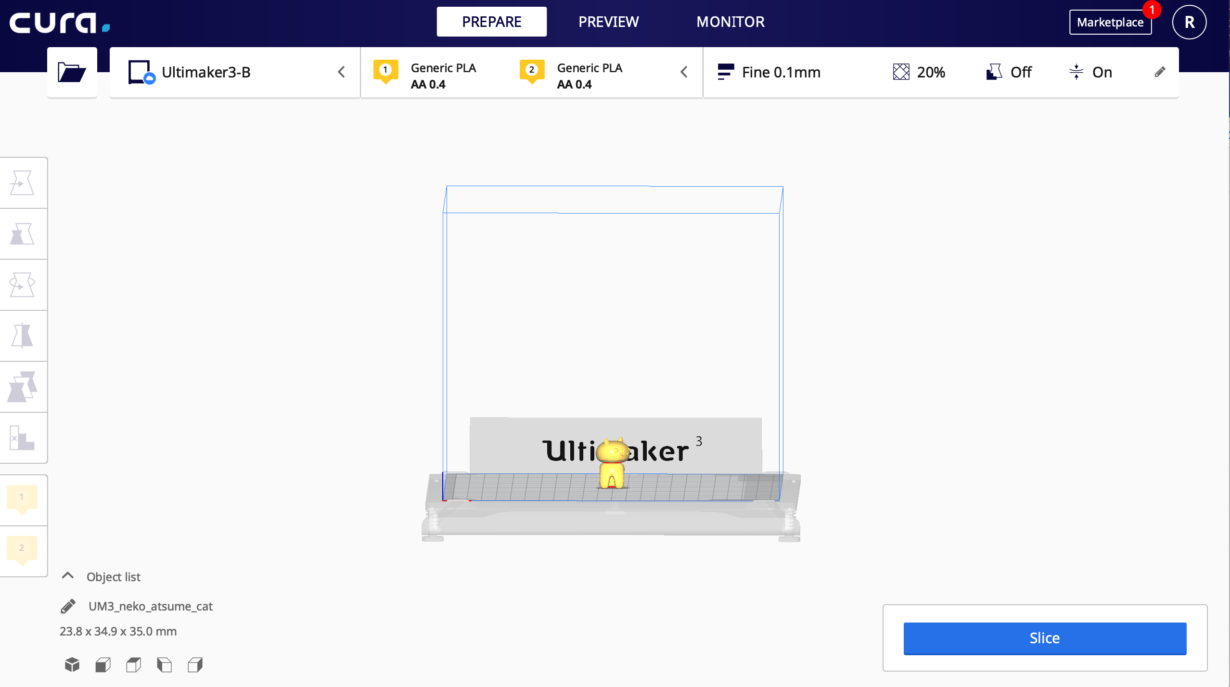

* Finally, select which printer you would like to use from the drop-down menu next to the file icon. For instructions on how to add 3D printers to your printer list, see next section.

**Adding 3D printers**

* Access to the 3D printer that you book should be given automatically once your booking is approved. Occasionally the printer you have been granted access to might not show up on your printer list right away, in which case extra steps should be taken
* First, sign into Cura with the account associated with your McGill email address
* Next, click on the drop-down menu and select “Manage Printers”

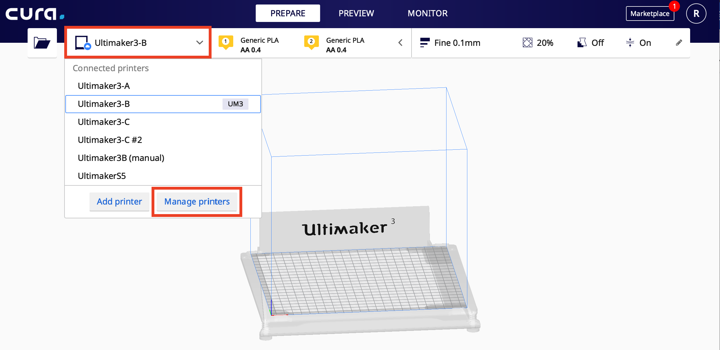

* In the menu that appears, select the Network Enabled printer you would like to add, and click on the “Add” button

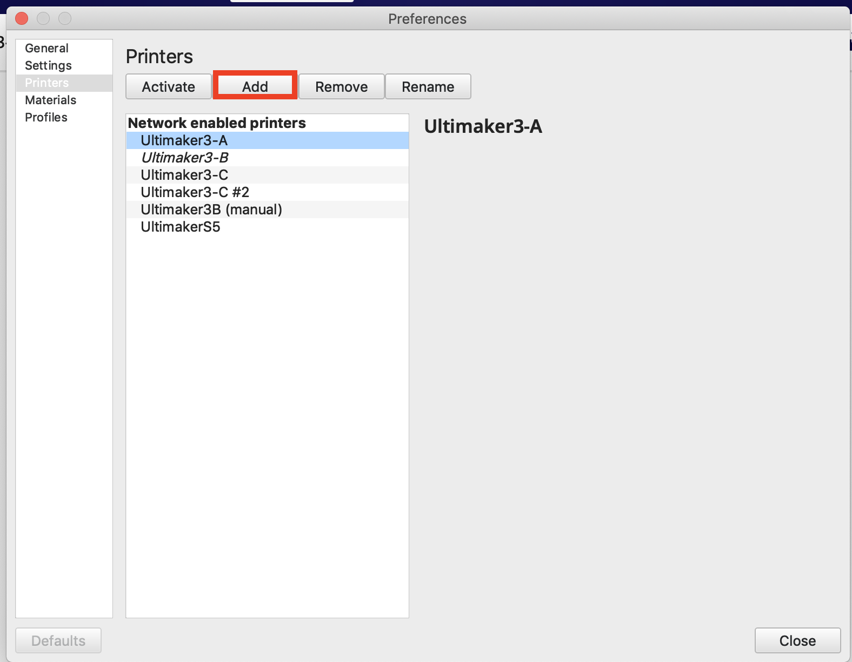

* After exiting the menu, the printer should now appear on your printer list. If problems persist, see us during our service hours or send us an email at [3dprint.library@mcgill.ca](mailto:3dprint.library@mcgill.ca)

### Making changes to your .stl file:

* In Cura, you can make some minor changes to your .stl file
* Once your .stl file is uploaded to Cura, select the asset that you wish to edit (multiple .stl files can be uploaded and printed at once)
* The three most basic options for editing are Moving, Scaling, and Rotating. They appear in that top-down order on the left-hand side of the screen.

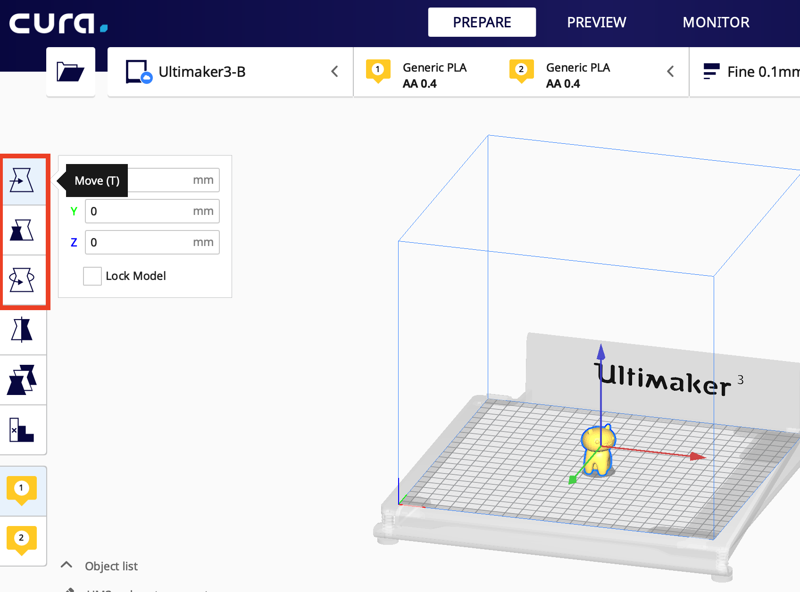

* Make any necessary changes before moving on to the next segment

### Slicing:

* Slicing is the process of generating the precise instructions for your printer, so it knows how to move the print head, where to add supports and so on.
* Because different printers have different properties, slicing has to be done with the properties of the printer you are going print with. In general, the automatic settings Cura generates should be fine for most basic builds. However, certain prints may require more customization.
* To make custom slicing settings, click on the menu in the upper right corner of Cura.

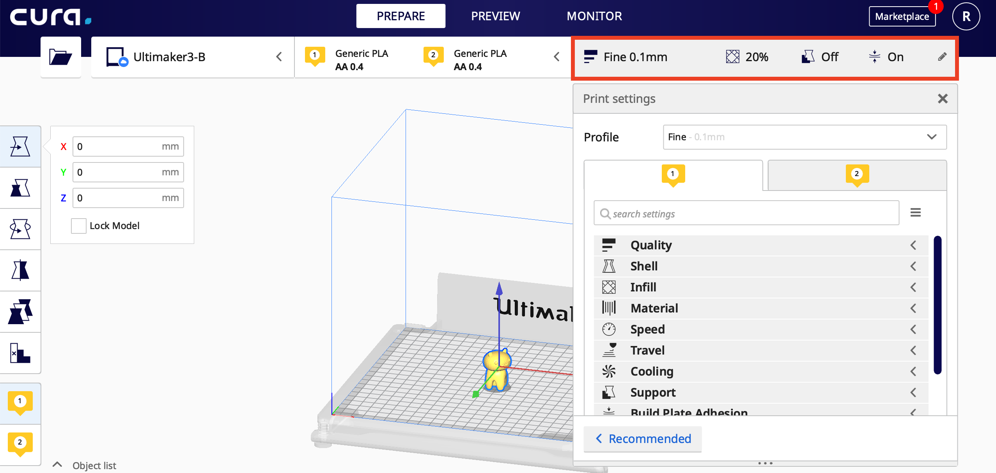

* A new menu with multiple customization settings should appear. We will be going over some of the more basic customization settings.
* *Support* is one of the most important and most used settings. 3D printers print from the bottom up, if your print has more complex features like an over-hang or sharp angles, gravity will end up pushing the plastic down and ruining your print. As a solution, Cura will automatically generate removable support structures in problem areas
* Supports can be generated either in PVA or whatever material you are printing in. PVA is water soluble; so, when your print is finished, you'll have to submerge your print in water for 24 hours afterwards. If you choose to print supports in the same material as what you are printing in, they should easily snap off although some filing may be required afterwards to smooth bumps. A nail file works fine for this purpose. Do note that not all the printers will have PVA loaded in due to how quickly it degrades once out of the package. Email us to find out which printers have PVA loaded in them.
* To print supports in the material you are printing with, select “Extruder 1” as your support extruder. To print supports in PVA in a PVA enabled printer, select “Extruder 2” as your support extruder.

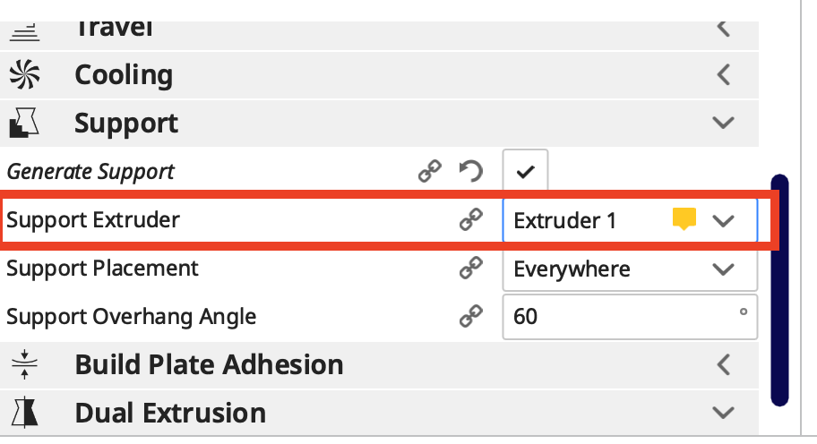

* The *Quality* parameter controls the vertical resolution of your print
* The lower the number the finer details will be visible, but the longer your print will take. Default settings should be fine unless you are trying to print something quickly.
* The *Shell* parameter controls how weak or strong your outer shell will be. For more durability you should set higher number, for decorative prints you are well off with lower number
* The *Infill* sets how much plastic will enclose parts of your print contain: 0% infill means hollow shell and 100% infill means completely solid object

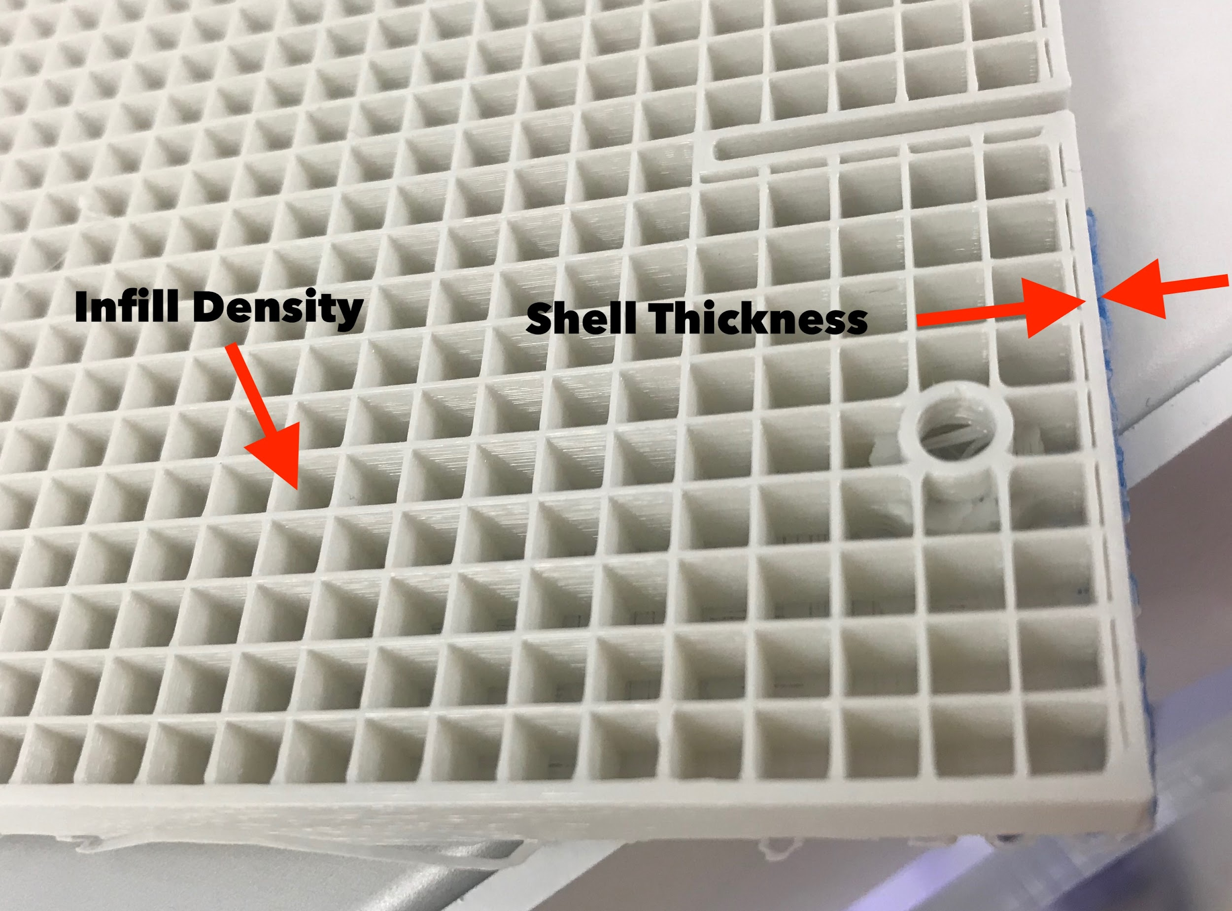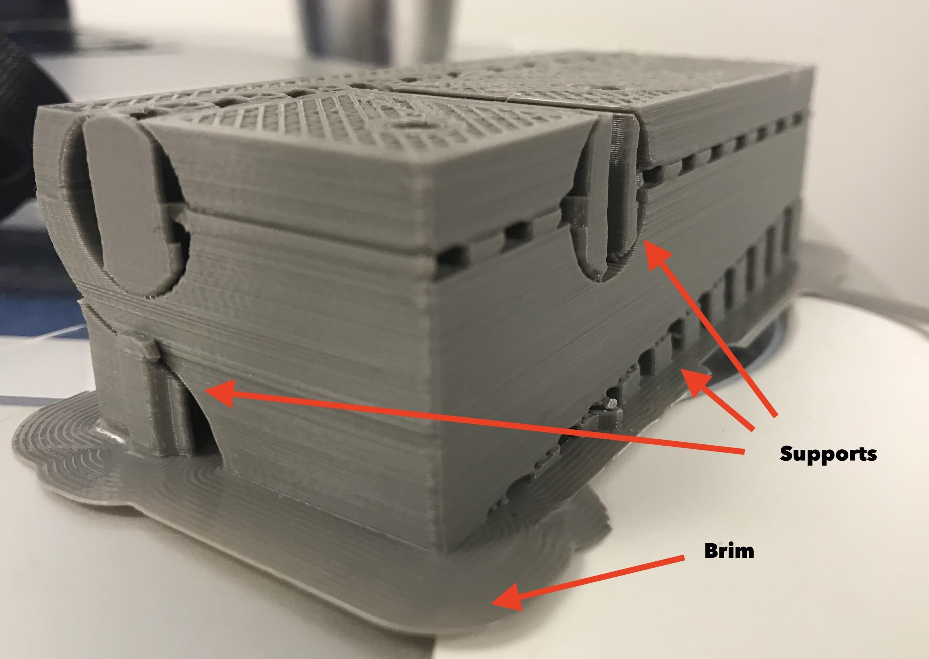

* For general prints you don’t need more than 20% of infill, for mechanically stressed parts we recommend at least 50% of infill
* The more infill you want, the more plastic you will use and the longer your print will take
* If your model doesn’t have a lot of bottom surface area, you might want to use the *Build plate Adhesion* setting so your print sticks to the bed properly.
* When you are happy with the parameters, click on Slice, the blue button in the lower right corner of the screen
* Once your file is finished slicing, a new menu with a print time estimate can be seen. Make sure that your print is under the ten-hour time limit. If not, you’ll have to adjust some slicing settings to bring down the print time
* Make sure that you have the correct printer selected in your printer list, and press “Print via Cloud”. After a few seconds, your print should be sent to whatever printer you selected as long as the bed is clear.
* For any advice, help with your print, or troubleshooting, feel free to stop by during our service desk hours! If it's your first print, book a time slot during our hours and we can walk you through the process.

1. PVA settings are still in the works.
2. PVA settings are still in the works.