Satellites for Enhancing Human Rights
by
Ram Jakhu

Introduction

In the area of human rights, satellites play dual role. They:
- help in enhancing human rights (by allowing people to exercise their rights, and by informing them about human rights and by publicising their violations); this is achieved primarily with the use of telecommunication satellites; and

- help in the enforcement of human rights (by documenting, and providing evidence of, violation of human rights); this is achieved primarily with the use of remote sensing satellites.

The Origin and Kinds of Human Rights

After the Second World War, individuals have started gaining (though slowly) importance at international level. Starting with some broad provisions in the UN Charter, several rights of individuals (as opposed to those their States) have already been recognized in numerous international treaties. Others are at various stages of formation. The foundations of a large majority of the human rights were laid in the 1948 Universal Declaration of Human Rights. Its provisions have been incorporated in several international treaties, often without any major changes.
One of most important and relevant of those rights is the right to hold opinion and freedom of expression. This freedom is considered to be the touchstone of all the freedoms and human rights. The freedom of expression is incorporated in Article 19 of the Universal Declaration, which states that “Everyone has the right to the freedom of opinion and expression; this right includes freedom to hold opinions without interference and to seek, receive and impart information and ideas through any media and regardless of frontiers.”
The meaning, scope, importance, practice and implementation of the right to freedom of expression have gained novel perspective in the new information age, which is primarily a result of convergence of three technologies; i.e. satellites, computers and the internet. They collectively enhance ‘globalisation’ in every sphere of human activities and concerns, including human rights.
Expansion of Satellite Communication Services
Satellites routinely carry images and opinions, nationally and internationally, through radio and television, the internet and the social media. Integration of cellphone applications, such as SMS and social media for gathering real-time information (the so-called “crowdsourcing") with satellite TV imaging create open source intelligence that can be used and spread widely in order to muster international responses against violation of human rights.
Consequently, the internet, communications for social media and television through smaller and cheaper VSAT are coming within the purchasing power of more and more people, especially where traditional infrastructures are non-existent or inadequate; .e.g. Middle East and Africa. An effective interplay of these technologies is evident from the Arab Spring.
Satellites have clear advantages over traditional means of communications. Satellites by using higher frequencies and employing higher transmitting power eliminate the need for large and expensive dish antennae. Thus with VSAT (very small aperture terminals) the users are able to bypass the limitation of availability of traditional means of communications and the arbitrary restrictions imposed by oppressive authorities. Consequently, satellite communication tools are becoming available to the common people in authoritarian countries and thus are empowering them to strive for freedom, especially in countries with despotic regimes. It is therefore not surprising that the U.S. Government is eliminating sanctions on communications tools for Iran and allowing satellite services to and export of satellites dishes to Cuba.
Last year, Iraq planned for a satellite television channel dedicated to the enhancement of human rights. The Iraqi Human Rights Ministry announced that: "Through this television station, we shall try to define these rights and increase national public awareness about relevant international agreements and conventions [as well as about] what the Iraqi constitution ensures in its chapter on rights and freedoms."
Though it is generally accepted that freedom of expression is fundamental to Western democracies, certain countries in Western Europe have been trying to impose restrictions on the use of satellite TV dishes. However, in 2011, the European Court of Human Rights delivered an extraordinary ruling proclaiming that to have a satellite dish “is a human right.” In the Court’s view, denying such right “could breach the right to freedom of expression by preventing people from practice religion.”
The people all over the world are gaining access to this technology for their basic cultural, religious and educational needs. There are thousands of satellite television channels serving billions of people in almost all corners of the world.
One can see satellite television dish antenna installed and used in a tiny hut made of bamboo and hay in a remote village named Jagatpur, Nepal, by a couple of illiterate people with meagre economic means.
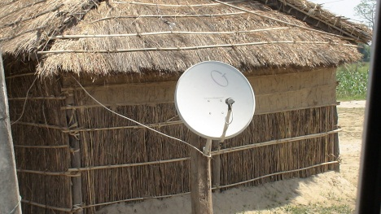
Also it is fascinating to see in Alger, Algeria, many roof-tops and several balconies of high-rise apartments belonging to middle class people with numerous white colored satellite television dish antennas.

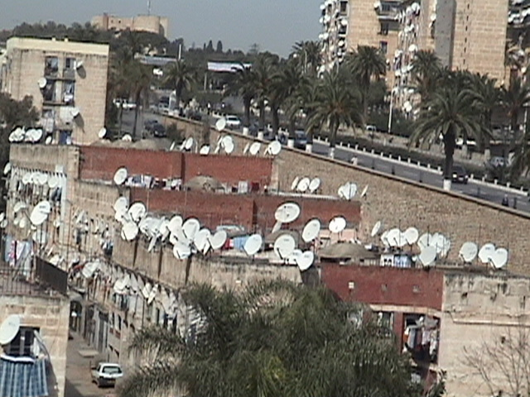
Satellites and Violations of Human Rights

Violations of human rights occur in many forms and are committed for many reasons. They could be carried out for security purposes or spreading propaganda against certain countries and identifiable groups of people. According to an American non-profit organization Council on Foreign Relations, “New technology (such as cell phones, social media, and satellite television) is also providing unprecedented opportunities to publicize abuse and organize protests, though repressive regimes are closely following with practices to censor new technology.” Timely, effective and extensive reporting of such violations might stop or avert abuses of human rights. It is believed that genocide in Rwanda could have been averted if the hate propaganda over the Radio-Television Libre des Milles Collines and activities of the Hutu extremists had been exposed over the Western television screens.

Satellites are being used, though to a limited extent, in violation of cultural rights of people (Art. 22 of UDHR). The most dramatic example of the negative impact of foreign satellite television on local cultural is that of Bhutan. This land-locked Himalayan Shangri-la it introduced television and the Internet in 1999. All of a sudden, its people were “bombarded” with about 50 satellite TV channels. In 2003, only four years after the introduction of foreign satellite television, the national newspaper, Kuensel, warned: “We are seeing for the first time broken families, school dropouts and other negative youth crimes. We are beginning to see crime associated with drug users all over the world - shoplifting, burglary and violence.” The Bhutanese accused “television of smothering their unique culture, of promoting a world that is incompatible with their own.”

Conclusion

Irrespective of fact that some countries (e.g. Iran) try to confiscate satellite dishes or to jam television signals, access to satellites for all sorts of communications, TV and radio broadcasts, social media, personal communications, the internet, etc. is increasing and will expand exponentially in the years to come. Satellites enable people in the exercise and enhancement of their human rights, particularly the freedom of expression.

