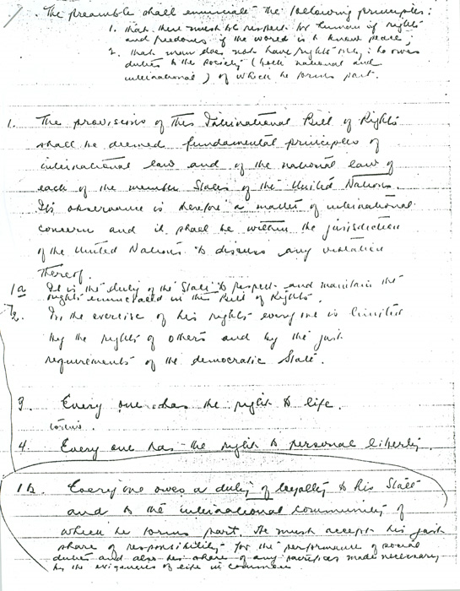

First draft of the Universal Declaration of Human Rights, handwritten by Professor John Humphrey (McGill University Archives)

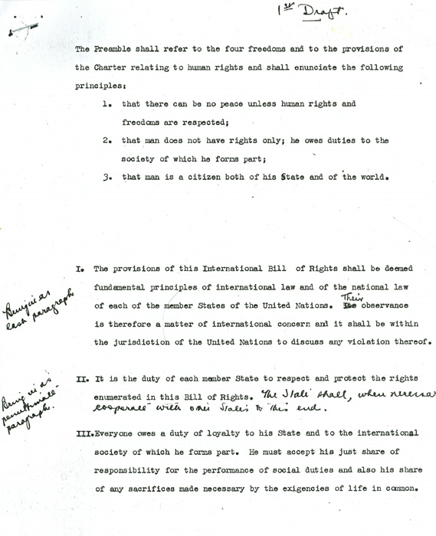

First typed draft of the Universal Declaration of Human Rights, with handwritten annotations by Professor John Humphrey (McGill University Archives)

