Resident Parking On-Call at the Glen Site

As stipulated in the Fédération des Médecins Résidents du Québec (FMRQ) Collective Agreement, parking is provided free-of-charge to residents who are on call. This document outlines the procedure to follow for parking during your on-call duty at the Glen Site. Please note that it varies based on whether or not you own a parking permit for your vehicle during daytime hours.
Access to the parking lot is directly in front of the Shriner’s (Block A) main entrance. It is clearly indicated with a red sign labeled “Emergency”. Please refer to the map and picture below for reference.

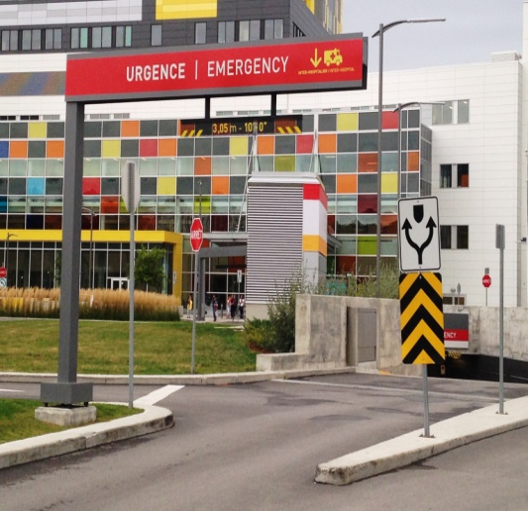
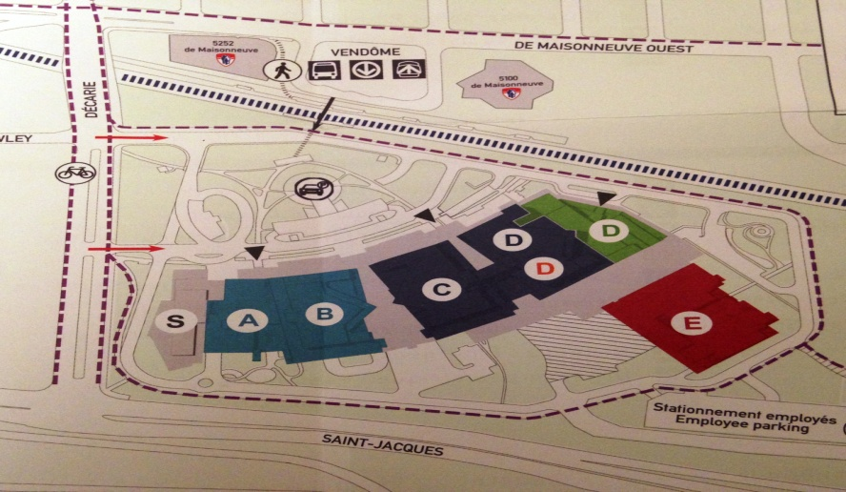

Once inside the underground parking lot, the space provided for resident parking is different for those who own a permit and those who do not.

If you have a parking permit for your vehicle
The location in which you park your vehicle will vary based on the length of time of your shift.
- For residents who will be using their parking space for a short period of time (i.e. to see one patient, perform a short surgery or procedure), there are 7 spots immediately adjacent to the emergency room doors.

They are labeled with the following sign:
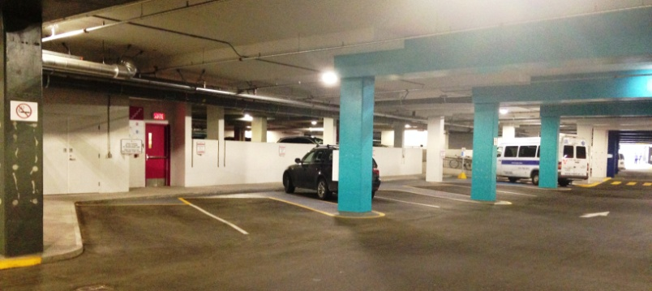
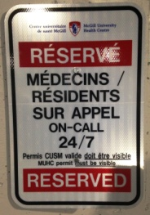

Please note, you may use these spots only if you will be in the hospital for a short period of time. You are responsible for ensuring you are parked in spots specifically reserved for doctors/residents and your permit must be visible at all times.
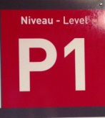
- In the event that you are coming for a lengthy shift (i.e. 8 pm to 8 am), you should park in the “P1” parking section which is identified by the following sign:

If you do not have a parking permit for your vehicle
You must park in the “P1” parking section only, which is identified by the sign shown above.
You will need to take a ticket to enter the section and pay for that ticket when you leave. To obtain a reimbursement, you will need to present to the parking office with your receipt and a copy of your schedule which confirms your call duty. The GLEN parking office is located at ARC 1000 or DRC 1000.
In the event that you replace a colleague who is ill, you can present documentation from your chief resident or teaching office that confirms you were on call. This can be an email or any other form of written proof.

Should there be any questions about parking regulations at the Glen, please feel free to send an email to the site chief of the hospital in question:
Royal Victoria Hospital: chief.rvh@arm-mcgill.ca
Montreal Children’s Hospital: chief.mch@arm-mcgill.ca
MUHC Parking: parking@muhc.mcgill.ca

