# Winter 2021

**GEOG 496: Regional Geographical Excursion, Barbados (3cr).**

*Reading Week:* *Feb 26 – Mar 7*

Want to find out more?

**Check the Geography Website**

…or Contact Prof Meredith: **tom.meredith@mcgill.ca**

**with “Barbados” in the subject line**.

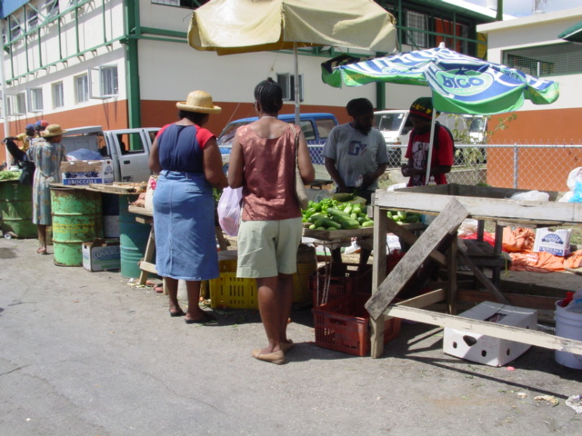

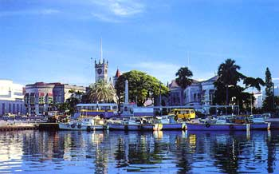

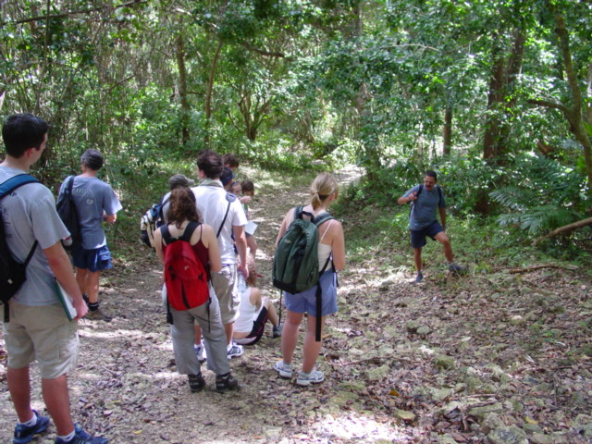

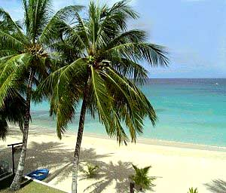

Thinking about a field course for

winter 2021?

Plan ahead…

Earn credit while integrating human and physical geography in BARBADOS!