Important Principles of Effective Feedback
Let’s consider feedback with three important ideas in mind – the content, the process, and building an educational alliance. These three ideas are interconnected, and all require attention.
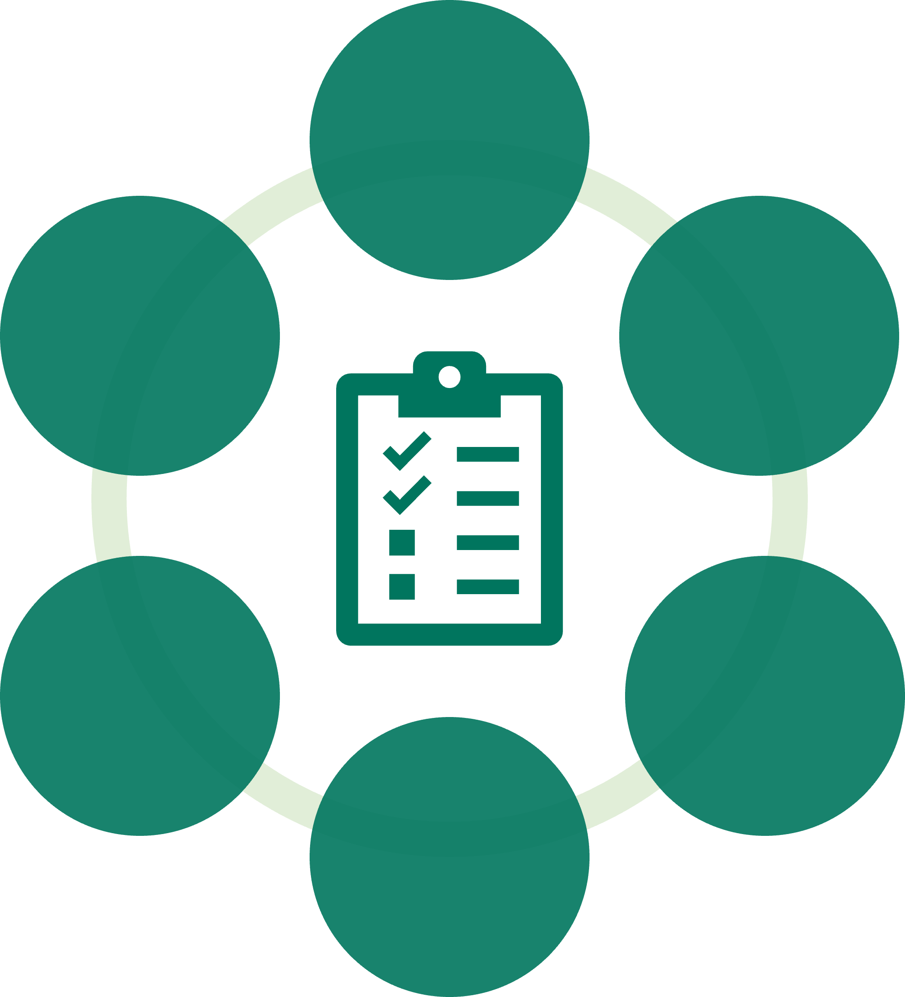
The content of a feedback discussion is represented in the image above by a clipboard and refers to what is being communicated.
The process, represented by the circle, is the framework within which the content is communicated to the learner.
An educational alliance is the relationship or connection between the teacher and learner that supports the feedback dialogue.
Below we will examine each in turn.
Educational Alliance:
What do we mean by an educational alliance?
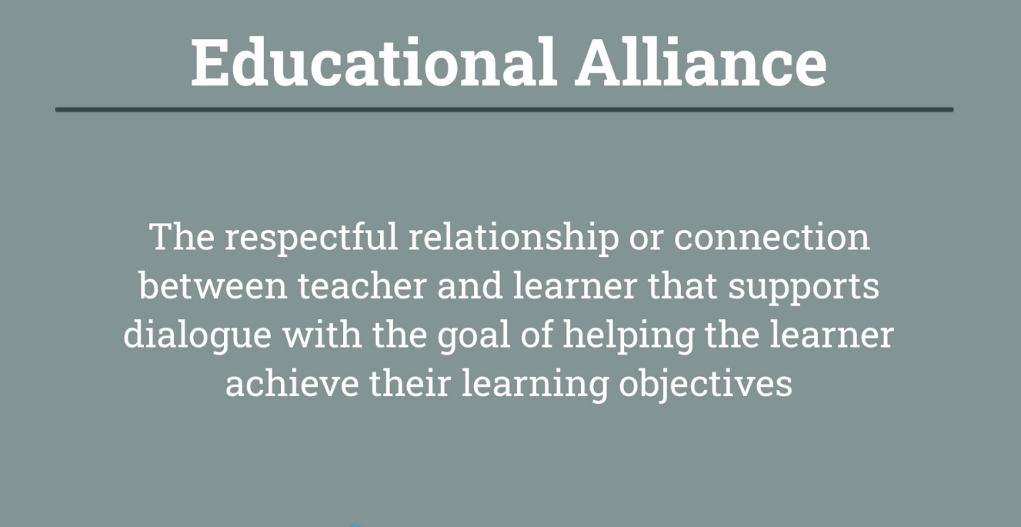
Relationship building is important to good teaching because feedback depends on the learning relationship. For feedback to be really heard, the learner must see that the teacher cares about them and their growth. Having a strong educational alliance therefore directly affects feedback validity and uptake.
An educational alliance is the foundation upon which feedback dialogues happen and strong educational alliances improve the incorporation of feedback into practice.
Content
What do we give feedback on?
As a teacher, you carefully choose content each time you teach. There are many things you could discuss, but you make decisions on the content you are sharing based on your learning objectives and the needs of the students. The same goes for content in feedback. This content comes from the observations you have made of your learner's performance and the preliminary educational assessment you make from this data.
Here is one model that can be used to help you consider the content of your feedback.
SOAP Model
Process
What are key elements in the process of giving feedback?
Feedback should be timely, honest, given without judgment in a safe space. It should invite self-reflection and consider the emotional impact on the learner.
Review the following document to learn more about the anatomy of a feedback session.
Anatomy of a feedback session

