McGill Staff, faculty, TA's, post-doctoral students and Casual staff have a staff email account: xxx.xxx@mcgill.ca Alumni and Students have a student account: xxx.xxx@mail.mcgill.ca
In some cases, you hold dual status "Staff & Student".

The way you can check this is go into Minerva:
Personal menu,
Password for McGill username.
If you see both a @mcgill.ca and @mail.mcgill.ca you have dual status.
If you cannot login to one of the accounts, you will need to reset the password to sync the password to both accounts.
IT has some suggestions:
You will be able to access your staff emails from the outlook web access: https://exchange.mcgill.ca,
Student access email from the exchange online system: www.outlook.com/mcgill.ca

1. Make sure you are using the correct username Log on using your McGill Username and McGill. What is my McGill Username and how do I change my McGill Password?
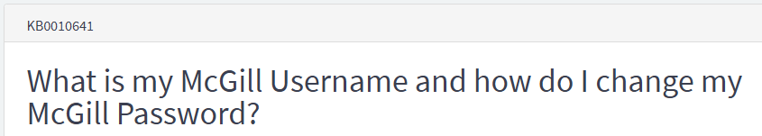
https://mcgill.service-now.com/itportal?id=kb_article_view&sysparm_article=KB0010641

2. Test your login at different sites,
Go to https://www.mcgill.ca/minerva and https://mymcgill.mcgill.ca

3. Reset the password
Go to Personal menu in Minerva > Password for McGill username. Make sure the new password is minimum 8 characters, alphanumeric and no space.
If you change the password. Please take a minute and review the Password Reset Checklist to ensure that all your devices are updated with your new password:
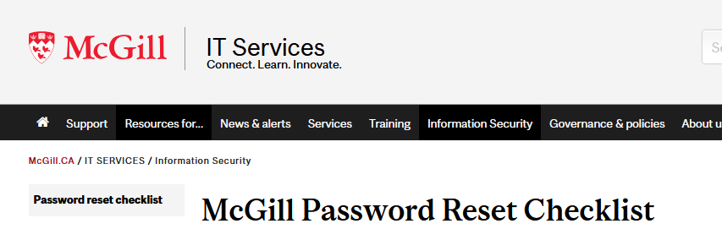
https://www.mcgill.ca/it/information-security/pw-reset

4. If you want to setup your emails in any mail client the directions can be found here. Josee Sansoucy, Secretary writes: It was hard for me to find updated links. You may also refer also to “additional information on point 4”. My findings on AI
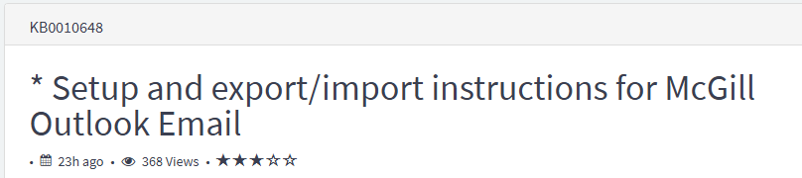
https://mcgill.service-now.com/itportal?id=kb_article_view&sysparm_article=KB0010648#general
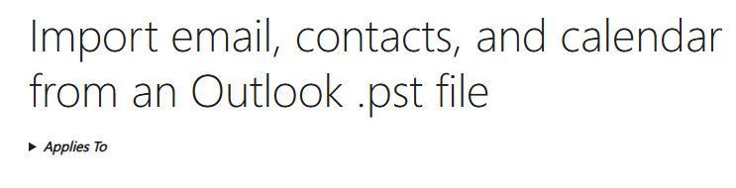
https://support.microsoft.com/en-us/office/import-email-contacts-and-calendar-from-an-outlook-pst-file-431a8e9a-f99f-4d5f-ae48-ded54b3440ac?ui=en-US&rs=en-US&ad=US

5. If you want all your student emails to deliver to his staff address you can create an outlook forwarding rule to forward any emails sent to your McGill account any email account he chose. To create an outlook rule in outlook web access “OWA” to forward all messages to any email account. “Hotmail, Gmail, Yahoo, another McGill account ETC”
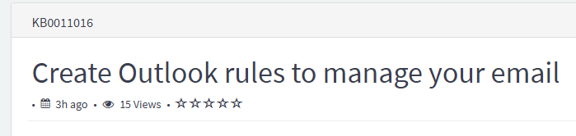
https://mcgill.service-now.com/itportal?id=kb_article_view&sys_kb_id=523f266e97508e54538d7da71153aff4&table=kb_knowledge&searchTerm=KB0011016

Any questions or IT related issue please contact IT service desk.
ITSupport@mcgill.ca
514-398-3398
Walk-in service is available weekdays from 9:00 am to 5:00 pm. No appointment is needed.
688 Sherbrooke West, Room 285

Additional information on point 4 above. If you want to setup your emails in any mail client, the directions from AI here:
To set up email in a mail client, you will generally need your email address and password, as well as the incoming and outgoing mail server information from your email provider
. While many modern clients can auto-detect settings, manual setup is sometimes necessary.
Gather your email server information
The first step is to get the specific server settings for your email account from your provider.
  - Log in to your provider's website or portal. The required information is often found in the account settings, email management, or technical support section.
  - Locate the manual setup settings. Search for keywords like "manual settings," "server settings," or "connect devices" to find the necessary details.
Key settings you will need
  - Username: Your full email address (e.g., yourname@example.com).
  - Password: The password for your email account.
  - Account type: You will choose between IMAP or POP3.
    - IMAP (recommended): Keeps emails on the server, allowing you to access and sync them across multiple devices.
    - POP3: Downloads and stores emails directly on your device. This is not ideal for checking email on multiple devices, as emails may not sync.
  - Incoming mail server: The server address for receiving emails. For example, mail.yourdomain.com or imap.gmail.com.
  - Incoming port: The port number used by your incoming mail server.
    - IMAP with SSL/TLS: Usually 993.
    - POP3 with SSL/TLS: Usually 995.
  - Outgoing (SMTP) mail server: The server address for sending emails.
  - Outgoing port (SMTP): The port number for sending emails, which requires authentication.
    - Most providers use 587 with SSL/TLS, but some use 465.
  - Outgoing server authentication: This must be enabled and typically uses the same credentials as your incoming server.
  - SSL/TLS: These security options must be enabled for both incoming and outgoing servers.
General setup steps in your email client
  - Open your mail client and go to the settings or preferences menu.
  - Select "Add Account" or the equivalent option.
  - Choose "Manual setup" or "Other account" when prompted.
  - Enter your email address and select your account type (IMAP is recommended).
  - Enter the incoming mail server settings (host name, port, and security type) that you found from your provider.
  - Enter the outgoing mail server settings (SMTP host name, port, and security type).
  - Confirm that the outgoing server requires authentication and is set to use the same credentials as your incoming server.

