NSERC Collaborative Research and Training Experience in Environmental Innovation (CREATE-EI)
About the program
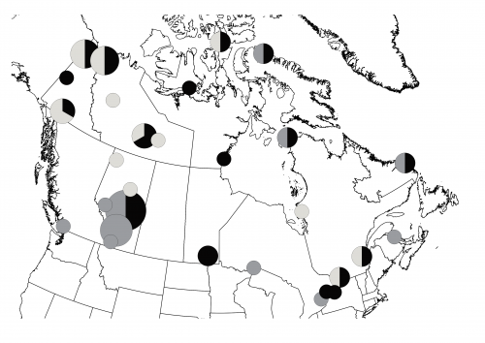
This graduate research and training program, with nodes at McGill University and the University of Alberta, aims at providing graduate training in innovative environmental assessment, monitoring and management for the next generation of natural resource consultants, managers, landuse planners, and policy makers to enhance Canada's competitive position and reputation as a country that efficiently develops its natural resources, while maintaining rigorous environmental standards and maximizing community engagement and benefits. CREATE-EI graduates conduct thesis-based research in environmental sciences (including conservation, wildlife management, aquatic ecology, terrestrial ecology, forestry, biodiversity, environmental contaminants), but their training is enhanced by coursework and internship experience with industry, government, ENGOs, and/or aboriginal organizations. An extensive list of collaborators involved for their commitment to and performance in improving environmental assessment, monitoring, and management, as well as their longstanding collaboration with co-researchers contribute to course design and delivery, internships, and advisory committees. CREATE-EI graduate students receive scholarship and stipend support throughout their program and are financially supported for expenses related to their internship and research work.
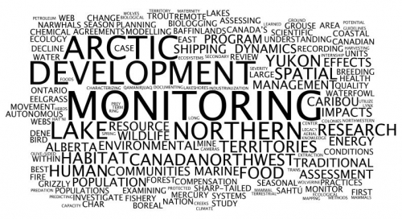
The left figure represents the word frequency of trainees' thesis and internship project titles and the right figure the geographic locations of collaborators, internship host organizations, and field activities (pie charts are sized by the number of organizations (ranging from 1 to 8) and show the proportion of governmental organizations (black), private organizations (dark grey), and aboriginal organizations (light grey).

About the internships
CREAT-EI student expectations include conducting at least two internships with two different host organization types (i.e., private sector, government, ENGOs, or indigenous organization). Typically, each internship will be two months in duration, but the amount of time spent in-house with the host organization may be less and may involve some remote work. Internship projects are short-term opportunities for graduate trainees to get familiarized with the working environment of the host organization and to develop core professional skills, while achieving specific short-term objectives and providing deliverables identified by the host organization.

How to proceed
To help better define and agree on the terms of an internship project, any host organizations willing to offer internship opportunities to our trainees should complete the first part of this template. Already identified host-student-supervisor match should complete the full template. Please return the completed template to:
manuelle.landry-cuerrier@mcgill.ca.

INTERNSHIP HOST

Organization Name:

Organization Department/Sector/Division/Branch:

Organization Location:

Organization Contact (student mentor):

INTERNSHIP PROJECT

Title:

Background Information:

Project Description:

Responsibilities and Specific Tasks:

Minimum Experience, Knowledge, Skills, and Abilities:

Expectations and Deliverables:

Preferred Timeline (including minimum time spent in the work place):

Work Space Availability:

Suggestions regarding local accommodation:

Field Work and Travel Requirement:

Funding Requirement and Availability:

CREATE-EI Academic Supervisor

I, the undersigned, confirm that I have read and understood the above internship description and agree to act in accordance with all terms and conditions therein.

NAME: [FULL NAME AND TITLE]

DEPARTMENT:

SIGNATURE:

DATE:

CREATE-EI Intern

I, the undersigned, confirm that I have read and understood the above internship description and agree to act in accordance with all terms and conditions therein.

NAME: [FULL NAME AND TITLE]

DEPARTMENT:

SIGNATURE:

DATE:

Host Organization Student Mentor

I, the undersigned, confirm that I have read and understood the above internship description and agree to act in accordance with all terms and conditions therein.

NAME: [FULL NAME AND TITLE]

ORGANIZATION/
DEPARTMENT:

SIGNATURE:

DATE:

