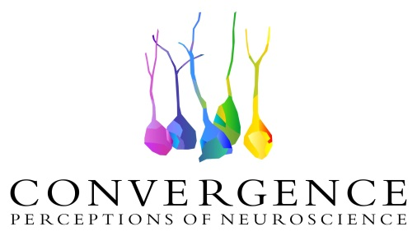
Public lecture: Sensory
As part of Convergence, Perceptions of Neuroscience
February 17th 2017
The Brain Repair and Integrative Neuroscience (BRaIN) Program that includes researchers from the Research Institute of the McGill University Health Centre (RI-MUHC) and the Montreal Neurological Institute (MNI) is proud to support Convergence, Perceptions of Neuroscience. This initiative brings together 17 neuroscience trainees from the BRaIN Program and 28 students from the Concordia University Faculty of Fine Arts to create works of art inspired by the trainees’ research projects. Two major events are planned for Spring 2017: an exhibit at the Visual Voice Gallery (April 22nd to May 20th) and a public outreach event as part of the annual meeting of the Canadian Association for Neuroscience (CAN) at la Grande Bibliothèque (BaNQ) and the Hotel Bonaventure (May 28-31 2017).
Join our participants for our next public lecture sponsored by the BRaIN Program. Our speakers will show to the audience how the peripheral nervous system is connecting us to the environment through our senses: vision, smell, audition, touch and taste… and how these senses are exacerbated in some animals.
Where: Montreal General Hospital, 1650 Cedar Av, at the Lounge (L6 500)
When: February 17, 3 to 4 PM
Presenters: Mr Hunter Shaw and Mr Stephen Beukema (Ph.D. candidates)
To learn more about the Convergence initiative, please visit our website http://www.convergenceinitiative.org/
Or write to info@convergenceinitiative.org

