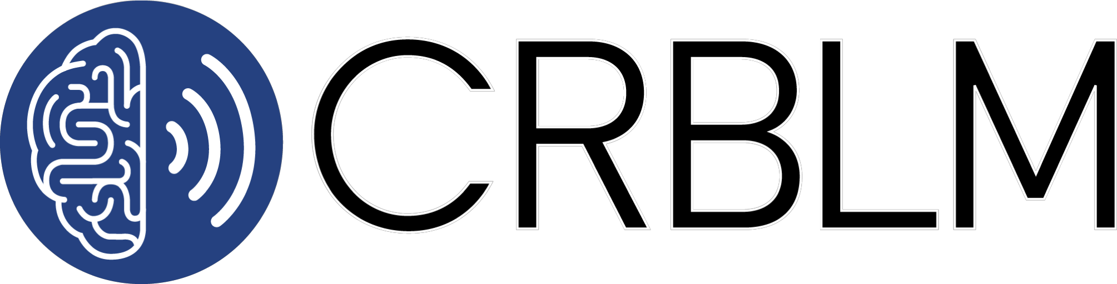
Research Incubator Award Application Form

Research Incubator Awards (RIA) provide seed funding to CRBLM faculty for interdisciplinary projects of exceptional innovation and broad significance to the field. This support is intended to provide a basis for innovative project development and pilot research ultimately leading to external funding for the ongoing collaborative work.

Objectives:
- To support intersectoral, multicenter (university) and multidisciplinary pilot projects in domains of language and music development, neuroscience, performance, function and dysfunction.
- To promote excellence in basic and applied research in those areas covered by our mandate.
- To encourage the formation of working groups developing projects which make a potential long-term significant contribution to our research mission, and with a high potential for attracting external funding.

Eligibility:
- Research Incubator Awards are given to teams consisting of a principal investigator plus two to four co-applicants (i.e., teams of 3 to 5 researchers)
- The principal investigator must be a regular member of the CRBLM.
- The project must involve at least one other regular CRBLM member; it may also involve other investigators who are collaborating members or non-members. The team may also include post-doctoral fellows and research students, but they will not be treated as applicants.
- CRBLM members may submit a maximum of one application as a principal investigator. However, they are permitted to apply as a co-investigator on other projects, provided the research objectives and team members are different.
Evaluation Criteria:
- Likelihood of development into a project that would attract external support.
- Quality of proposal: hypothesis, methodology, population, analysis, budget justification.
- The degree of innovation and impact of the project.
- The scope and novelty of the interdisciplinary collaboration.
- Feasibility of the research project.
- Proposals that include a clear and justified collaboration with industry or other organizations (such as a school board or community association) are encouraged.
Amount:
- A maximum of $10,000 is available per project. Please note that the award must be spent within 12 months, and that teams may be required to submit a very brief report at the end of that time.

Application:
- Complete this application form and send it back to info@crblm.ca. Note that you can type in or copy and paste text into the shaded form field. Applications are due May 15 of each year. The form may be completed in English or in French.

Project Title

Project Team
- List of faculty applicants including affiliation and role (ie., PI, co-PI, co-applicant).

- List of postdoctoral fellows involved in the project, including affiliation and role.

- List of graduate students involved in the project, including affiliation, role and academic status/year.

Summary
- Summary of the project (written for a general audience). The summary of successful projects may be publicized by the Centre (1⁄2 page maximum).

Project Description
- Description of the project including hypothesis, methodology, population, statistics and expected outcome (2 pages maximum).

Budget:
Include a maximum 1-page budget justification including the total budget requested and a clear and detailed description of budget items, including amounts.

