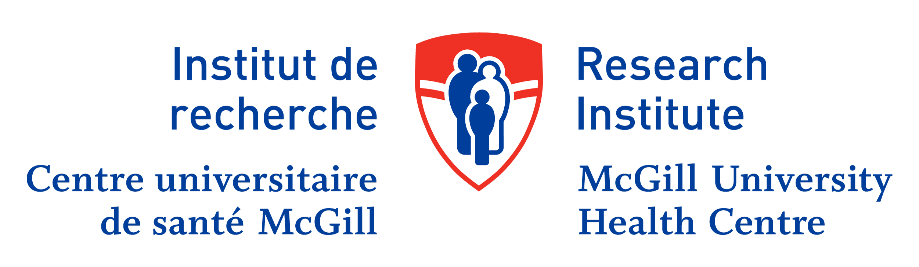

Centre for Outcomes Research and Evaluation Weekly Seminar

April 19th, 2018
Noon – 1:00 PM

Dr. Daksha Shah
City TB officer
Municipal corporation of Greater Mumbai
Deputy Executive health officer
Full bright Scholar US.
Public health Policy and management NCD Tulane University.

Is it really possible to END TB by 2030?

The presentation discusses magnitude challenges strategies and issues of TB control in a large metro city revealing some realities of field and motivates to think what can be done to address the issue.

Where:

5252 boul. de Maisonneuve, 3rd Floor
Conference Room 3D.01

Discussions and interactions with the speaker will be hold in the kitchen next to the conference room after the presentation.

Light refreshments will be served before the presentation.

This presentation will also be live streamed and available on YouTube.
Please use the link in the email invitation.

