18 Jan 2016

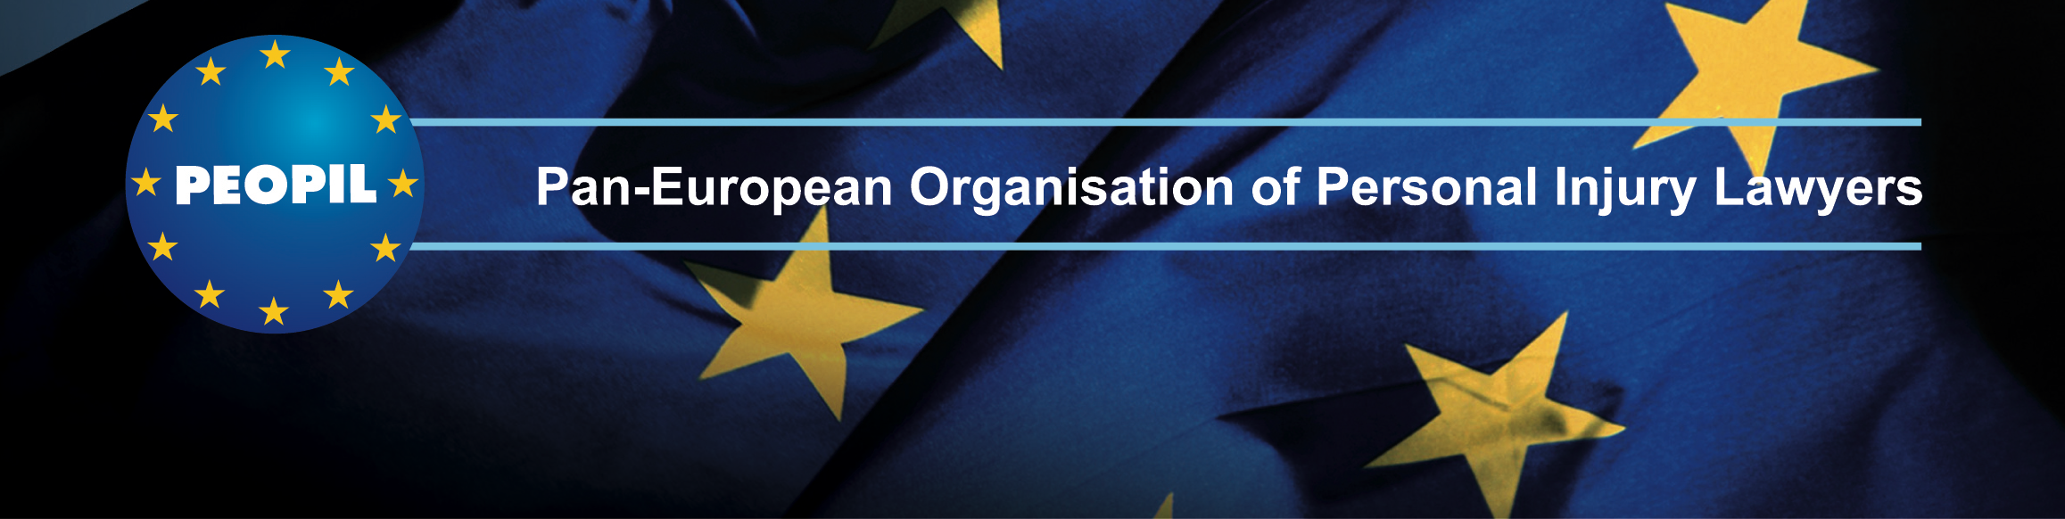

Ninth Annual
McGill University/PEOPIL
CONFERENCE ON INTERNATIONAL AVIATION LAW & INSURANCE
at
The Hub - Edinburgh's Festival Centre
Castlehill
Edinburgh, Scotland
20 May, 2016
Organized by
The McGill University Institute of Air & Space Law
&
PEOPIL (Pan-European Organisation of Personal Injury Lawyers)

This event brings together World-Leading aviation liability and insurance experts to address the following topics:
- Recent Developments in Aviation Liability and Insurance
- Comparative Jurisprudence under the Warsaw System and the Montreal Convention of 1999
- Jurisdiction & Forum Non Conveniens
- Liability of Airlines, Airports, Lessors, Manufacturers, Maintenance Providers & ANSPs
- Challenges of Settlement

FRIDAY – 20 MAY 2016
PROGRAM
& DINNER
Location:
The Hub - Edinburgh's Festival Centre
Castlehill, Edinburgh

8:00 – 9:00
REGISTRATION

9:00 – 10:15
Air Carrier Liability
- Recent Warsaw and Montreal Convention Interpretations
- Recoverable Damages
- Conflicts Between U.S. and European Courts
- The Challenges of Achieving Global Uniformity
- A Comparative Analysis of “Thorny” Issues under the Montreal Convention, including:
  - Liability for Pre-Impact Fright in a Death Case
  - If there is no Article 33 Jurisdiction of the Passenger’s Claim against the Airline, will the Manufacturer’s Contribution Claim against the Airline also be barred by Article 33?
  - Airline Liability for Injuries to Passengers Resulting from the Actions of Other Passengers.
  - Comparative Fault and Multiple Defendants

Chair: Alan Reitzfeld – Holland & Knight, New York, USA
Speakers:
Simon Balls – Kennedys, London, UK
Robert F. Hedrick - Aviation Law Group PS, Seattle, USA
Anna Masutti - Lexjus Sinacta, Milan - Bologna, Italy
Joseph Wheeler - International Aerospace Law & Policy Group and Maurice Blackburn Lawyers, Brisbane, Australia

Refreshment Break

10:45 – 12:00

Jurisdiction & Venue
- Which forum is best for the plaintiffs/defendants?
- How to pick and choose among the venues of carriers, manufacturers, and others?
- Is the fifth jurisdiction of the Montreal Convention being used more often?
- Forum Non Conveniens –West Caribbean Airways & Bashkirian case updates
- What are the recent developments in forum non conveniens, and when does it work well, or work poorly?

Chair: Prof. Anna Konert – Lazarski University, and K&K Aviation Lawyers, Warsaw, Poland
Speakers:
Sophie Cochery – HMN & Partners, Paris, France
Stratis Georgilas – G-H Chambers, Athens, Greece
Rob Lawson QC – Quadrant Chambers, London, UK
Laura M. Safran QC - DLA Piper, Calgary, Canada

12:00 – 13:00
Lunch

13:00 – 14:00
Products Liability
- Recoverable Damages
- The Conflict Between North American and European Courts
- TCAS, Autopilot and Automation
- Will we see more use of the Hague Convention on Products Liability?
- Is there Liability Exposure for Foul Cabin Air and Radiation?

Chair: Heather C. Devine – Gowling Lafleur Henderson LLP, Hamilton, Canada
Speakers:
Jean-Michel Fobe – Sybarius Advocats, Brussels, Belgium
Michael Scoville - Perkins Coie LLP, Seattle, USA
Philip Shepherd QC – XXIV Barristers’ Chambers, London, UK
Éric Vallières - McMillan LLP, Montreal, Canada

14:00 – 15:00
Liability of Airports, ANSPs, Lessors and Maintenance Providers

• Latest and forecasted developments in the air navigation services (such as RPAS, remote towers and virtual infrastructures) and their impact on the liability of service providers
• The national liability regime (including case law) applicable to airport operators - a national perspective: Swiss law, and selected other European countries
• The performance of national public law tasks by airport operators
• The application of the national liability legislation to airport operators
• The contractual liability of the airport operator:
- vis-à-vis the public authority, as the airport land owner who granted the airport operator the concession contract (whether operated by a public or a private operator, the airport always remains a public asset that requires public service/general interest obligations)
- vis-à-vis its various contractual counterparts (including airlines, groundhandlers, retailers, security and safety providers, etc.)
• The lessor and manufacturer liability, latest developments

Chair: Axelle Cartier - Joint Aviation Authorities-Training Organisation (JAA-TO), Hoofddorp, The Netherlands
Speakers:
Isabelle Lelieur – VINCI Airports, Paris, France
Prof. Francis Schubert – Skyguide, Genève, Switzerland
Dr. Julien Subilia - AVIALEGAL, counsel, attorney-at-law, Lausanne, Switzerland

15:00 – 15:30
REFRESHMENT BREAK

15:30 – 17:00
Difficulties of Settlement & Emerging Insurance Issues
- The Challenges of State Liability: A look at KAL 007, Lockerbie, the September 11, 2001 U.S. terror attacks, MH 17 and Cuban Brothers to the Rescue
- Insurance for Acts of Terrorism and Conflict Zones
- A look at MH 370
- Difficulties Imposed by Sanctions and International Trade Controls
- The new Model AVN 1D
- Insuring UAVs (Unmanned Aerial Vehicles, or RPAS, Remotely Piloted Aircraft Systems)
- Cyber Security Issues

Chair: Kinga Kolasa-Sokołowska – THB Polska, Warsaw, Poland
Panelists:
Mitch Baumeister - Baumeister & Samuels, P.C., New York, USA
Qian Chen –Jingtian Law Firm, Shenzhen, China
Andrew Harakas - Clyde & Co, New York, USA
Russell M. Mirabile -XL Catlin, New York, USA
Richard A. Powell – AIG, London, UK

18:00 – 19:30 Gala Dinner

PEOPIL & McGill Aviation Conference

REGISTRATION FORM

Pan-European Organisation of Personal Injury Lawyers

&

McGill University Institute and Centre for Air & Space Law

CONFERENCE ON INTERNATIONAL AVIATION LAW & INSURANCE

Edinburgh, Scotland

19-20 May 2016

Name _________________________________________________________

Firm: _________________________________________________________
Address: _________________________________________________________

Email: _________________________________________________________

REGISTRATION FEE
INCLUSIVE OF: one day seminar, lunch and coffee breaks, and a Gala Dinner.

 | Total  Number |  | Total  Amount
DELEGATE RATE* |  | @ £440
Early Registration Rate (before March 1)* |  | @ £350
Speakers* |  | @ £365
Students, government, academics, and PEOPIL Young Lawyers Section members |  | @ £145

* Members of PEOPIL, the European Aviation Club, and graduates of McGill University enjoy a £40 discount off of these rate categories.

PAYMENT METHODS:
Payment by Credit/Debit Card
I wish to pay by MasterCard or Visa (WE DO NOT ACCEPT ANY OTHER CREDIT CARDS)
I wish to debit my account with the amount of £ ______
Card No: ______________________________________________
Expiry date:___________________
3 digit Security Code (on the back of the card) _______________
Name as on card:_________________________________________
Cardholder's address:______________________________________
Country _____________________________________________
Date & Signature:____________________________________________
By bank transfer:
I attach proof of payment by bank transfer to PEOPIL (at no charge to the organisers)
Account No 0101 5883
LLOYDS BANK, OLD MARKET SQUARE, NOTTINGHAM NG1 6FD, ENGLAND, UK
Account Beneficiary: PEOPIL
Sort Code 30-96-18
BIC LOYDGB21069
IBAN GB 09 LOYD 3096 1801 0158 83
Payment by Cheque I enclose a cheque for £ ___________

PLEASE RETURN FORM TO:
PEOPIL, Imperial House, 31 Temple Street,
Birmingham B2 5DB, England, UK
Fax: +44 (0)121 6439405
Terms and conditions:
This booking form constitutes a legally binding document.
McGill and PEOPIL reserve the right to vary or cancel the seminar where the occasion necessitates. McGill and PEOPIL accept no liability if, for whatever reason, the conference does not take place. Cancellations will be acceptable in writing and a charge to cover administration will be made as follows:- over 21 days 15%, 14-20 days 50%, 13 days or less 100%.
Transfers to another person will be acceptable in writing and a charge of 15% of the fee to cover administration costs will be applied.

Date and Sign:___________________________________________________________________

PLEASE NOTE: Accommodation is not included in this package and McGill/PEOPIL are not responsible for hotel reservations. You may book a room directly with one of the Conference Hotels.
HotelMap for PEOPIL & McGill University Aviation Conference:
https://www.HotelMap.com/pro/MMB3U

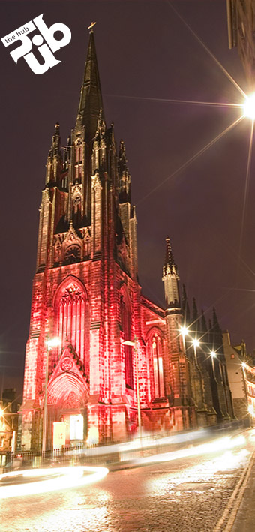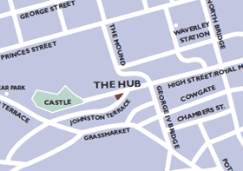

Bronze Level Sponsor:
