McGill Organizational Chart

With the “McGill Organization Chart” application, senior management can get an instant snapshot of an area or of the entire university. Staff with proper authorization can view details of their own record and anyone reporting directly and indirectly to them.

This application uses Banner HRIS and Lenel data to obtain accurate standard org charts which include a variety of information on the employee in the Administrative and Support, Academic and Trades and Services groups. It will not include casuals and academic students.

The data is always based on the latest refresh of the Banner Data Warehouse.

 | The Organizational Chart application is run on another system than Minerva, but you must log into Minerva first. The application will only work with Microsoft Explorer, so be sure to select that browser.  The Organization Chart application is sometimes referred to as Nakisa, which is the name of the company from which McGill purchased this software.

1.0 Logging in
- Go to the Minerva for Faculty and Staff website at www.mcgill.ca/minerva-faculty-staff

- Click on the Login to Minerva key icon, and log in as usual, using your McGill ID and PIN.

- In the MAIN Menu, click on “Nakisa – Organization Chart System” (this will take you to another page)

- Click on “External Link to McGill Organization Chart” (this will launch a new browser window).

- Click on the “OrgChart” button (top of left side bar) to start. You will be presented with this screen:

_
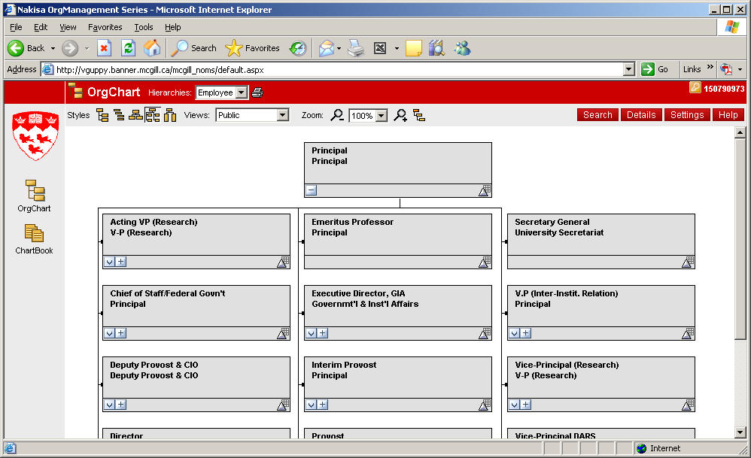
_
Screenshot 1: when you first open the OrgChart

Once you are in, notice the top navigation bar, where you will see 3 gray buttons: “Styles”, “Views”, and “Zoom”. This will allow you to customize the information you’re seeing, and its layout.

2.0 Changing the view

By default, the OrgChart will display the “Public” view. The Public view only provides only job titles and department name.

To change views, click on “Views” at the top. Depending on your security access, you can set it to “University” or to “Self and Below”. The highest security view is “University”, which provides complete information on the person’s job (pictures are extra). The “Self and Below” view limits the data to the user’s job and to those reporting directly and indirectly to the user.
_
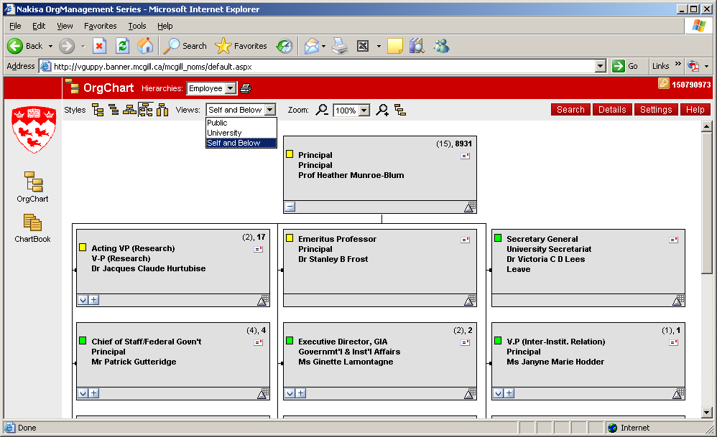
_
Screenshot 2: The self and below view

3.0 Styles and Zoom

Notice the two other buttons at the top: “Styles” and “Zoom”. These allow you to display and sort the org charts in various ways, depending on what you prefer.

Styles allows alternative chart layouts for viewing and printing.

Zoom offers you additional OrgChart views:
• Reset Chart view to root (top) view
• Zoom in or out on the chart

 | Settings  When you close the Org Chart application, it will remember your selected display settings.

4.0 To find a person

To locate a particular person’s listing, click on the red button in the top right frame of the OrgChart window to access the Search Panel box. Select a search criteria from the first dropdown menu and a Filter from the second dropdown. Enter a name or partial name into the open text field and click on the “Go” button.

Once the search is completed, the result(s) will be displayed in an Employee box underneath. Search results will appear alphabetically according to the search criteria entered, but you can sort these results by name or by position title by clicking on the title bars. If your search has multiple pages, click on the arrows next to the page number listing.

Notice that different types of employees are identified by small coloured flags to help you distinguish different people more easily.

Legend of Employee Types in the McGill OrgChart

Yellow square – Academic
Blue square – Trades
Green square – Admin & Support

4.1 Place in Org chart

Click on the employee row in the Employee box.
_
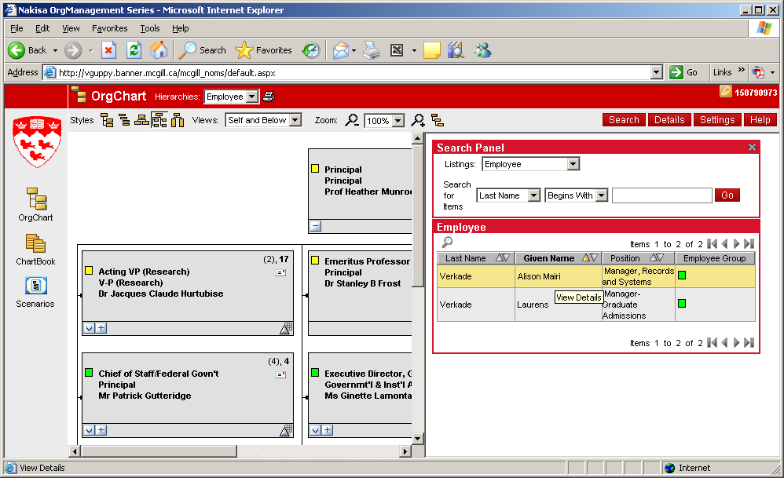
_

To locate the employee on the org chart click on “View in OrgChart” under Details. This will call up a chart showing the employee and everyone reporting to them.
_
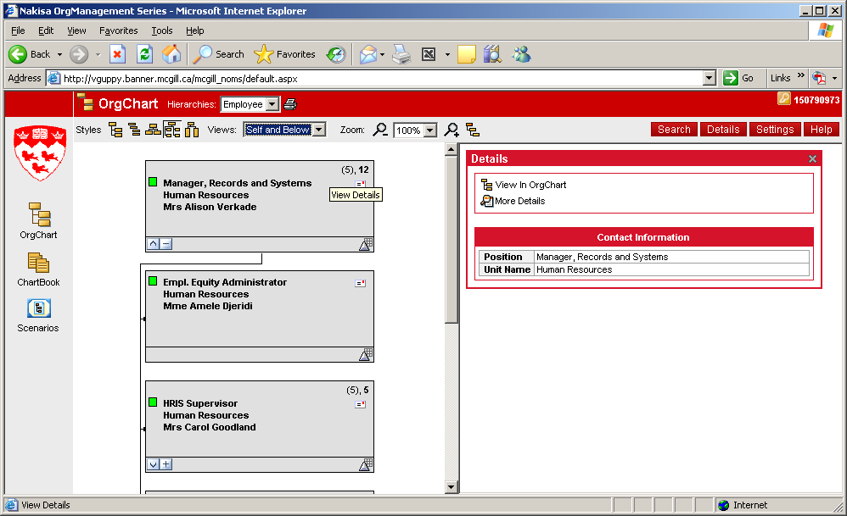
_

Each employee in the chart is displayed with title, department and name. The value in brackets in the upper right of each card indicates how many person report directly to this person, and the one in bold indicate how many report in total (directly and indirectly).

4.1.1 Expanding and closing views in the Org chart

The Expand/Close buttons on the Org Chart identify individuals who have personnel reporting to them. Clicking on the buttons allows you to expand or close the view of the selected individual with or without those direct reports. Click on to expand the view and on to close the view.

The Root Chart buttons allows you to view the selected individual with or without their supervisor. Click on the Up arrow to view the individual with supervisor and on the Down arrow to view the individual without supervisor. To view their details in the right frame, click on an individual's name in the OrgChart node.

 | Got lost?  If you don’t know exactly where you are anymore, simply click on the Root button. This will return OrgChart to the default view.

4.2 Person’s details

When you click on the name of the person in the chart, the application will call up an index card (see example below) with detailed information on the person divided up in two sections.
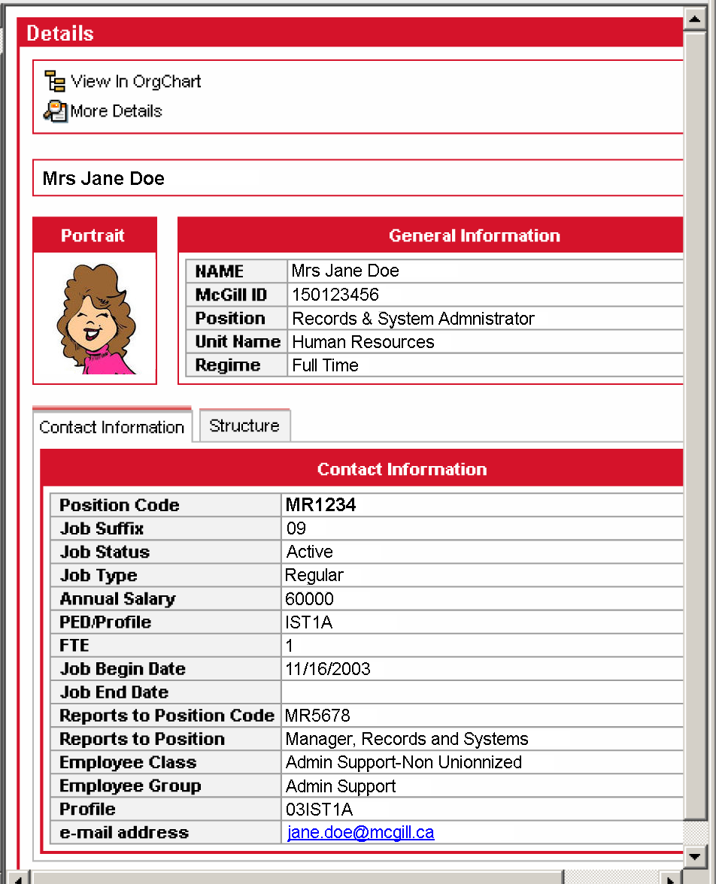

These two sections are “General Information” and “Contract Information” which list all available information for the selected employee.

Structure shows the selected employee's supervisor and peers.

5.0 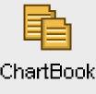ChartBook - printing

5.1 Accessing the printing
Click on the ChartBook icon on the top left corner. This will bring up the “ChartBook Menu” screen to generate the ChartBook.
_
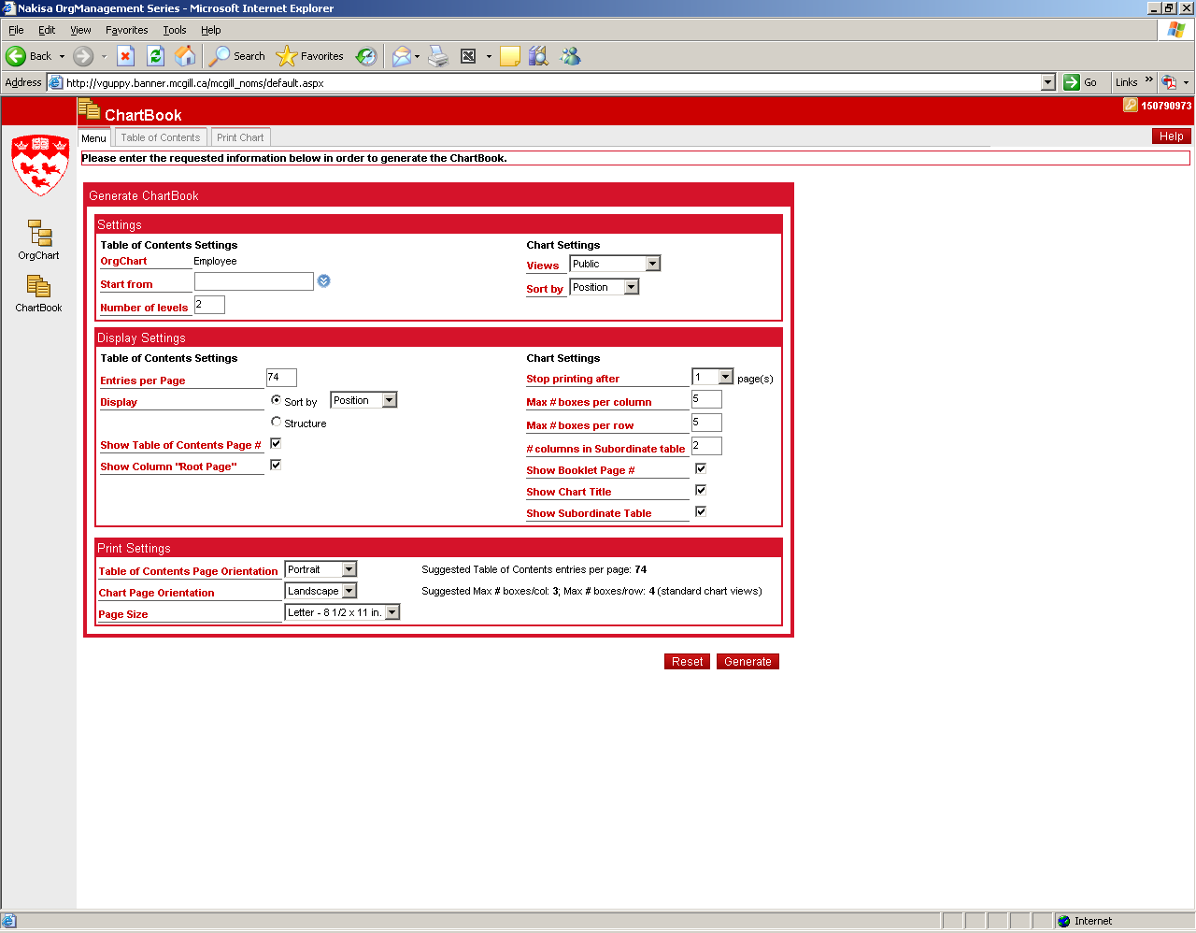
_
Fill out the appropriate fields under:

- Settings: For example, the “Start from”. Search for the person you want to start printing the org chart from.
- Display Settings:
- Print Settings: eg. Set “Table of Contents Page Orientation” to Portrait and “Chart Page Orientation” to Portrait.
- Click on the  button on the bottom right corner.

This will bring up the org chart to be printed. If you want to modify the settings you can switch back to the “Generate ChartBook settings screen” by clicking on the  button on the top left hand side. Make any necessary changes and click on the button again.

_
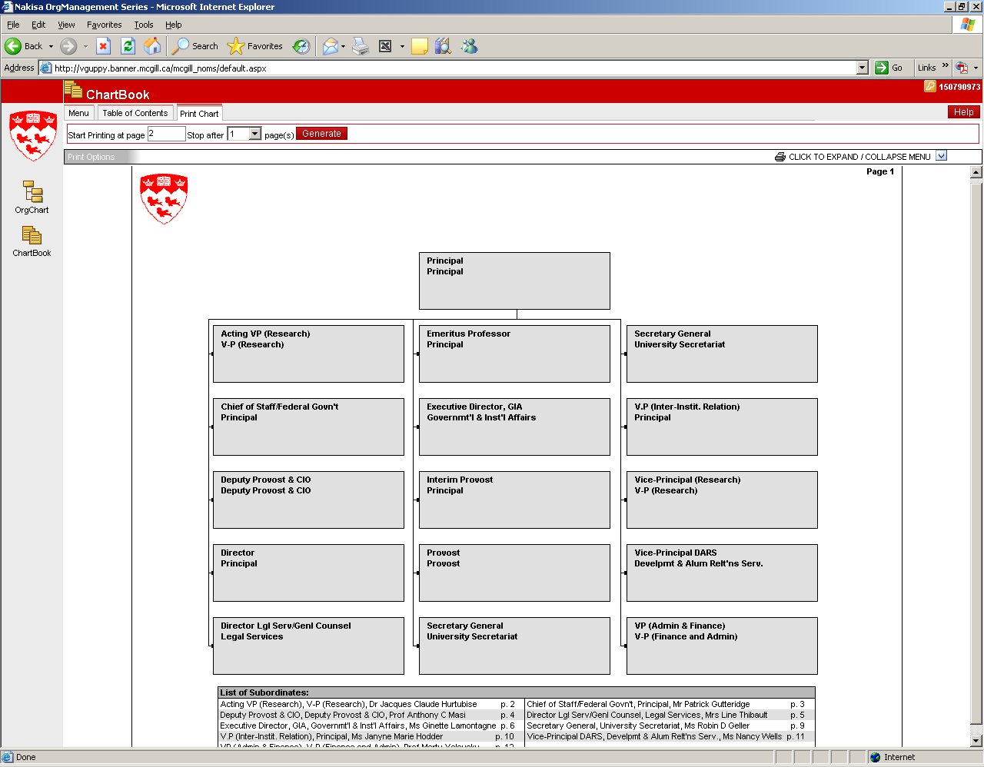
_

- Ready to Print: Click on the  button or the to expand the screen. A browser window will pop up to allow you to preview the document. You can at this point add a note by typing into the Add Note box and clicking on the Add Note button. The note will appear on the document: you can reposition it by dragging it with your mouse. If the report doesn’t fit on the page, you can change paper formats or force the image to fit the page.

_
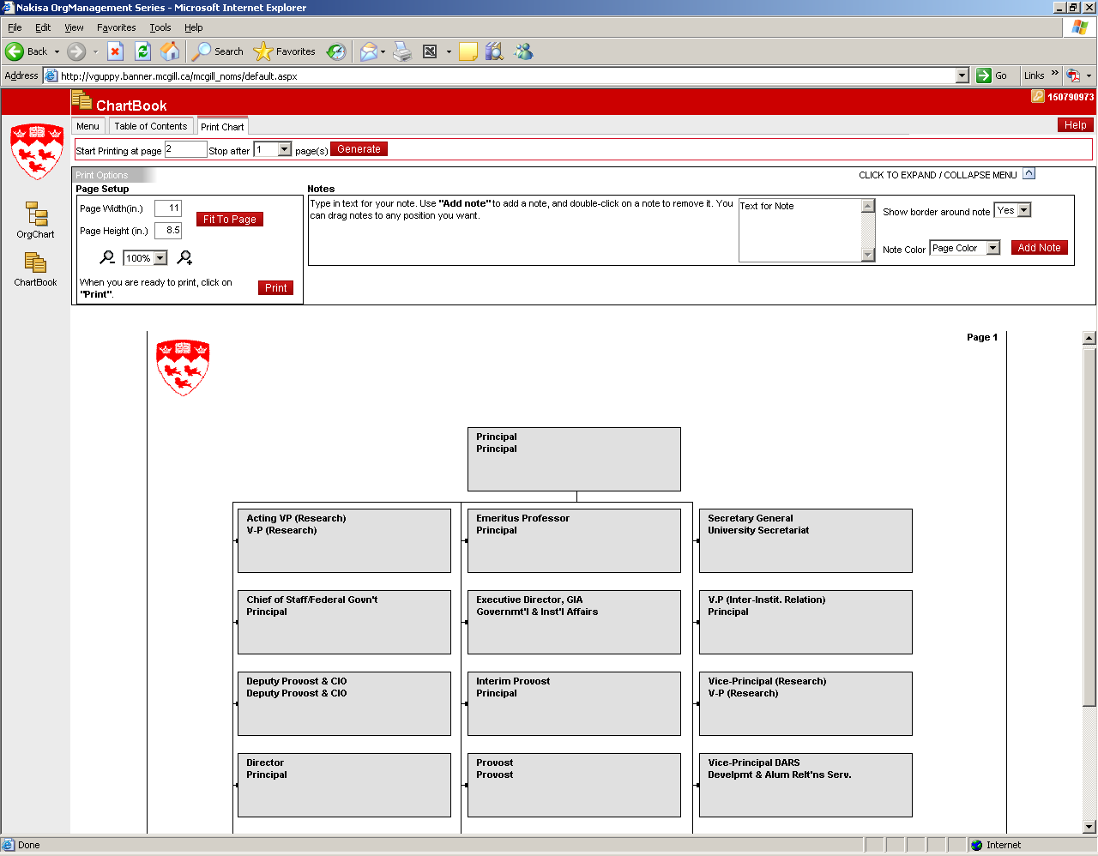
_

Once you are satisfied with the preview, click on the red button on the upper left side of the screen to print the org chart.

NOTE:

1) If the lines do not print on the org chart please do the following on the internet:

Click on Tools
Click on Internet Options
Click on Advances tab
Scroll down to Printing Section (about ¾ of the way down)
Click on Print background colors and images.

2) If the org chart does not fully fit on the page change the setting under the “Page Setup”:

Left: to 0.25
Right 0.25
Top 0.166
Bottom 0.166

Remove Header and Footer

_
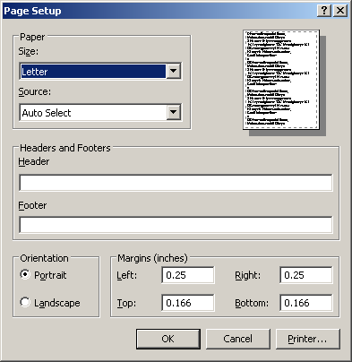
_

5.2 Importing Org Charts to PowerPoint and Word

Steps to import:

1. Setup the org chart that you wish to export (i.e. select the hierarchy, view, style, etc.) 2. Click on the Printer Icon Print OrgChart<http://demoserver/ERPDemo/Images/print.gif> to generate the printable page.
3. Click on the "Convert to Image" button.

This will prompt you to save a JPG version of the org chart. You can then Insert that picture into PowerPoint/Word,etc.

6.0 Help!

If you find that a reporting structure is incorrect please fill out the “Maintain a Position” form to correct the reports to. This form can be found at
http://www.mcgill.ca/hr/forms/ under the Records and Systems section.

Call Human Resources at 398-1062 to schedule a training session if required.

Call IST Customer Services at 398-3398 for technical support.

Nunzia Lo Presti
September 2, 2005

