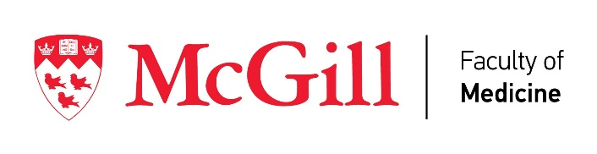
Department of Psychiatry

Application Form for the Leyton Addiction Research Prize

Eligible applicants will:

1) be a first author on a drug or alcohol addiction-related paper either published or accepted for publication between March 19, 2016 and March 20, 2017
2) have conducted the research with a faculty member in McGill University’s Department of Psychiatry
3) have been a McGill undergraduate, graduate student, post-doc, or psychiatry resident when conducting the research

The recipient of the Leyton Addiction Research Prize will be announced at Student Research Day in the spring of 2017.

Applicants should complete the form below and send an electronic copy of the paper plus supplementary on-line information (if any) to Cindy Lui at graduate.psychiatry@mcgill.ca by March 20, 2017.

Last Name: First Name:

Programme/Year: Supervisor:

Title of Paper:
Journal name:

Date of Publication or Acceptance:

Signature Date

