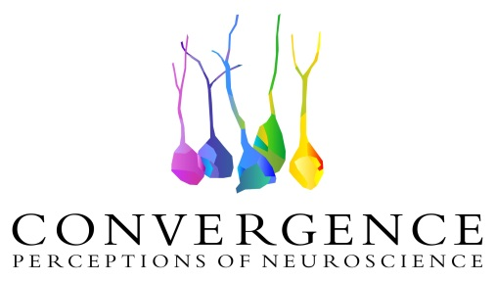

***The “Convergence” initiative takes flight: unifying* *McGill trainees and Concordia University fine arts students toward creation and outreach***

The initiative is based on the definition ofthe word convergence; the plan is to create a connection, a convergence, between scientists and artists, to raise public awareness on the importance of brain research in society.

For the next eight months, teams of Concordia University fine arts students and trainees from the Brain Repair and Integrative Neuroscience (BRaIN) Program at McGill University will collaborate to create works of art inspired by neuroscience research projects. A highly successful first step of *Convergence* was reached on October 12th, where neuroscientists delivered 5 minutes talks about their research projects to artists at Concordia University.

According to Dr. Cristian Zaelzer, Research Associate at McGill, founder and director of *Convergence*, “this initiative is about bringing the passion, the wonder in every observation, in every data point, and in every question pondered to everyone in a language that can be easily understood”.

The project brings together seventeen trainees from the BRaIN Program and fifty students from the Concordia Faculty of Fine Arts in disciplines as diverse as dance, ceramics and art history. “Convergence” was developed over the summer by a cross-disciplinary team lead by Dr. Zaelzer, and in collaboration with Dr. Andrée Lessard, manager for the BRaIN program. “Neuroscientists usually get very little media attention, and sometimes feel that nobody cares about their work unless they receive the Nobel Prize. Nevertheless, their contribution is on an inestimable value for the society. I am thankful for being part of this unique project that will break out the walls and give trainees an opportunity to reach out the population; to show them that science is accessible to all” says Dr. Lessard.

The Concordia University School of Fine Arts and the Canadian Association for Neuroscience (CAN) also joined the movement as partners and sponsors.

The students’ creations will be exhibited at a public event with media coverage at La Grande Bibliothèque (BaNQ) and at the Hotel Bonaventure this Spring, as part of the 2017 Annual Canadian Neuroscience meeting in Montreal. This national meeting is organized by the Canadian Association for Neuroscience (CAN), representing approximately a thousand researchers from across the country.

On November 25, the Concordia artists will visit the McGill side to attend Lectures on basic science related to the brain; an event sponsored by the Canadian Association for Neuroscience. The public is invited to join in from 5 to 6 p.m. in the Livingston Lounge, L6 500, at the Montreal General Hospital of the McGill University Health Centre.

To learn more about “Convergence,” please visit <http://www.convergenceinitiative.org/>

or write directly to info@convergenceinitiative.org

